Please download a copy of this report template to fill it out and upload it to Engage.
Once it has been uploaded, let us know by completing this online form: https://forms.office.com/e/074X53zd1J
Society Name | Date
Student Action for Refugees | 18/03/2026

Which three tasks did you complete?
☒ Educational post on social media
☐ Fundraiser in support of a related charity/cause
☐ Event centered on related themes
☒ Group-specific safety commitment statement
☒ Collab awareness event/activity with another student group
☒ Resource guide for members
☐ Discussion session

For more info on each of these tasks, visit Get SASHA Accredited - Leeds University Union

Task 1:

Describe the task and how you approached it

Educational post on social media

- We created a post on social media to educate our members on what SASHA does, including some topics we learnt about in our SASHA training, including consent being reversible and informed; and how to intervene safely.

What was the response to this?

This post got over 900 views and 20 likes. With our members at around 60, we feel satisfied that the content has reached our members.

What is the impact of this action (predicted or already realised)

We were able to share the existence of our new welfare form through this post, which was a direct result of our training with SASHA. We elected a welfare secretary to monitor this form and welfare within the society. This form has been used to report concerns within our volunteer groups.

Share here any photos/links that show you completed this action

https://www.instagram.com/p/DV1D5S9jD-S/?img_index=1

If this link doesn’t work, the post is available on our Instagram @leeds_star

Our commitment statement and educational post are on the same slideshow.

Task 2:

Describe the task and how you approached it

Group specific commitment statement.

We shared on our Instagram a commitment statement detailing our endeavor to be as inclusive as possible as a society as well as the type of culture we try to promote.

What was the response to this?

This post got over 900 views and 20 likes. With our members at around 60, we feel satisfied that the content has reached our members.

What is the impact of this action (predicted or already realised)

We hope by sharing this on our Instagram, we will be able to reach not just our current members but future potential members, ensuring anyone who wants to be part of Leeds STAR knows that they are welcome regardless of race, sexuality, gender, accent or background.

Share here any photos/links that show you completed this action

https://www.instagram.com/p/DV1D5S9jD-S/?img_index=1

If this link doesn’t work, the post is available on our Instagram @leeds_star

Our commitment statement and educational post are on the same slideshow.

Task 3:

Describe the task and how you approached it

Resource guide for members
We created and distributed a resource guide for, reporting harassment, bullying and hate crimes. This is tailored to our student volunteers, as well as specific resources for the refugee/asylum community.

What was the response to this?

This post was viewed by over 700 people and has 13 likes.

What is the impact of this action (predicted or already realised)

We hope by having this on our page, our followers will be able to refer back to it if they need it. We were also able to share our wellbeing form as a support resource which has been used by our members to report concerns.

Share here any photos/links that show you completed this action

https://www.instagram.com/p/DV3I8ocjMRV/?img_index=1

available on Instagram @leeds_star

Task 4:

Describe the task and how you approached it

Collab for awareness with another student group

Our president gave a speech at the Women’s week rally on 3 March 2026, discussing the effect that changes to the UK asylum system will have on women, particularly focusing on how the work ban fuels violence against women, often leading to sexual harassment and assault.

What was the response to this?

The speech was well received and aimed to educate students on the importance of the work of organizations like SASHA, while highlighting intersectionality.

What is the impact of this action (predicted or already realised)

To highlight the importance of intersectionality in considering our action against sexual harassment and assault, and how these issues can impact women, women of colour and those from a disadvantaged background in disproportionate ways. This speech demonstrated the relevance of STAR in this discussions.

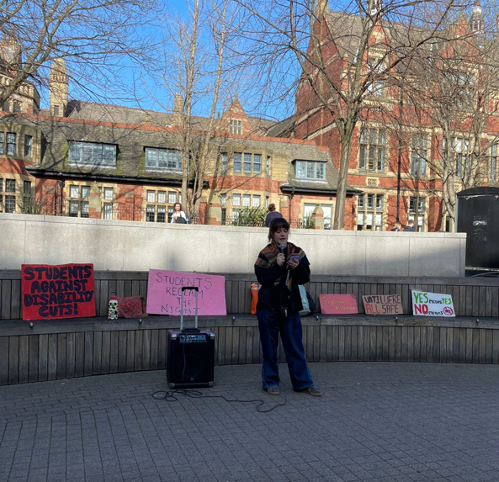
Share here any photos/links that show you completed this action

REMINDER! let us know you have submitted your report by completing this online form: https://forms.office.com/e/074X53zd1J
You will not be SASHA Accredited unless you complete both this report and the form.

