- tou

INDIVIDUAL ACTIVITY RISK ASSESSMENT | Degree of Risk | Risk Rating Matrix
 |  | 
  Society Name: | Cosy Games Society
  Category: | Social
  Author(s): | Ellen Spence  (Treasurer)
  Author(s) signature and date: | 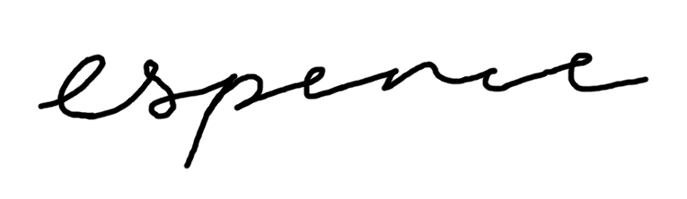(29/05/2026)
  Persons Responsible: | Club and society committees and leaders
  Staff Sign Off:
  Staff Additional Check: | [Signature] [Date]
  Locations: | Woodies, 104 Otley Rd, Headingley, Leeds LS16 5JG  to  Dry Dock, Woodhouse Ln, Leeds LS2 3AX
  Details of Activity: | Otley Run (Pub Crawl)
  People who may be affected: | - Society members and participants  - Staff
  Likelihood
  5 | Inevitable
  4 | Highly Likely
  3 | Probable
  2 | Unlikely
  1 | Remote possibility
  Severity
  5 | Very high - multiple deaths
  4 | Highly - death, serious injury, permanent disability
  3 | Moderate - Off Uni/work for at least 5 days
  2 | Slight - First aid treatment
  1 | Nil - Very minor
  Severity
  Likelihood |  | 1 | 2 | 3 | 4 | 5
  Likelihood | 1 | 1 | 2 | 3 | 4 | 5
  Likelihood | 2 | 2 | 4 | 6 | 8 | 10
  Likelihood | 3 | 3 | 6 | 9 | 12 | 15
  Likelihood | 4 | 4 | 8 | 12 | 16 | 20
  Likelihood | 5 | 5 | 10 | 15 | 20 | 25
  Risk rating score | Action
  1 - 4 | Broadly acceptable – no action required
  5 - 9 | Moderate - Reduce risks if reasonably practicable
  10 - 15 | High risk - Priority action to be undertaken
  16 - 25 | Unacceptable - Action must be taken immediately

Identify Hazards | Estimate the risk |  |  |  | Evaluate the risk |  |  |  | Evaluate residual risk
Hazard | How may harm result? | Likelihood | Severity | Rating | Risk control measures | Likelihood | Severity | Rating | Further action required?  Only fill out if additional control measures are needed to be implemented or reviewed  Include timescales and who is responsible for implementation
Alcohol | High levels of intoxication could lead to injury or illness. | 3 | 2 | 6 | Ensure members are made aware beforehand of the effects/dangers of alcohol and how to take care of themselves/stay safe when drinking. Additionally, at least one committee member will stay sober and look after anyone that ends up overly intoxicated. Water will be available at all times and members will also be made aware of this. | 2 | 2 | 4
Spiking | This could be a serious health risk causing both physical and emotional harm. Additionally, it would leave the member even more vulnerable to further crimes. | 2 | 4 | 8 | Ensure attendees are aware beforehand of steps they can take to avoid being a victim of spiking (do not leave drinks unattended, do not accept drinks from strangers etc.) and also how to recognise signs of potential spiking (if their drink tastes funny/looks cloudy, if they see someone attempt to slip something in a drink etc.). If a member is worried that they may have been spiked or is feeling unwell they can tell a committee member, and we will immediately notify bar staff of any issues. Following this we will also notify emergency services if a major incident has occurred and ensure the member receives any care/support needed. | 1 | 3 | 3
Night Travel | If members stay late travelling at night from the bar this can make it more difficult for members to navigate and may also leave them more vulnerable to crime. | 2 | 3 | 6 | Members will be urged when travelling home to go in groups where possible. For anyone not able to travel in a group, they will be asked to share location updates with friends or committee members. Committee members will be available to contact for the night, and we will ensure that all attendees know how to contact us. We will also encourage members to download the SafeZone app, so they have access to campus security if needed. | 1 | 3 | 3
Dimly lit areas | This could make it more difficult for attendees to navigate around any of the venues and puts them at greater risk of falling. | 2 | 2 | 4 | A committee member will always be on hand to help anyone navigate around the venues if they feel unsure. Attendees will also be asked to keep any loose items, such as bags or coats, tucked under chairs to ensure they do not become trip hazards. | 1 | 1 | 1
Separation from group | Someone gets lost and may become distressed/may be more vulnerable to crime. | 3 | 3 | 9 | Updates on our location will be posted on our discord, additionally committee members will be available to contact during the event, and members will be made aware of this. Also, while moving from a location a committee member will check to ensure that all members are aware and ready to travel with the group. | 1 | 2 | 2

