INDIVIDUAL ACTIVITY RISK ASSESSMENT | Degree of Risk | Risk Rating Matrix
 |  | 
  Society Name: | Cosy Games Society
  Category: | Social
  Author(s): | Ellen Spence  (Treasurer)
  Author(s) signature and date: | 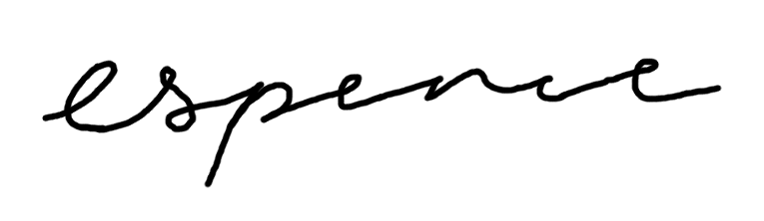(14/11/2025)
  Persons Responsible: | Club and society committees and leaders
  Staff Sign Off:
  Staff Additional Check: | [Signature] [Date]
  Locations: | Arcade Club, Abbey Retail Park, Savins Mill Way, Kirkstall, Leeds LS5 3RP
  Details of Activity: | Group visit to an arcade
  People who may be affected: | - Society members and participants  - Staff
  Likelihood
  5 | Inevitable
  4 | Highly Likely
  3 | Probable
  2 | Unlikely
  1 | Remote possibility
  Severity
  5 | Very high - multiple deaths
  4 | Highly - death, serious injury, permanent disability
  3 | Moderate - Off Uni/work for at least 5 days
  2 | Slight - First aid treatment
  1 | Nil - Very minor
  Severity
  Likelihood |  | 1 | 2 | 3 | 4 | 5
  Likelihood | 1 | 1 | 2 | 3 | 4 | 5
  Likelihood | 2 | 2 | 4 | 6 | 8 | 10
  Likelihood | 3 | 3 | 6 | 9 | 12 | 15
  Likelihood | 4 | 4 | 8 | 12 | 16 | 20
  Likelihood | 5 | 5 | 10 | 15 | 20 | 25
  Risk rating score | Action
  1 - 4 | Broadly acceptable – no action required
  5 - 9 | Moderate - Reduce risks if reasonably practicable
  10 - 15 | High risk - Priority action to be undertaken
  16 - 25 | Unacceptable - Action must be taken immediately

Identify Hazards | Estimate the risk |  |  |  | Evaluate the risk |  |  |  | Evaluate residual risk
Hazard | How may harm result? | Likelihood | Severity | Rating | Risk control measures | Likelihood | Severity | Rating | Further action required?  Only fill out if additional control measures are needed to be implemented or reviewed  Include timescales and who is responsible for implementation
Alcohol | High levels of intoxication could lead to injury or illness. | 3 | 2 | 6 | Ensure members are made aware beforehand of the effects/dangers of alcohol and how to take care of themselves/stay safe when drinking. Additionally, at least one committee member will stay sober and look after anyone that ends up overly intoxicated. Water will be available at all times and members will also be made aware of this. | 2 | 2 | 4
Spiking | This could be a serious health risk causing both physical and emotional harm. Additionally, it would leave the member even more vulnerable to further crimes. | 2 | 4 | 8 | Ensure attendees are aware beforehand of steps they can take to avoid being a victim of spiking (do not leave drinks unattended, do not accept drinks from strangers etc.) and also how to recognise signs of potential spiking (if their drink tastes funny/looks cloudy, if they see someone attempt to slip something in a drink etc.). If a member is worried that they may have been spiked or is feeling unwell they can tell a committee member, and we will immediately notify bar staff of any issues. Following this we will also notify emergency services if a major incident has occurred and ensure the member receives any care/support needed. | 1 | 3 | 3
Night Travel | Travelling at night to/from the arcade can make it more difficult for members to navigate and may also leave them more vulnerable to crime. | 2 | 3 | 6 | Members will be urged when travelling to go in groups where possible. For anyone not able to travel in a group, they will be asked to share location updates with friends or committee members. Committee members will be available to contact for the night, and we will ensure that all attendees know how to contact us. We will also encourage members to download the SafeZone app, so they have access to campus security if needed. | 1 | 3 | 3
Dimly lit areas | This could make it more difficult for attendees to navigate around the venue and puts them at greater risk of falling. | 2 | 2 | 4 | A committee member will always be on hand to help anyone navigate around the venue if they feel unsure. Attendees will also be asked to keep any loose items, such as bags or coats, tucked under chairs or secured away to ensure they do not become trip hazards. | 1 | 1 | 1
Stairs inside the venue | Attendees could potentially fall, especially if intoxicated, | 1 | 2 | 2 | Anyone overly intoxicated will be aided when using the stairs. | 1 | 2 | 2
Strobe lighting in arcade games | Attendees with light sensitivities or medical conditions such as epilepsy may be unable to play games with flashing lights as it could result in discomfort or seizures. | 1 | 4 | 4 | Anyone with epilepsy will be asked to inform committee members beforehand and advice will follow. Others with sensitivity to flashing lights will be advised also, whether this includes stepping outside, getting some fresh air or if needed, leaving the venue entirely. | 1 | 3 | 3

