- rat

CLUB AND SOCIETY INDIVIDUAL RISK ASSESSMENT | Degree of Risk | Risk Rating Matrix
 |  | 
  Society Name: | Bangladeshi Society (BDSOC)
  Category: | Cultural
  Author(s): | Mir Zayed Bin Abdul Kader (President)
  Author(s) signature and date: | Mir Zayed Bin Abdul Kader (President); 11 April 2026  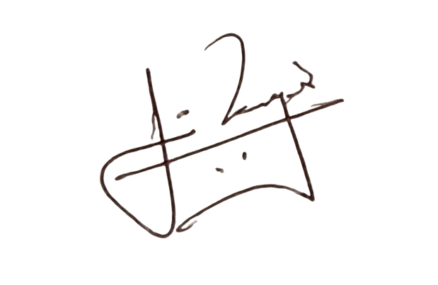
  Persons Responsible: | Mir Zayed Bin Abdul Kader (President); Afsana Riny (Secretary); Urjoshyee Ushba (Treasurer)
  Staff Sign Off: | [Signature] [Date]
  Staff Additional Check: | [Signature] [Date]
  Locations: | LUU spaces; University teaching rooms; occasional city venues
  Details of Activity: | Cultural events, socials, adda sessions, charity fundraisers, awareness campaigns, committee meetings, and university-wide collaborative events.
  People who may be affected: | - Society members and participants  - Staff
  Likelihood
  5 | Inevitable
  4 | Highly Likely
  3 | Probable
  2 | Unlikely
  1 | Remote possibility
  Severity
  5 | Very high - multiple deaths
  4 | Highly - death, serious injury, permanent disability
  3 | Moderate - Off Uni/work for at least 5 days
  2 | Slight - First aid treatment
  1 | Nil - Very minor
  Severity
  Likelihood |  | 1 | 2 | 3 | 4 | 5
  Likelihood | 1 | 1 | 2 | 3 | 4 | 5
  Likelihood | 2 | 2 | 4 | 6 | 8 | 10
  Likelihood | 3 | 3 | 6 | 9 | 12 | 15
  Likelihood | 4 | 4 | 8 | 12 | 16 | 20
  Likelihood | 5 | 5 | 10 | 15 | 20 | 25
  Risk rating score | Action
  1 - 4 | Broadly acceptable – no action required
  5 - 9 | Moderate - Reduce risks if reasonably practicable
  10 - 15 | High risk - Priority action to be undertaken
  16 - 25 | Unacceptable - Action must be taken immediately

Identify Hazards | Estimate the risk |  |  |  | Evaluate the risk |  |  |  | Evaluate residual risk
Hazard | How may harm result? | Likelihood | Severity | Rating | Risk control measures | Likelihood | Severity | Rating | Further action required?  Only fill out if additional control measures are needed to be implemented or reviewed  Include timescales and who is responsible for implementation
Lack of communication of RA | Members unaware of procedures; injury during activities | 2 | 2 | 4 | Share annual RA; per-event RA; brief at start of each session | 1 | 1 | 1
Emergency procedures not communicated | Injury during evacuation or medical emergency | 2 | 2 | 4 | Point out fire exits; share emergency contacts; campus procedures; call 999 off-campus | 1 | 1 | 1
Accessibility barriers | Injury or exclusion due to lack of access or unsuitable activity | 2 | 3 | 6 | Book accessible venues; adjust activities; invite disclosure; provide quiet seating | 1 | 1 | 1
Health conditions/allergies incl. food | Allergic reaction or exacerbation of condition | 2 | 3 | 6 | Collect info via sign-up; label allergens; avoid cross-contamination; first aid kit and contacts on hand | 1 | 1 | 1
Crowding and room capacity | Collisions; difficulty evacuating in emergency | 2 | 2 | 4 | Book suitable room size; cap attendance; keep walkways clear; avoid blocking exits | 1 | 2 | 2
Slip/trip hazards | Minor injuries from falls | 2 | 2 | 4 | Check floors before events; wet floor signs; tidy cables and bags; keep routes clear | 1 | 1 | 1
Influence of alcohol at socials | Injury or abuse; potential hospitalisation | 3 | 3 | 9 | Prefer alcohol-free events; harm reduction messaging; no BYO in booked spaces; escort intoxicated members safely; follow LUU policies | 1 | 2 | 2
Drink spiking | Serious health risk; loss of consciousness | 2 | 4 | 8 | Use Union venues; drink-protection measures; buddy system; report to staff and police | 1 | 3 | 3
Abuse/violence incl. sexual harassment | Harm to members or public | 1 | 3 | 3 | Zero tolerance policy; clear reporting routes; Ask for Angela scheme; escalate to LUU/authorities | 1 | 1 | 1
Handling equipment/props | Manual handling injuries; damaged items | 2 | 3 | 6 | Two-person lifts for heavy items; use trolleys/ramps; wear gloves; check condition; remove damaged items | 1 | 2 | 2
Electrical equipment brought by members | Electric shock or fire | 1 | 4 | 4 | PAT-tested kit where applicable; avoid unsafe devices; report faults; avoid overloading sockets | 1 | 2 | 2
External trips (local travel) | Transport incidents or injuries | 2 | 3 | 6 | Prefer public transport; confirm routes and tickets in advance; maintain contact tree; dynamic RA on day; no driving on society business | 1 | 2 | 2

