Please download a copy of this report template to fill it out and upload it to Engage.
Once it has been uploaded, let us know by completing this online form: https://forms.office.com/e/074X53zd1J
Society Name | Date
Women’s Rugby Union | 07/03/2026

Which three tasks did you complete?
☒ Educational post on social media
☐ Fundraiser in support of a related charity/cause
☒ Event centered on related themes
☒ Group-specific safety commitment statement
☐ Collab awareness event/activity with another student group
☐ Resource guide for members
☐ Discussion session

For more info on each of these tasks, visit Get SASHA Accredited - Leeds University Union

Task 1:

Describe the task and how you approached it

For this task, we created a Women’s Rugby Union social commitment statement that was put together by our committee to outline what we do as a club to ensure our members feel safe and supported at all our social events. It is important to us as a club that our events are inclusive and enjoyable for everyone, fostering a safe and respectful environment. We have this posted on our Instagram and Facebook so anyone that views our club's social media can see our commitment. We believe it is something that is beneficial and will empower our members. We approached this task by highlighting exactly how we currently maintain this type of environment, while also reflecting on points that we could improve on. All committee members were given access to the document, allowing everyone to contribute and make sure it was as inclusive as possible. We encouraged everyone to edit this, even if it was only one sentence, to ensure it was a joint effort, and all our committee believed in the post. This is something we can now share on our story as a reminder and we will encourage the next committee to keep sharing this as an ongoing commitment to creating a positive, welcoming and inclusive environment.

What was the response to this?

While the welfare secretaries wrote up the initial statement, our committee responded by adding their own points and adjustments. This proactive response is what helped shape our statement into a nuanced reflection of our club expectations and values.

What is the impact of this action (predicted or already realised)

We hope this statement has been able to inform and reassure our members of our expectations at club social events. It has been especially important to our members who don’t drink, making them feel included and considered in social environments. We believe this will have a positive impact on clubs' engagement, especially for the next year, as it shows people who are new to the club about our core values so should help retainment as well as encouraging more members to join and participate in club events.

Share here any photos/links that show you completed this action

https://docs.google.com/document/d/19BqegGzaR5i7uByTM1Uj1iP7UtT7ub5L9dRbcrFBPTM/edit?usp=sharing

Task 2:

Describe the task and how you approached it

For our educational post on social media, we decided to use our social commitment statement to educate our followers on what we do as a club to ensure safety, inclusivity and a consensual environment at all our social events. We felt that this would be a really effective way to educate viewers, particularly people who may be interested in joining our society, on our expectations and commitments to wellbeing and inclusivity.

What was the response to this?

The response to this post was that it was reassuring to our members and that our expectations for club socials have been made clear, particularly for our newer members. Several of our members remarked that they felt the statement helps foster inclusivity and that by formatting it into a social media post it emphasised the clubs seriousness toward the undertaking of the statements. For many, joining a new club is a daunting experience so having this statement has shown new members that we committed to ensuring a positive and welcoming environment across all club activities.

What is the impact of this action (predicted or already realised)

We hope that this post can help break down the negative stereotypes surrounding university sports societies by outlining the high level of responsibility we take towards creating a respectful and consensual social environment. It also makes it clear to all club members that the expectations we have of them must be actively upheld at all times. We hope that it encourages members to use their voice and speak to committee if they ever feel like these standards haven’t been maintained. We want to create an environment where anyone and everyone feels comfortable enough to question our committee and hold us accountable for our commitments. The post had good engagement on Instagram and Facebook, receiving likes from lots of our members.

Share here any photos/links that show you completed this action
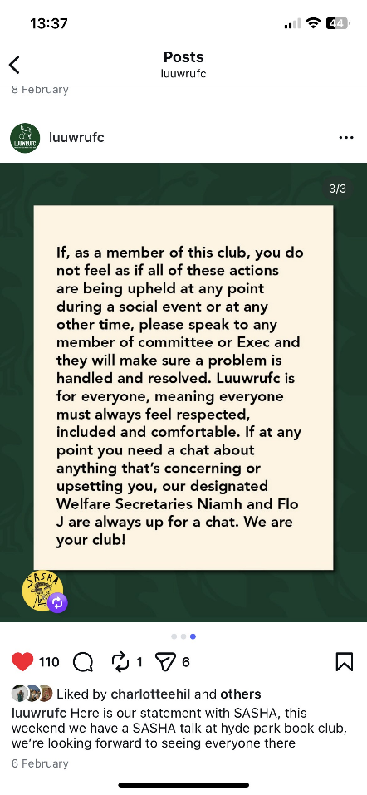
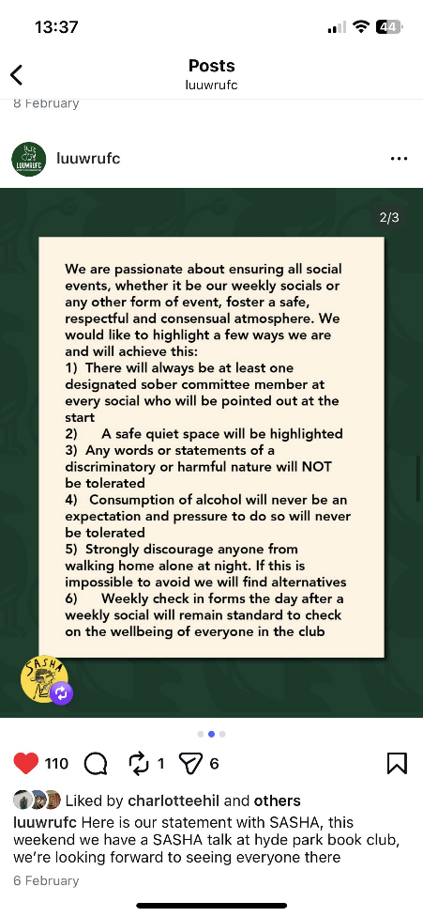
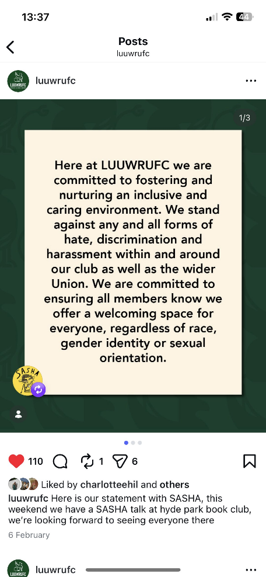

Task 3:

Describe the task and how you approached it

For the third task, we held an event in partner with SASHA to discuss themes around safety on nights out, consent, respect and what our club is doing to support student wellbeing. All our members were offered the opportunity to attend our event and the group met at Hyde Park Book Club for a coffee and discussion morning. We wanted to create a relaxed and comfortable environment for our members to talk openly guided by a member of SASHA who came down to lead the session alongside our Welfare Secretaries. We encouraged open communication and understanding to take place. We wanted to discuss over coffee as it felt like a welcoming environment to encourage members down to. Having a relaxed feel for such a heavy topic really helped the event and promoted a positive environment full of thoughtful discussions.

What was the response to this?

We received a really positive response from those who attended, particularly from the freshers who felt they now had a better understanding of how committee is involved in upholding general club wellbeing. It was also really useful as committee to get an understanding of how our members feel regarding the topics discussed and to hear their positive feedback. This has helped us reflect on how we communicate what committee is doing to the wider club, helping to bridge the gap on understanding!

What is the impact of this action (predicted or already realised)

We hope that this event has sparked a wider ongoing conversation in the club that empowers members to take responsibility for creating a positive club mentality. It was also fed back to us that our members would like more events like this in the future, giving people a chance to continue asking questions, sharing opinions and learning from each other.

Share here any photos/links that show you completed this action

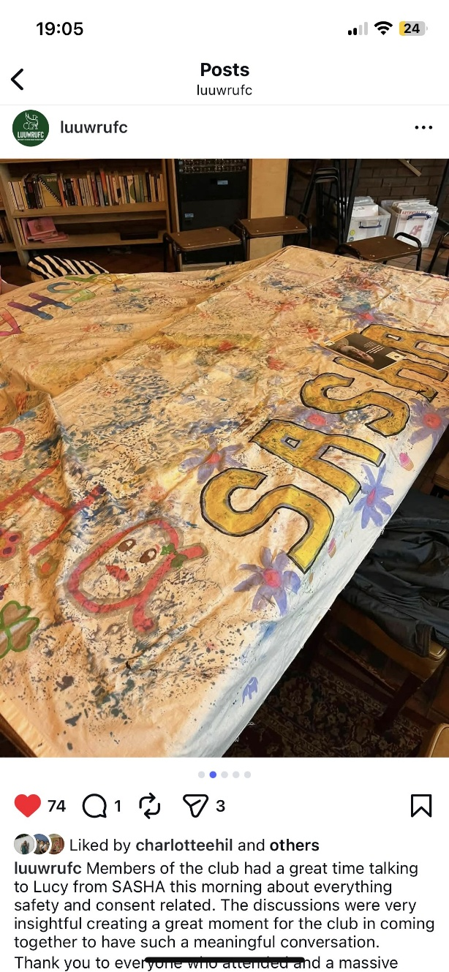
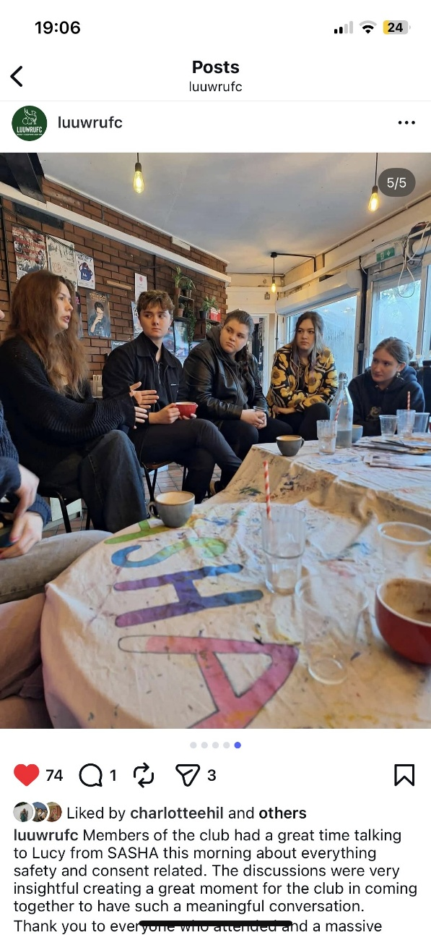

REMINDER! let us know you have submitted your report by completing this online form: https://forms.office.com/e/074X53zd1J
You will not be SASHA Accredited unless you complete both this report and the form.

