CLUB AND SOCIETY RISK ASSESSMENT | Degree of Risk | Risk Rating Matrix
 |  | 
  Society Name: | LUU Leeds Surf Club
  Category: | Outdoor Society
  Author(s): | Holly Davies
  Author(s) signature and date: | 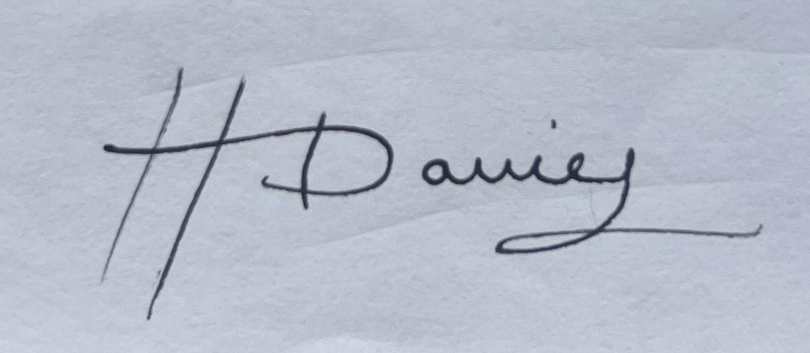  21/07/2025
  Persons Responsible: | Club and society committees and leaders
  Staff Sign Off: | [Signature] [Date]
  Staff Additional Check: | [Signature] [Date]
  Locations: | Two international trips, previously to Morocco and Portugal. Newcastle and trips to other UK areas such as Newquay and Scarborough.
  Details of Activities: | A surfing and social society. Due to the lack of availability for local surfing, we take members on trips across the country and also on two international trips. We also run socials on a weekly basis.
  People who may be affected: | - Society members and participants  - Members of the public  - Staff
  Likelihood
  5 | Inevitable
  4 | Highly Likely
  3 | Probable
  2 | Unlikely
  1 | Remote possibility
  Severity
  5 | Very high - multiple deaths
  4 | Highly - death, serious injury, permanent disability
  3 | Moderate - Off Uni/work for at least 5 days
  2 | Slight - First aid treatment
  1 | Nil - Very minor
  Severity
  Likelihood |  | 1 | 2 | 3 | 4 | 5
  Likelihood | 1 | 1 | 2 | 3 | 4 | 5
  Likelihood | 2 | 2 | 4 | 6 | 8 | 10
  Likelihood | 3 | 3 | 6 | 9 | 12 | 15
  Likelihood | 4 | 4 | 8 | 12 | 16 | 20
  Likelihood | 5 | 5 | 10 | 15 | 20 | 25
  Risk rating score | Action
  1 - 4 | Broadly acceptable – no action required
  5 - 9 | Moderate - Reduce risks if reasonably practicable
  10 - 15 | High risk - Priority action to be undertaken
  16 - 25 | Unacceptable - Action must be taken immediately

Identify Hazards | Estimate the risk |  |  |  | Evaluate the risk |  |  |  | Evaluate residual risk
Hazard | How may harm result? | Likelihood | Severity | Rating | Risk control measures | Likelihood | Severity | Rating | Further action required?  Only fill out if additional control measures are needed to be implemented or reviewed  Include timescales and who is responsible for implementation
Surfboard Injury | Members using a surfboard or in close proximity to others using surfboards are at risk of being hit, especially when falling off the board | 2 | 2 | 4 | Ensuring that the board is always under control  Watching around to ensure there is nobody nearby when catching waves. | 1 | 2 | 2
Unsuitable or damaged surf equipment | Can result in members using equipment that increases risk of injury in the water | 2 | 2 | 4 | All equipment should be checked properly prior to use, and checked regularly by the kit secretary.  If any equipment is deemed unsuitable it should not be used and reported to the club / hire company immediately | 1 | 2 | 2
Dangerous surfing (Weather conditions) | Leads to unpredictable and thus more unsafe waves, stormy weather makes for windier conditions | 2 | 3 | 6 | Conditions will be checked in advance, and if deemed unsafe, members will not surf  Surfing will only happen between marked flags on beaches with lifeguards  If conditions become unsafe during a surfing session, committee members will call all members into the beach and do a headcount  In case of emergency, lifeguards or coastguard should be informed immediately | 1 | 2 | 2
Member struggling in the water due to currents | Particularly relevant to inexperienced surfers, can be dangerous especially if separated from the group | 2 | 3 | 6 | Prior to the trip commencing, all members must fill in a form confirming that they are confident swimmers  A trained member of the committee will explain surf etiquette and currents to all members prior to entering the water  Conditions will be checked in advance, and if deemed unsafe, members will not surf  Surfing will only happen between marked flags on beaches with lifeguards  In case of emergency, lifeguards or coast guard should be informed immediately | 1 | 3 | 3
Handling bulky equipment | Heavy and bulky equipment increases risk of harm to members handling it | 1 | 2 | 2 | Members should be informed by committee of how to properly handle bulky equipment  If a member is struggling with a piece of equipment then a member of committee should designate others or themselves to help (for example, two people holding a surfboard) | 1 | 1 | 1

