CLUB AND SOCIETY ANNUAL RISK ASSESSMENT | Degree of Risk | Risk Rating Matrix
 |  | 
  Society Name: | Photography Society
  Category: | General Interest
  Author(s): | Eva Zur
  Author(s) signature and date: | 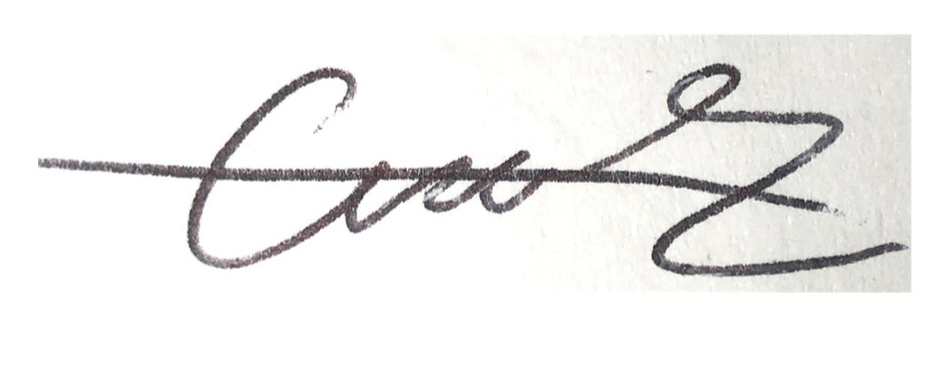  01.8.25
  Persons Responsible: | Chaithra Rajesh Balakrishnan  Aritro Roy  Eva Zur
  Staff Sign Off: | [Signature] [Date]
  Staff Additional Check: | [Signature] [Date]
  Locations: | LUU union
  Details of Activity:
  People who may be affected: | - Society members and participants  - Staff
  Likelihood
  5 | Inevitable
  4 | Highly Likely
  3 | Probable
  2 | Unlikely
  1 | Remote possibility
  Severity
  5 | Very high - multiple deaths
  4 | Highly - death, serious injury, permanent disability
  3 | Moderate - Off Uni/work for at least 5 days
  2 | Slight - First aid treatment
  1 | Nil - Very minor
  Severity
  Likelihood |  | 1 | 2 | 3 | 4 | 5
  Likelihood | 1 | 1 | 2 | 3 | 4 | 5
  Likelihood | 2 | 2 | 4 | 6 | 8 | 10
  Likelihood | 3 | 3 | 6 | 9 | 12 | 15
  Likelihood | 4 | 4 | 8 | 12 | 16 | 20
  Likelihood | 5 | 5 | 10 | 15 | 20 | 25
  Risk rating score | Action
  1 - 4 | Broadly acceptable – no action required
  5 - 9 | Moderate - Reduce risks if reasonably practicable
  10 - 15 | High risk - Priority action to be undertaken
  16 - 25 | Unacceptable - Action must be taken immediately

Identify Hazards | Estimate the risk |  |  |  |  | Evaluate the risk |  |  |  | Evaluate residual risk
Hazard | How may harm result? |  | Likelihood | Severity | Rating | Risk control measures | Likelihood | Severity | Rating | Further action required?  Only fill out if additional control measures are needed to be implemented or reviewed  Include timescales and who is responsible for implementation
Trips & Falls | May cause injuries, spraining.  Tripping over equipment such as tripods and cables could cause harm and potentially damage equipment. |  | 3 | 2 | 6 | Ensure equipment is set up safely and correctly before the beginning of events, minimising the chance of an accidental trip.  Provide members with relevant health and safety information if needed.  Before photography outings or events, perform a risk assessment of the location to identify any potential tripping hazards.  Ensure outdoor events are within well-lit areas.  Ensuring attendees are wearing appropriate footwear for the terrain  Clear walkways | 2 | 1 | 2
Manual Handling | Pain stemming from poor handling of equipment.  Possible damage to equipment from poor handling. |  | 2 | 2 | 4 | Ensure equipment is set up safely and correctly before the beginning of events.  Provide shoulder straps to minimise strain from poor handling and chance of damage to equipment. | 1 | 1 | 1
Electrical Failures | Faults with technology leading to malfunction.  Minor chance of electric shock. |  | 1 | 2 | 2 | Regular checks on electrical equipment to ensure good working order, free from faults that could lead to failure during shoots.  LUU can PAT test equipment. Any electrical equipment used in the building should be PAT tested.  Bring spare batteries for outside shoots. | 1 | 1 | 1
Privacy Concerns | Inadvertently taking photos of individuals without consent, leading to distress or legal action if shared.  Copyright issues from sharing the work of others online and claiming as their own. |  | 2 | 1 | 2 | Get members’ informed consent to the possibility of photos being taken of them and posted at the beginning of an event.  Encourage photos to be taken of models or props rather than other photographers.  Set guidelines for how photos will shared and stored.  If cameras are lended out, note down the name of who has taken the camera so credit can be given. | 1 | 1 | 1
Fire | Injury caused by heat and flames  Suffocate or poisoning from smoke  Injury from the collapse of the building | 2 |  | 5 | 10 | All backdrops, display boards, and decorative materials used for exhibitions or workshops are flame retardant or have been fire-proofed prior to use.  Extension leads, cables, and lighting equipment are set up to avoid trip hazards and must not block fire exits or evacuation routes.  No open flames or heat sources (e.g., candles, flares, smoke bombs) are permitted at any indoor or outdoor photography session without a risk assessment and prior approval.  LUU Fire Safety Regulations are enforced at all events and activities.  All fire exits and evacuation routes in venues used for exhibitions, meetings, or indoor shoots are checked and kept completely clear at all times.  Before any event begins, all attendees (including guests and models, if any) are briefed on the emergency evacuation procedures and nearest exits.  Where seating is provided (e.g., for talks or photo editing sessions), a minimum of 1.2m clearance is maintained for aisles and around seating areas.  Photography equipment such as lighting stands, tripods, and umbrellas must be securely set up to prevent falling hazards in case of evacuation.  In case of a fire or emergency, the event coordinator or society lead must be prepared to make an announcement or assist in directing attendees safely out of the building.  The President or designated safety officer should carry a charged phone or radio to communicate with LUU staff in the event of an emergency.  A pre-event reminder is made at all indoor gatherings to inform attendees about emergency exits and fire safety procedures. | 1 | 5 | 5
Lone Working | Injury exacerbated due to lack of available help nearby |  | 2 | 4 | 8 | Avoid working alone whenever possible — especially in studios, darkrooms, or unfamiliar outdoor locations.  If working alone, always inform a friend or committee member of your location and estimated time of return.  Keep your phone fully charged and within reach throughout the session.  Do not use heavy or elevated equipment (e.g., ladders, lighting rigs) without someone present.  For outdoor photography, avoid isolated or poorly lit areas, particularly after dark. | 1 | 4 | 4
Slips, trips and falls during socials | 95% of major slips result in broken bones  They can result from a range of other types of accidents, such as falls from heights or poor house keeping |  | 2 | 2 | 4 | Ensure all bags, cables, and equipment are stored safely out of walkways.  Clean up spills immediately and report any wet or uneven surfaces to venue staff.  Wear sensible footwear, especially for events involving walking or dancing. | 1 | 2 | 2
Consumption of alcohol during socials | Excessive drinking which could lead to headaches, nausea, blackouts and alcohol poisoning  Peer pressure which could lead to discomfort and isolation  Confusion and loss of coordination which could lead to serious injury |  | 3 | 2 | 6 | Members are encouraged to drink responsibly and know their limits.  The society does not tolerate pressure to drink — all events are inclusive and alcohol consumption is optional.  Always look out for your friends and never leave drinks unattended. | 2 | 2 | 4
Attending socials at  night | Excessive drinking could lead to further injury  Encounters with intoxicated people which could lead to further harm |  | 3 | 2 | 6 | Stick with a group or use the buddy system when traveling to and from evening events.  Plan your journey in advance and use well-lit, familiar routes or trusted transport options.  If you ever feel unsafe, contact LUU security or use the SafeZone app (if available). | 2 | 2 | 4

