Please download a copy of this report template to fill it out and upload it to Engage.
Once it has been uploaded, let us know by completing this online form: https://forms.office.com/e/074X53zd1J
Society Name | Date
Gryphon Racing | 16/03/2026

Which three tasks did you complete?
☒ Educational post on social media
☐ Fundraiser in support of a related charity/cause
☐ Event centered on related themes
☐ Group-specific safety commitment statement
☐ Collab awareness event/activity with another student group
☒ Resource guide for members
☒ Discussion session

For more info on each of these tasks, visit Get SASHA Accredited - Leeds University Union

Task 1: Educational post on social media

Describe the task and how you approached it

In order to further share what team members have learned in our training sessions and discussions, we created a post about the role of consent in our society and the importance of being an active bystander. As our society is a Formula Student UK team, we also wanted to share with our sponsors why getting SASHA accredited is an important goal especially due to its relationship with international aims to increase the presence of women within STEM.

What was the response to this?

This post sparked discussions with our sponsors and partners about the importance of being an active bystander to enable women to feel safe and comfortable in STEM fields and as part of our society more specifically. Additionally, members that were not able to attend our discussion session were able to learn about the steps we have taken towards SASHA certification, and why it is so important to work towards.

What is the impact of this action (predicted or already realised)

Now that all of our members are aware of how sexual harassment and assault relates to us, and how important it is to face these problems to ensure women can enjoy and be successful in their time in engineering, we are more likely as a society to collaborate with other societies or charities that tackle these issues in the future.

Share here any photos/links that show you completed this action

Here is a link to our instagram post: https://www.instagram.com/p/DVZaNo7AFgc/?img_index=3&igsh=b2o2cW4xbngzazNj

Task 2: Resource guide for members

Describe the task and how you approached it

As a society, we have an existing wellbeing master-document which outlines the support available to students which is regularly updated to ensure students always have access to support. This document was updated following the SASHA consent and active bystander training to include information on how to be an active bystander, as well as outlining national and Leeds-based support for survivors of sexual violence. The resource also consciously includes resources that are available to male survivors rather than only female resources, as most of our society are men.

What was the response to this?

Many society members have appreciated the addition of information on how to be an active bystander. Those that use the document find it very helpful and have recommended further additions which tailored the guide for our members, as our society is largely made up of male members.

What is the impact of this action (predicted or already realised)

The wellbeing resource is frequently used, so the addition of resources focused on sexual harassment and assault has normalised discussions on these topics. Discussions of local and national resources has highlighted which resources are well known, and how our regular social venues interact with sexual harassment.

Share here any photos/links that show you completed this action

Here is a link to the wellbeing resource: https://leeds365.sharepoint.com/:w:/r/sites/LeedsGryphonRacing/_layouts/15/Doc2.aspx?action=edit&sourcedoc=%7B74fdac46-5e2c-433e-8048-51377bce5a50%7D&wdOrigin=TEAMS-MAGLEV.teamsSdk_ns.rwc&wdExp=TEAMS-TREATMENT&wdhostclicktime=1773665803335&web=1 and a screenshot of the relevant pages (below). As this document is in a folder for our group, it may not be accessible. If you would like to meet me to prove that the document is live, please contact me - Kimi Campbell, Welfare Officer hy20ec@leeds.ac.uk
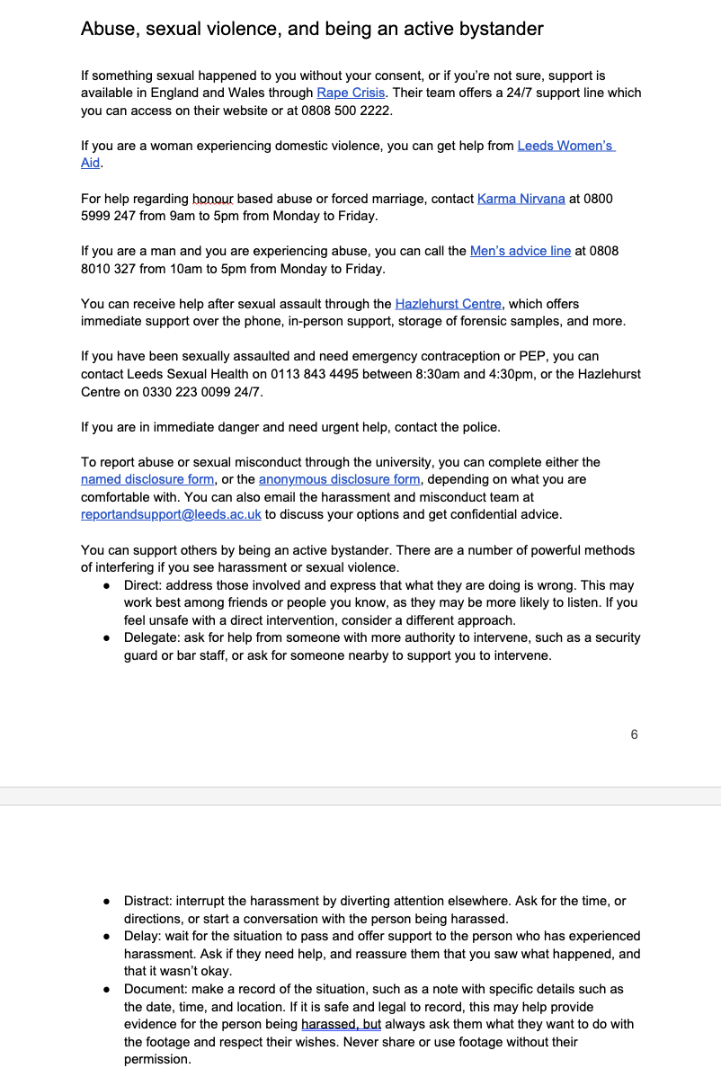

Task 3: Discussion session

Describe the task and how you approached it

We held a discussion session with our society’s committee members and wider leadership to encourage conversations about consent and empower our leadership to be active bystanders. Rather than aiming for all members to attend this discussion, we wanted to focus on leadership so that we could have a more interactive session. This was necessary for the discussion session to succeed, because better engagement with the discussion should result in more understanding of the importance of being an active bystander.

What was the response to this?

The discussion was very active, and members took great interest in the presentation and asked questions about what to do in certain scenarios. We spoke about our personal experiences with being active bystanders, and many attendees said they would apply the new advice to their own experiences away from the society, such as going out with friends, as well. Participants also requested that the discussion be extended outside of leadership, and believed that the points discussed were necessary to speak about with the whole society.

What is the impact of this action (predicted or already realised)

This session was extremely impactful in empowering members to speak out about situations of sexual harassment. As we often go to bars or the pub as a society, members do sometimes witness situations of harassment – and this discussion has helped to demonstrate how we can respond to these situations in order to keep our community and environments safe. The recommendations from participants that we extend the discussion are extremely welcome and our committee will be looking to continue discussions about being an active bystander into our future events.

Share here any photos/links that show you completed this action

Here is the powerpoint presentation that accompanied our discussion session, and some pictures from our participants.
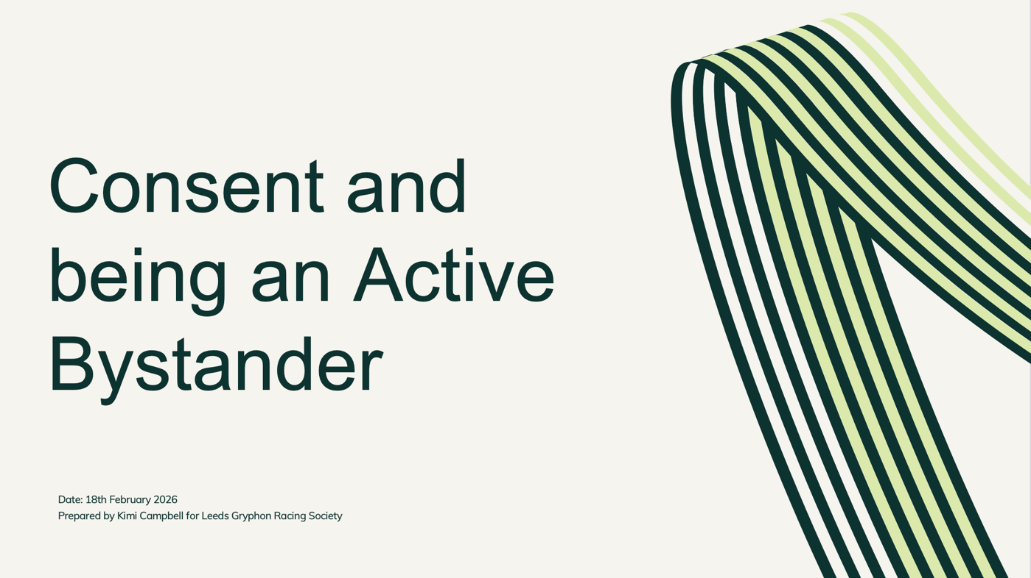
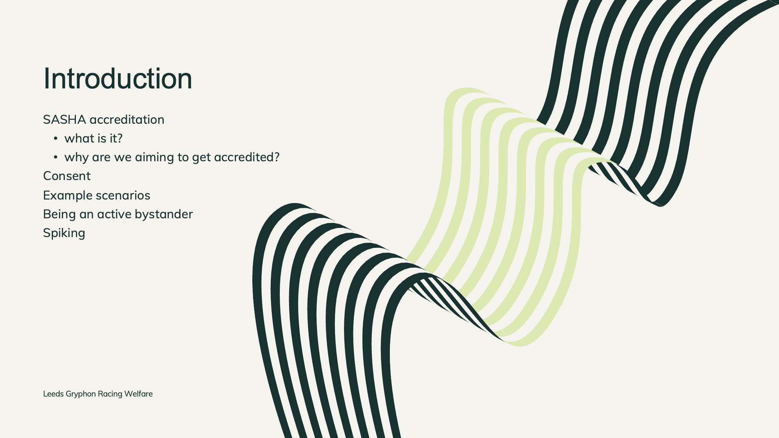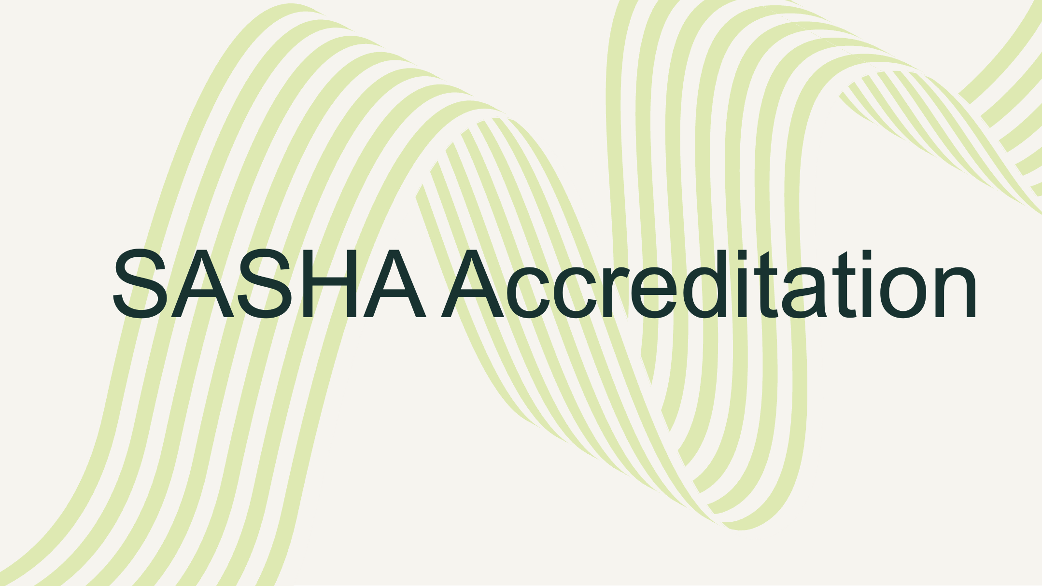
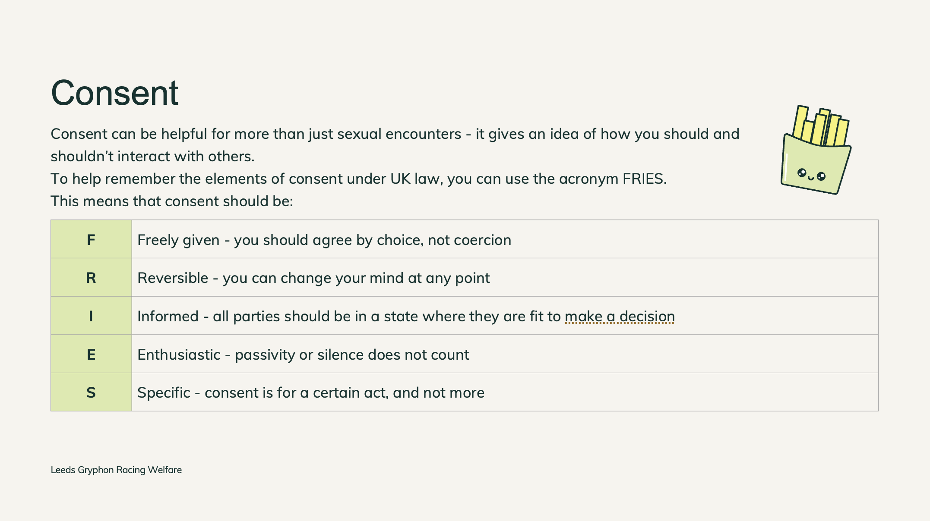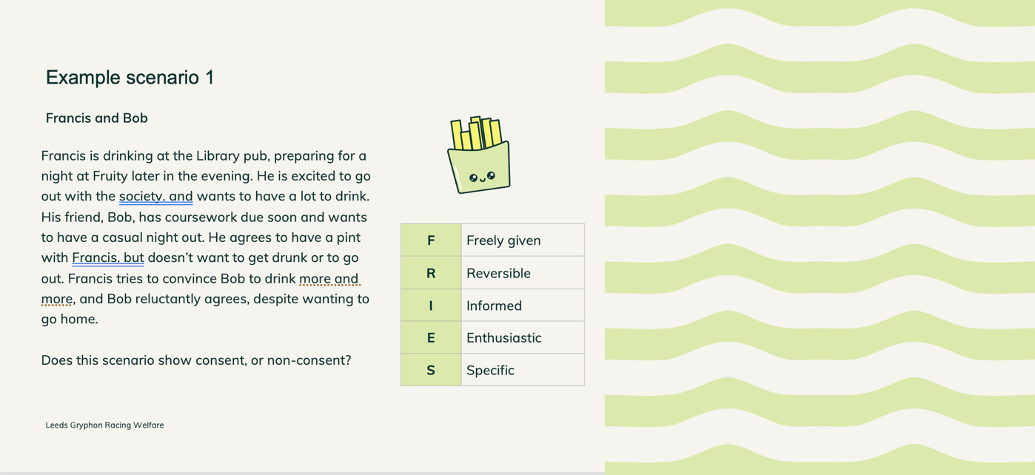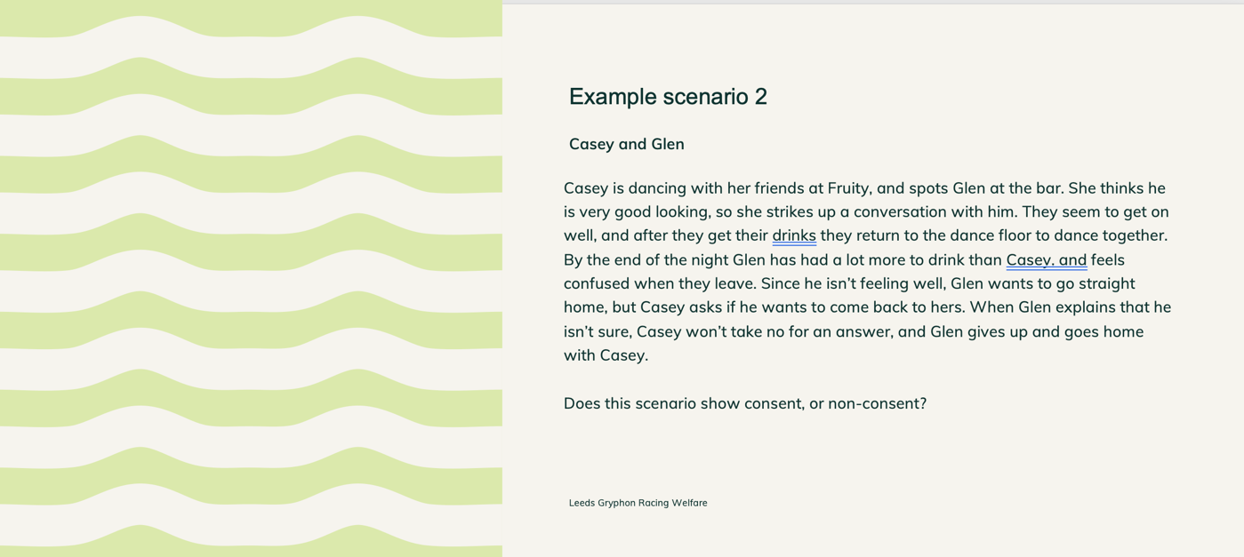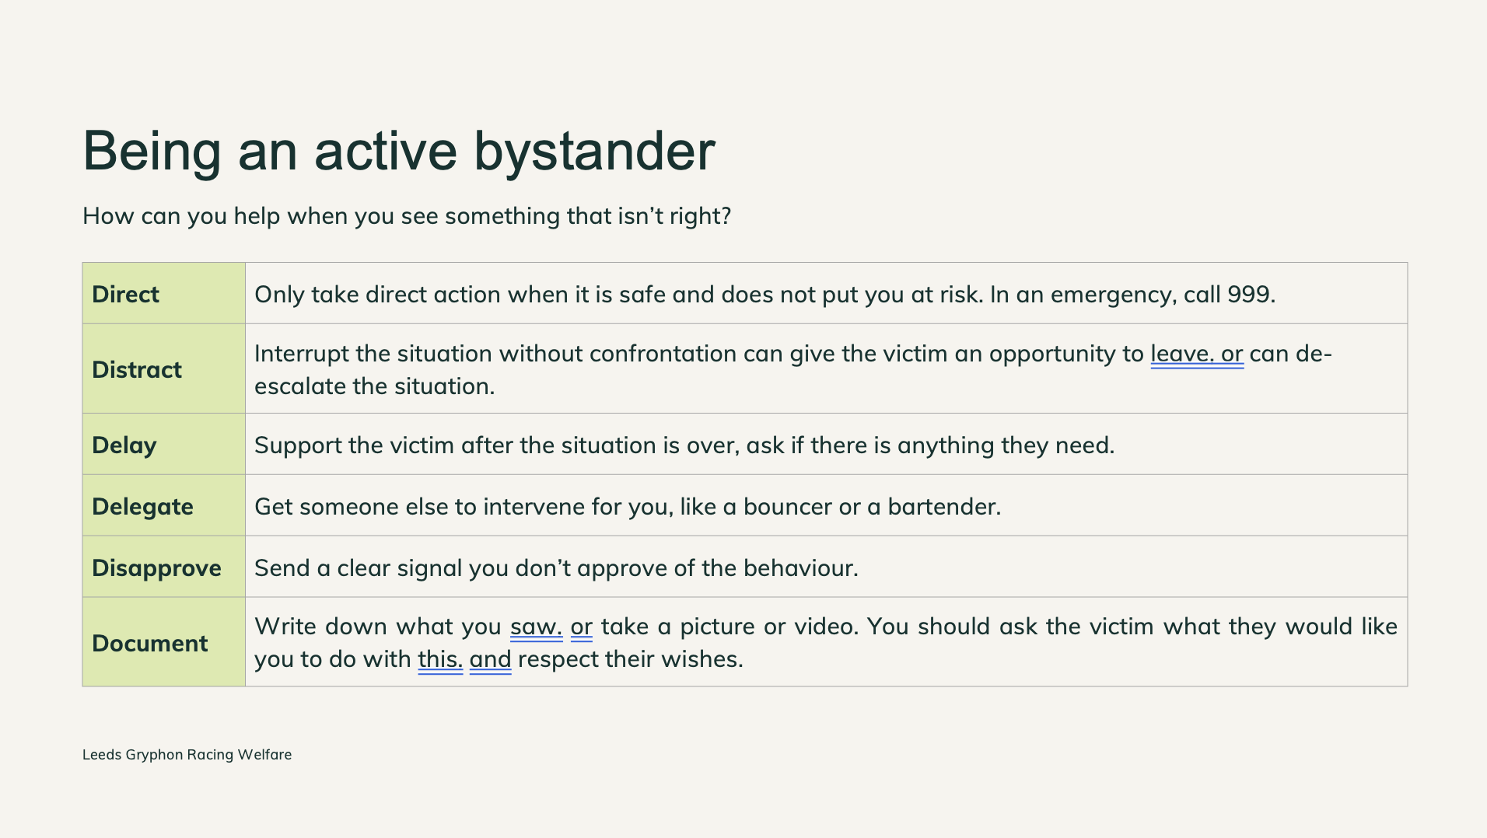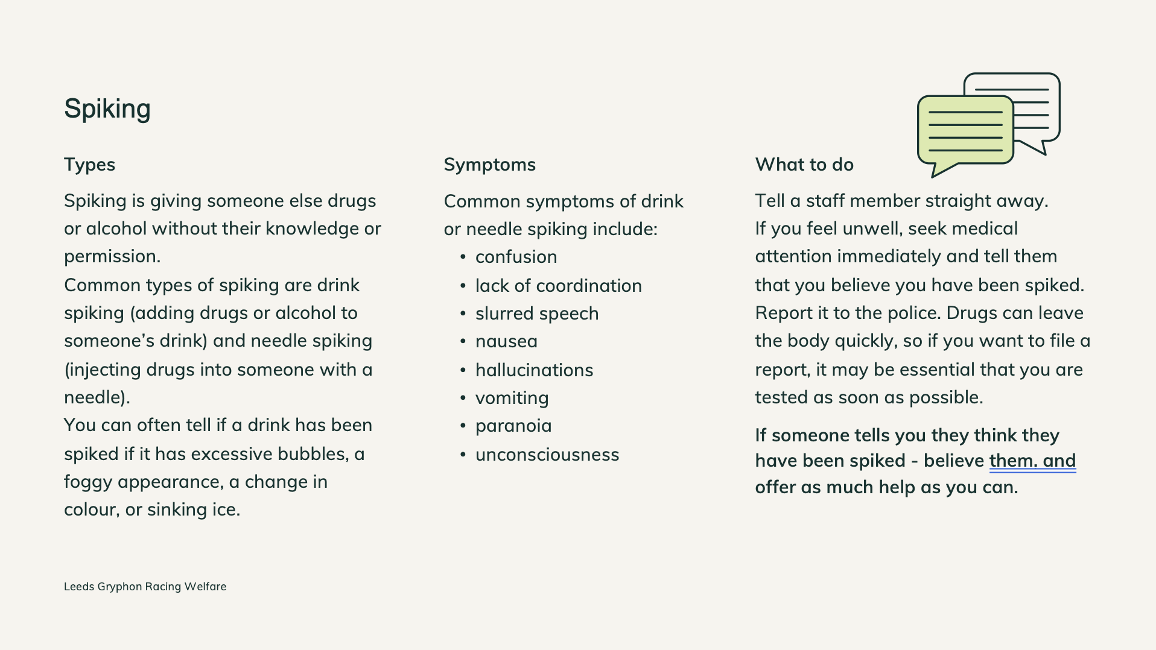
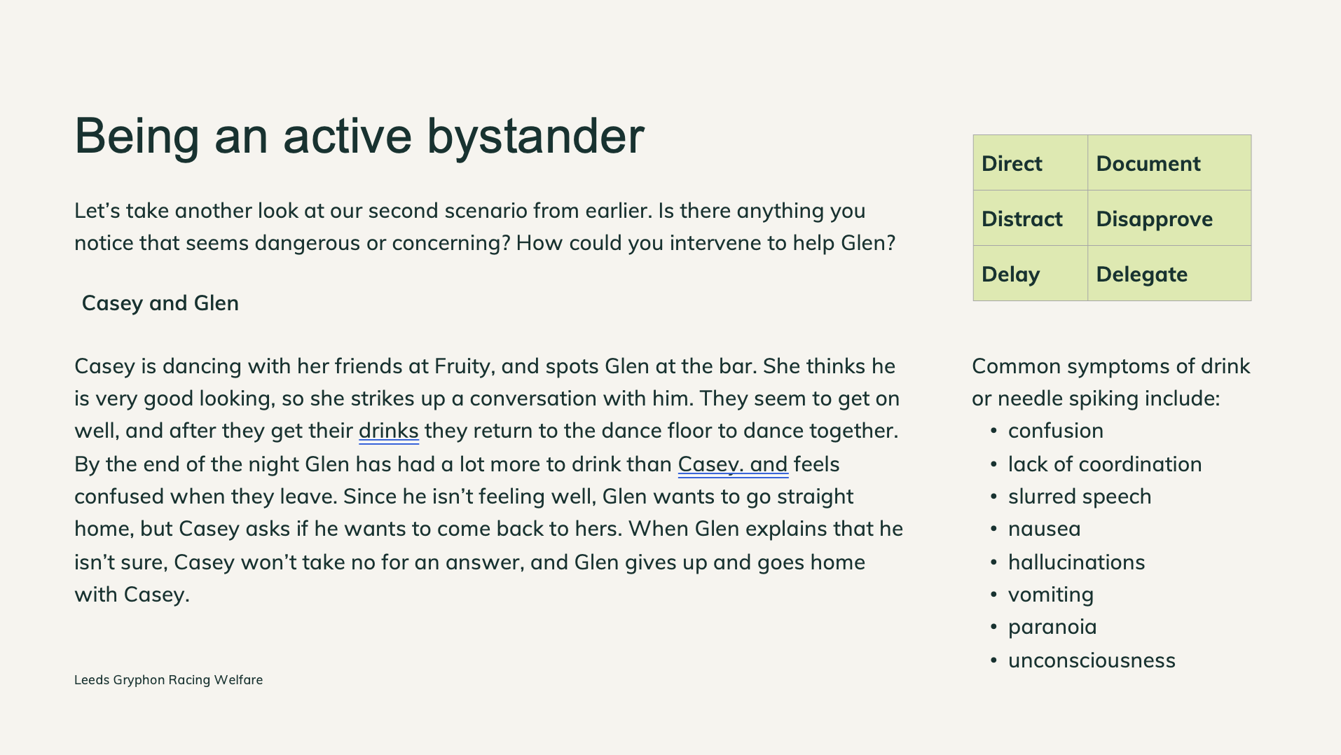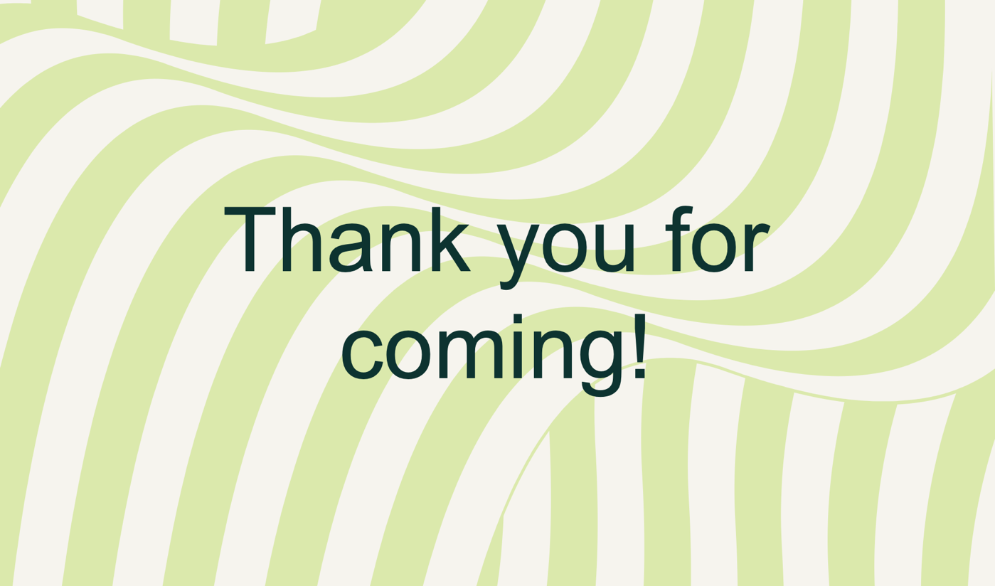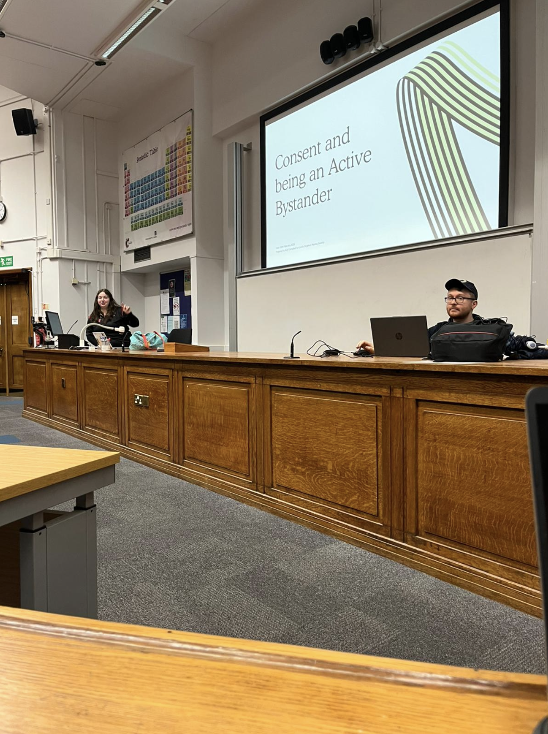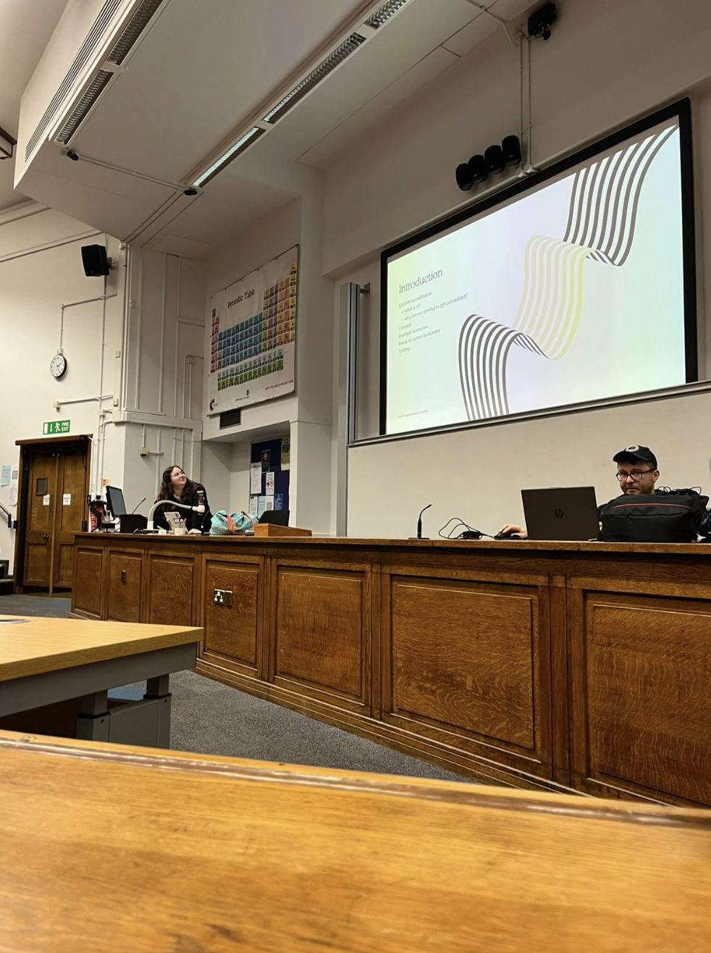

REMINDER! let us know you have submitted your report by completing this online form: https://forms.office.com/e/074X53zd1J
You will not be SASHA Accredited unless you complete both this report and the form.

