CLUB AND SOCIETY RISK ASSESSMENT | Degree of Risk | Risk Rating Matrix
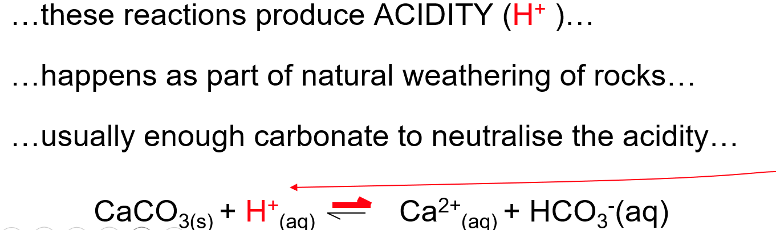

Identify Hazards | Estimate the risk |  |  |  | Evaluate the risk |  |  |  | Evaluate residual risk
Hazard | How may harm result? | Likelihood | Severity | Rating | Risk control measures | Likelihood | Severity | Rating | Further action required?  Only fill out if additional control measures are needed to be implemented or reviewed  Include timescales and who is responsible for implementation
Collision | During football games, players can suffer concussions from collisions with each other or from falling and hitting the ground | 2 | 2 | 4 | All players and coaches to read the 'if in doubt, sit it out' guidance: https://www.sportandrecreation.org.uk/policy/research-publications/concussion-guidelines  All players and coaches to familiarise themselves with the necessary steps in the guidance: recognise the signs of concussion and red flags which require urgent medical assessment, remove anyone suspected of being concussed immediately, and return safely to daily activity.  SPA concussion clinics will be sign posted by committee and attendance at any required concussion training sessions is mandatory. | 2 | 1 | 3
Unsuitable playing facility | Players and coaches are at risk of physical injury due to the condition of the playing surface, which may be affected by adverse weather or inadequate maintenance (e.g slipping, falling, or twisting ankles). | 4 | 1 | 4 | Follow facility pitch weather protocols, including the cancellation of training session if adverse weather has made the surface unsafe or slippery.  Communicate with the opposing university ahead of travel during adverse weather to confirm that the pitch is playable and the fixture will proceed.  Ensure referees conduct a pre-match pitch inspection before approving warm-ups or confirming that the match can go ahead. | 3 | 1 | 3 | Committee to check weather forecast ahead of activity and cancel activity if necessary
unsuitable equipment, kit or attire | Players risk injury due to poor equipment standards | 3 | 2 | 6 | Ensure all equipment is inspected before use. For example, balls should be inflated according to the manufacturer’s guidelines and cones, or other training equipment should be checked for damage. Any broken or unsafe equipment must not be used and should be replaced promptly.  All players must wear appropriate sportswear, including suitable footwear and shin guards. The coach or club captain is responsible for checking that all participants are properly equipped before the activity begins. | 2 | 1 | 1
Jewellery/piercings | During physical activity events like football Jewellery or piercings could be ripped out causing potential cuts/ tears to the skin. | 2 | 2 | 4 | A fully stocked first aid kit must be brought to all training sessions and matches.  A players must remove jewellery and watches before participating in any activity to reduce the risk of injury.  A qualified first aider should be present at all training sessions and matches.  The team captain and committee must be aware of first aid contacts and procedures at each venue prior to any activity taking place. | 1 | 1 | 1
fire | All members within the venue at a social are at risk of burns or inhaling smoke in the event of a fire. | 1 | 5 | 5 | All members must be familiar with the emergency procedures at every social event, including the location of emergency exits, fire extinguishers/blankets, and the nearest assembly point  Committee members are responsible for knowing the names and number of attendees at each event to ensure that everyone can be accounted for in the event of an emergency  The committee must ensure that emergency exits remain clear at all times, preventing crowding and ensuring that no personal belongings or equipment obstruct access | 1 | 4 | 4
Food allergies and intolerances | During socials/ balls including food and beverage members with allergies may have an allergic reaction leading to anaphylaxis. | 2 | 4 | 8 | All members will be asked to disclose any known allergies, and this information will be shared with the venue to ensure appropriate precautions are taken.  In the event of an allergic reaction, the medical emergency procedure must be followed immediately.  Committee members are responsible for completing the LUU food approval from prior to any social events involving food. | 2 | 2 | 4
Overcrowding at socials | Members of the society could get injured/crushed if the social becomes too crowded. | 2 | 4 | 8 | Ticket sales will be limited to a safe number and if numbers exceed expected people may be asked to leave. | 2 | 2 | 4 | Committee to take a register on the door to make sure only attendees with tickets can enter and capacity is not exceeded
Alcohol Intoxication | Over consumption of alcohol at socials increases the risk of illness and potential injury whilst excessively drunk. | 4 | 2 | 8 | Committee members will remain vigilant for sings of excessive alcohol consumption and will restrict further alcohol intake if a member appears to be intoxicated  Any individual who becomes overly intoxicated will be appropriately cared for by committee members.  The committee will also ensure that all members are aware of and adhere to the society’s code of conduct. | 3 | 2 | 6
Slips, trips and falls | Members may slip on spillages or fall over obstacles (i.e. stairs, cables, uneven floors), resulting in injury. | 4 | 2 | 8 | All spillages will be immediately cleaned up, and if a mop is required a wet floor sign will be used.  All areas will be well lit, particularly where there is a tripping hazard. Further Ensuring any equipment is not stacked in a hazardous way.  In the event where an incident does occur, medical emergency procedures will be followed, with a first aid trained committee on hand. | 3 | 2 | 6
bouldering/ climbing | During organised bouldering socials students may become injured by falling or colliding with another climber. | 3 | 2 | 6 | To reduce the risk of injury all members new to the sport will undertake a compulsory introductory climbing session to ensure safety to themselves and others.  New climbers will be made to sign a waiver so committee and bouldering staff are aware of who has received an appropriate risk assessment/training. | 2 | 2 | 4
violence | Other members may feel threatened or be attacked by another member | 3 | 2 | 6 | Disorderly members will be immediately dealt with by attempting to calm them and diffusing the situation. Further action may require asking the member to leave and if they refuse and continue to be dangerous, calling the police.  Committee will make members aware of the society code of conduct. | 2 | 1 | 2
Walking to socials. | Members may get lost if walking to a new venue and late at night people are more at risk to others. | 3 | 3 | 9 | All members will be encouraged to remain in groups when travelling and the address of each venue will be clearly communicated.  All members shall also know how to contact a member of the committee and will be advised to take routes that are well lit.  Members will be advised to download the University of Leeds Safe Zone App | 2 | 2 | 4
Manual handling | Committee and members may become injured carrying equipment at socials. | 3 | 4 | 12 | No members should ever carry equipment that is beyond their capabilities.  When handling instructions are provided, these should be read and followed.  In situations that require it, the committee would work as a team to move the object. Committee will complete “Manual handling” training on Love to Learn or learning locker to ensure full health and safety is understood. | 2 | 3 | 6
Electrical Shock/Burns | Members could receive an electric shock from damaged equipment or a spark could result in a fire. Overloading sockets | 2 | 4 | 8 | All electrical equipment must have a valid PAT test certificate or proof of purchase within the year.  Committee members will ensure that no sockets are overused and only use power sockets that are available. | 1 | 2 | 2
Strobe lighting | Members with epilepsy may be sent into an epileptic shock | 2 | 2 | 4 | Warnings for strobe lighting will be issued and all members should be checked for having such conditions.  Committee members will check in with members throughout the social.  Committee to report any incidents/students requiring medical attention to venue staff and LUU. | 1 | 2 | 2
Excessive noise | Loud music may damage eardrums and may cause upset in any residential areas. | 3 | 2 | 6 | Warnings for excessive noise will be issued and all members will be asked if they are okay with the volume.  Committee members will ensure music decibels will be monitored at safe levels.  Regarding residents, the committee will attempt to keep noise restricted to the venue in hand, reducing the risk of potential noise complaints. | 2 | 1 | 2

