Please make a copy of this report template to fill it out and upload it to Engage.
Once it has been uploaded, let us know by completing this online form: https://forms.office.com/e/074X53zd1J
Society Name | Date
Roundnet | 13/3/2026

Which 3 tasks did you complete?
☒ Educational post on social media
☐ Fundraiser in support of a related charity/cause
☐ Event centered on related themes
☐ Group-specific safety commitment statement
☐ Collab awareness event/activity with another student group
☒ Resource guide for members
☒ Discussion session

For more info on each of these tasks, visit Get SASHA Accredited - Leeds University Union

Task 1:

Describe the task and how you approached it

For an educational post on social media we made an infographic which gave information about what SASHA is, what consent means, and how you can help as a bystander.

What was the response to this?

Liking and sharing of the post

What is the impact of this action (predicted or already realised)

Hopefully better educating our society members about consent and what they can do, we hope this is something they will keep in mind in their everyday lives

Share here any photos/links that show you completed this action

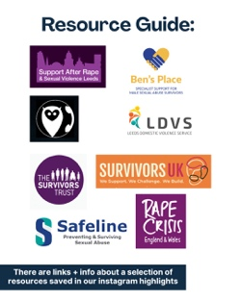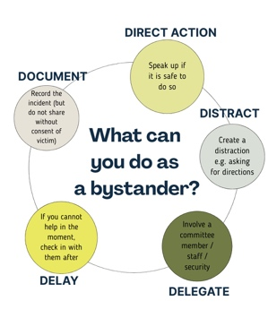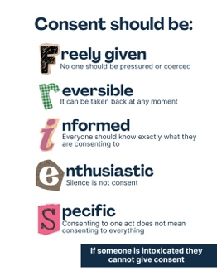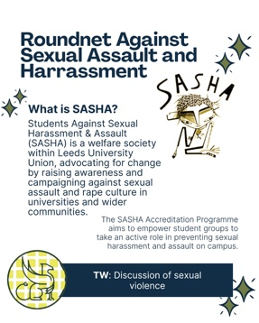

Task 2:

Describe the task and how you approached it

We compiled a variety of services available to people who may have experienced sexual assault or harassment or simply want to better educate themselves. We shared information about each service via Instagram stories (as we thought this would be most accessible to our members) including a link to their website and a sentence explaining what they do. We have saved them on our highlights so people can access at any point.

What was the response to this?

Difficult to tell but hopefully members appreciate it.

What is the impact of this action (predicted or already realised)

If something were to happen to someone they could easily access information and not have to actively search for it when they are already feeling vulnerable. Giving a sentence about each can help someone find the service that is most appropriate fast and easily.

Share here any photos/links that show you completed this action

The stories can be viewed on our Instagram @uol_roundnet

Task 3:

Describe the task and how you approached it

We had a committee meeting dedicated to discussing how we can best prevent sexual assault and harassment within the society and what we should be doing if something were to happen, thinking especially about what we learned regarding bystander intervention.

What was the response to this?

We have implemented having a sober committee member at every social and we feel that people in the society appreciate having a sober member there.

What is the impact of this action (predicted or already realised)

Whilst we have not had any incidents thus far, as a committee we feel much better prepared to deal with anything that could happen as a team.

Share here any photos/links that show you completed this action

REMINDER! let us know you have submitted your report by completing this online form: https://forms.office.com/e/074X53zd1J
You will not be SASHA Accredited unless you complete both this report and the form.

