Leeds University Union

Code of Practice: Leeds University Union Volleyball Club
This document runs alongside the constitution. If you wish to raise issues with the contents of this code, please contact the committee named beneath in some circumstances it may be necessary to hold an EGM.

Introduction

Aims:
- to offer coaching and competitive opportunities in Volleyball
- to promote Volleyball within the local community
- to ensure a duty of care to all members of the club
- to provide all its’ services in a way that is fair to everyone
- to ensure that all present and future members receive fair and equal treatment

Club Activities:

We offer our members:
- A chance to learn new skills
- A chance to represent the university in volleyball locally, regionally and nationally.
- Fun
- Experience
- Social outlet

We will achieve these aims through:
- BUCS playing opportunities
- Non BUCS playing opportunities
- Trials
- Training
- Socials

When and where we meet:

- Advanced training – Monday 5:30pm-7:30pm, Hall 2 (The Edge), Sunday 6pm-8pm, Gryphon sports centre.
- Beginners/Intermediate training – Friday 7pm-9pm, Hall 1b (The Edge).
- BUCS matches on Wednesdays.
- Tournaments held throughout the year.
- Socials/meetings to be held throughout the year
- Find out more from the Social secretary via our Facebook page.
- Times and venues subject to change, keep up to date via the Facebook page.

Coaches:
- Men’s 1st Coach: Zak Gasson Hudson
- Women’s 1st Coach: Jack Deaton
- Men’s 2nd Coach: Jake D’Cruz
- Women’s 2nd Coach: Toby Tapp
- Development Coach: Jake D’Cruz

Details of club membership

- Membership available on a full year and single term basis.
- Pay online via the Leeds University Union website.
- Members must have paid by the end of the first month of term.
- We have a ‘no pay no play’ policy.
- Ask the club secretary for any more information about membership.

What we expect from our members:

We expect our members to:
- Adhere to LUU Social Guidelines and Club Code of Conduct & Club social guidelines
- To inform either the men’s or women’s team captain 24 hours before training or the week before a match if you cannot attend
- To have a positive attitude at all times
- To respect all members
- To adhere to safety guidelines as stated on the risk assessment
- To give feedback on matches and sessions where appropriate
- To listen and respect the coaches during training sessions
- To communicate politely and effectively where appropriate
- We must insist that no clothing associated with Leeds University Union Volleyball Club is worn on socials.

What our members should expect from us:

We agree to:
- Communicate any necessary information to all club members via email, training sessions, or on the Facebook page
- Show respect to all members
- Create a friendly/inviting atmosphere during training, matches and socials
- Deliver well planned events e.g. tournaments, matches, training and socials
- Consider safety elements at all times
- Give appropriate notice to all members for AGMs/EGMS and any other society events

Contact us:

Please contact the committee members with any queries at: luuvolleyball@outlook.co.uk, or visit Leeds University Union Volleyball Club page or our Facebook page.

We the undersigned agree to uphold the above code of good practise

President Name: Amy Tran
Signature:
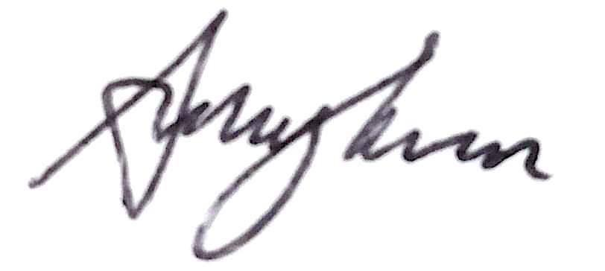
Date: 10/09/21

Treasurer Name: Toby Tapp
Signature:
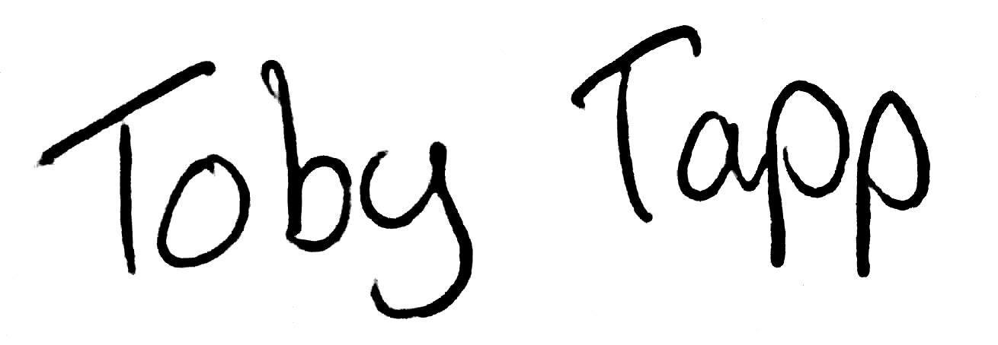
Date: 10/09/21

Secretary Name: Sophie Gurung
Signature:
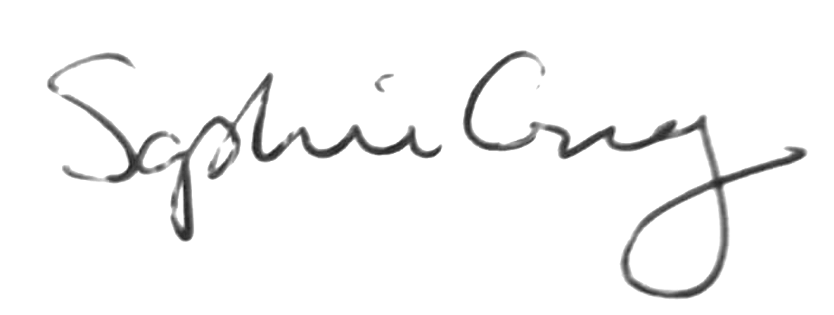
Date: 10/09/21

