CLUB AND SOCIETY INDIVIDUAL RISK ASSESSMENT | Degree of Risk | Risk Rating Matrix
 |  | 
  Society Name: | Saudi Society
  Category: | Culture
  Author(s): | President : Mohammed Al Baluchi  Secretary: Hasan Mujallid
  Author(s) signature and date: | 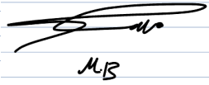27/08/2025  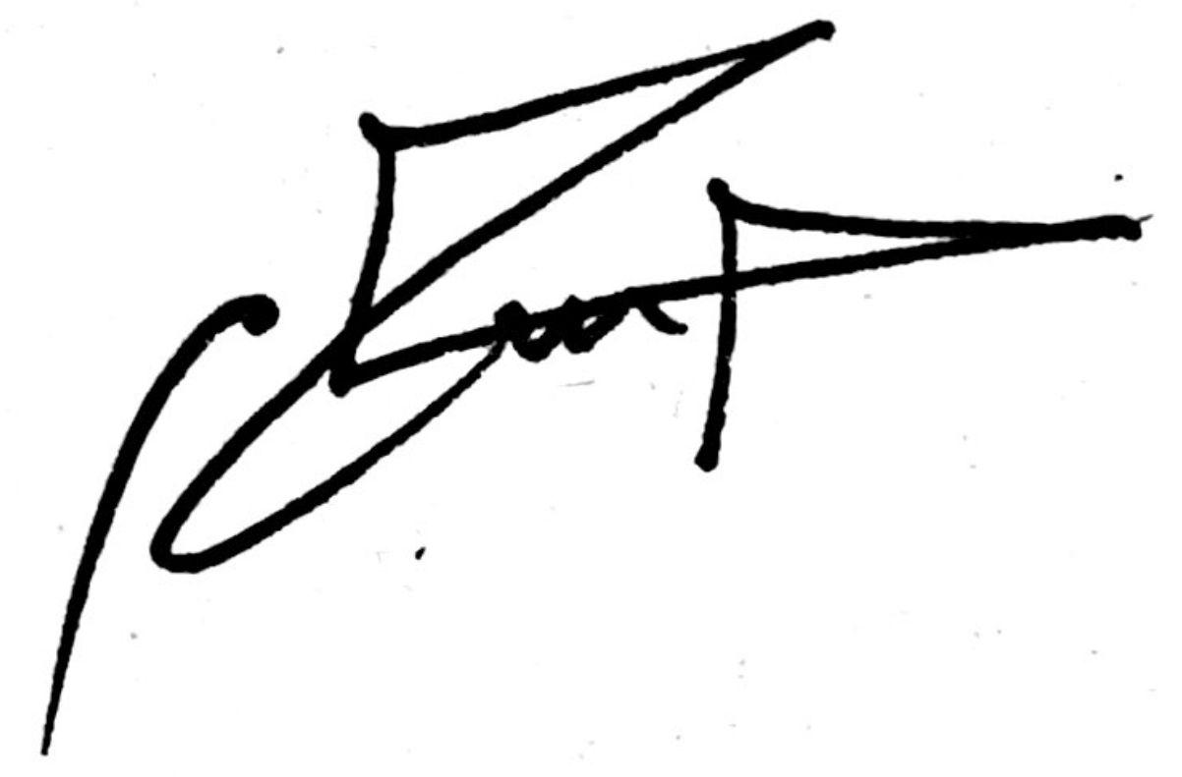27/08/2025
  Persons Responsible: | President : Mohammed Al Baluchi  Secretary: Hasan Mujallid
  Staff Sign Off:
  Staff Additional Check:
  Locations: | Leeds , Uk
  Details of Activity: | Saudi Society organises a range of cultural and social activities, including:  - Saudi National Day and Saudi Founding Day celebrations (stalls, traditional food, stage presentations, trivia, anthem, and cultural showcases).  - Regular socials such as board games, group meals, and cultural evenings.  - Educational and cultural presentations on Saudi heritage, traditions, and society.  - Trips and visits to local cultural sites and community events where appropriate.”
  People who may be affected: | - Society members and participants  - Staff
  Likelihood
  5 | Inevitable
  4 | Highly Likely
  3 | Probable
  2 | Unlikely
  1 | Remote possibility
  Severity
  5 | Very high - multiple deaths
  4 | Highly - death, serious injury, permanent disability
  3 | Moderate - Off Uni/work for at least 5 days
  2 | Slight - First aid treatment
  1 | Nil - Very minor
  Severity
  Likelihood |  | 1 | 2 | 3 | 4 | 5
  Likelihood | 1 | 1 | 2 | 3 | 4 | 5
  Likelihood | 2 | 2 | 4 | 6 | 8 | 10
  Likelihood | 3 | 3 | 6 | 9 | 12 | 15
  Likelihood | 4 | 4 | 8 | 12 | 16 | 20
  Likelihood | 5 | 5 | 10 | 15 | 20 | 25
  Risk rating score | Action
  1 - 4 | Broadly acceptable – no action required
  5 - 9 | Moderate - Reduce risks if reasonably practicable
  10 - 15 | High risk - Priority action to be undertaken
  16 - 25 | Unacceptable - Action must be taken immediately

Identify Hazards | Estimate the risk |  |  |  | Evaluate the risk |  |  |  | Evaluate residual risk
Hazard | How may harm result? | Likelihood | Severity | Rating | Risk control measures | Likelihood | Severity | Rating | Further action required?  Only fill out if additional control measures are needed to be implemented or reviewed  Include timescales and who is responsible for implementation
Lack of awareness surrounding health and mental wellbeing of students | Members may experience stress, anxiety, or other health issues and not know where to seek appropriate support. Without proper direction, they may be given incorrect advice, delaying access to professional help. | 2 | 2 | 4 | All committee members are fully mindful of mental health and physical health, and know how to sensibly approach issues whilst also having the knowledge of when/how to alert professionals and redirect students to appropriate services. Information on LUU wellbeing services is shared with members. | 1 | 1 | 2
Lack of safety measures such as first aid and communication | In the event of an accident or sudden illness, a lack of trained first aid provision or poor communication could escalate the situation, increasing the severity of injuries or causing panic. | 2 | 5 | 5 | All members are encouraged to alert a core member of the committee of any medical conditions they may have so appropriate provisions can be made for them. Demonstrate all emergency procedures to visitors. Make members aware of nearest first aider and procedures surrounding first aid. At least one committee member will carry an emergency contact list and know the location of the nearest hospital/first aid station. | 1 | 3 | 3
Theft | Personal belongings or valuables of members and attendees may be stolen if left unattended, resulting in distress, financial loss, or mistrust within the group. | 3 | 3 | 5 | Ensure all spaces used have appropriate and secure storage spaces for members to store their belongings and encourage members to leave expensive valuables at home. Committee to monitor belongings during events and provide a secure cloakroom or supervised area if available. | 2 | 1 | 3
Overcrowded areas | Large groups without proper management may lead to pushing, collisions, and restricted personal space, increasing the risk of injury or discomfort. In severe cases, overcrowding can obstruct emergency exits. | 3 | 3 | 5 | Use megaphones to control large crowds. Implement effective management procedures. Do not exceed venue capacity. Recruiting volunteers to manage crowds. Pre-registration or ticketing will be used to prevent unexpected over-capacity. | 2 | 2 | 3
Slips, trips and falls | Members, staff, or visitors may slip on spillages, trip over cables, or fall on poorly lit stairs, leading to injuries ranging from minor bruises to sprains or fractures. | 3 | 3 | 5 | General good housekeeping. Wet floor signs used after mopping. All areas well lit, including stairs. No obstructions in walkways such as boxes, trailing leads or cables. Staff keep work areas clear. Report any spillages or trip hazards. Committee to check venue before and during events to ensure walkways remain safe. | 2 | 2 | 3
Cancellation/Missing transport | If arranged transport is delayed, cancelled, or missed, members may be stranded in unfamiliar areas, leading to stress, confusion, or potential safety concerns when travelling alone. | 2 | 2 | 3 | Extra money will be kept on hand in case alternative modes of transport must be used. All members will be made aware of the routes taken to the desired destination and a meeting point will be arranged if anybody becomes lost or loses contact with the rest of the group. | 1 | 1 | 2
Abuse (verbal, physical, sexual) | Members may experience harassment or abuse from others inside or outside the event space, leading to physical harm, emotional distress, or escalation into conflict requiring intervention. | 2 | 4 | 4 | Ensure members stay in groups in order to avoid anybody being left vulnerable on their own and avoid confrontation. Ensure members have a high standard of behaviour, set out these expectations. Report any issues to bouncers/security staff. A zero-tolerance policy is in place, with safeguarding contact available if escalation is required. | 1 | 2 | 3
Strobe lighting | Exposure to flashing or strobe lighting may trigger seizures or fits in members with epilepsy or light sensitivity, causing injury or medical emergencies. | 2 | 4 | 4 | If epileptic, condition should be reported to core committee. If some members are unable to attend clubs with heavy strobe lighting, alternative socials will be arranged for them such as going out for a meal. All members should be regularly checked up on. | 1 | 2 | 2
Excessive noise | Prolonged exposure to loud music, cheering, or sound systems may damage hearing, cause headaches, or make communication difficult, creating a stressful environment. | 2 | 3 | 3 | Keep noise to an appropriate level and ensure there are quieter places available should members need. | 1 | 2 | 2
Adverse weather | Outdoor activities may expose members to heatstroke, dehydration, or sunburn in hot weather, or hypothermia and slips in cold/rainy conditions. | 2 | 4 | 4 | Ensure drinking water is accessible at all times. Regular breaks. Suggest appropriate clothing. Committee will monitor conditions and shorten or cancel activities if weather becomes unsafe. | 1 | 2 | 2
Blocked exits | If emergency exits are obstructed, members may be unable to evacuate quickly in the event of fire or other emergencies, resulting in crush injuries or entrapment. | 2 | 4 | 4 | Keep all spaces tidy and exits completely clear. Have separate exits and entrances. Committee will conduct a pre-event walk-through to confirm all exits are accessible and unobstructed. | 1 | 2 | 3
Society members driving to social events | Road accidents may occur if drivers are distracted, unfamiliar with the route, or driving poorly maintained vehicles, leading to injuries to passengers or others on the road. | 2 | 4 | 4 | All drivers must be a registered driver with the LUU. Members must not distract the driver. Follow LUU guidelines when reporting incidents. Encourage carpooling where possible and ensure drivers take breaks on longer journeys. | 1 | 3 | 3
Fire | If a fire occurs due to faulty equipment, open flames, or electrical faults, staff and visitors may suffer burns, smoke inhalation, or be trapped if evacuation is delayed. | 2 | 4 | 4 | All committee members are fully mindful of protocols taken in such case. As well as making everyone aware of fire exits at all times and aware of emergency numbers to contact. Committee will identify nearest assembly point and brief members at the start of the event. | 1 | 3 | 3
Food safety and allergies | Serving traditional Saudi food may cause allergic reactions, food poisoning, or cross-contamination. | 3 | 4 | 9 | Request all members/guests to disclose allergies in advance. Label all food clearly. Use licensed caterers when possible. Ensure proper food hygiene and storage. Keep first aid kit and trained first aider available. | 1 | 2 | 2
Electrical equipment (mics, mixers, stage lighting, screens) | Risk of electric shock, fire, or tripping from loose wires. | 2 | 4 | 8 | Ensure all electrical equipment is PAT tested. Only competent people to set up equipment. Tape down all loose wires. Do not overload sockets. Identify and brief committee on emergency shut-off points. | 1 | 2 | 2
Manual handling (tables, chairs, heavy items) | Risk of back strain, slips, or injury from lifting and moving heavy furniture or equipment. | 3 | 3 | 9 | Provide manual handling guidance to volunteers. Use trolleys where possible. Team lifting for heavy items. Ensure clear walkways before moving equipment. | 1 | 2 | 2
Cultural sensitivity and behaviour | Potential conflict or offence caused by cultural misunderstandings or inappropriate behaviour. | 2 | 3 | 9 | Set clear code of conduct shared with all members. Committee to monitor behaviour and step in early if tensions arise. Provide safe and inclusive environment, ensuring respect for diversity. Escalate issues to LUU staff if needed. | 1 | 2 | 2

