Code of Conduct and Standards
LUU Clubs and Society Code of Conduct for all members and participants LUU Clubs and Society Code of Standards for all committee members How to use this document:
Step 1: Read through the sections - all the information here is to support you, not tell you what to do
Step 2: Any questions? Get in touch with your Development and Engagement Coordinator for your category.
Step 3: Core officers need to commit to the guidelines by signing at the end of the document. Step 4: Upload this signed document to LUU Engage
Overview
This Code of Conduct will help you understand the do’s and don'ts for your Society-organised socials and guide you through what is reasonable behaviour when participating in any activity or event under the name of Leeds University Union (LUU) and/or your Club or Society.
Our shared primary concern is always the wellbeing of students and protecting those that lead our Clubs and Societies.
These codes and practices will help you keep everyone safe and look after the wellbeing of everyone during events and socials.
Please read this document carefully, these guidelines are part of your Club or Society constitution. Note
Within this Code of Practice, the words member(s) and participant(s) are used interchangeably. As are the words Club(s) and Society(s) that are LUU groups.
Intent
Your Club and Society should strive to uphold LUU’s values of inclusion, empowering, fun, supportive, and collaborative. This will mean that your Club/Society upholds a safe environment, reducing the risk to members and participants. The Club/Society is inclusive, creating opportunities for all members, including those from underrepresented backgrounds. Society should be a welcoming and friendly space that promotes openness and accessibility. Lastly, the society is a place where opportunities are created and members develop.
What is an organised event?
Your activity or event is considered as ‘organised’ if it matches any one of these criteria:
1. It is branded in any way as being affiliated with the Club or Society, LUU or the University of Leeds
2. Publicised in any way by the Club or Society as a Club or Society activity/event/social (including online)
3. Funded in part or whole by LUU, the University of Leeds or through your LUU account 4. Requires the use of equipment owned by the Club or Society or LUU
5. Group transport is booked through LUU
6. Clothing that identifies or affiliates you with your Club or Society or LUU or the University of Leeds
Committee responsibilities
As Club or Society Committee members, you are responsible for the conduct of all your members and participants. The Committee is responsible for sharing these expectations and guidelines with all members and participants. This can be done by uploading the completed Code to LUU Engage and enabling members to have visibility.
You are also responsible for looking after any disciplinary processes which may arise. In summary, the Committee are responsible for:
1. A duty of care to all Society members and participants to ensure their health and safety 2. Minimising hazards as much as possible, including those associated with social events 3. Ensuring all members are drinking responsibly at all socials which include alcohol
4. Educating and informing members of the expectations when representing the Club or Society
5. Fully investigating any incidents through your constitution and reporting these to the Activities Team
Member responsibilities
The responsibilities of Committee members does not abdicate the responsibility of individual members and participants.
Members are responsible for:
1. Ensuring they have read and understood the Code of Conduct and Constitution
2. Minimise hazards as much as possible, and to contribute towards a positive culture of health and safety. Any mitigations put in place by the Committee to reduce risk should be met positively and proactively by members
3. Upholding the values, ethos and expectations of LUU and the Club/Society 4. Reporting any concerns to the Committee or Student Activities team
Encouraged behaviours
We want you to enjoy your events and socials as a Club or Society and we of course encourage you to have a good time. Here’s a few ideas on how you can do this:
● Organise activities and events to promote socialisation within the Club or Society
● Aim to make events as inclusive as possible to all members and students; this includes hosting a range of events, thinking of innovative ideas and not relying primarily on alcohol focused events
● Be mindful of access, inclusivity and equality when organising events
● If drinking alcohol, drink responsibly and encourage other members to do so ● Respect members of the public, public and private property and public spaces
We encourage you and your members to use acceptable language. This includes using language that is respectful, appropriate and inclusive; the type of language you would use in a professional setting or academic classroom.
● By respectful language we mean that you and your members engage with each other, are interested in what is being said and value everyone’s contributions. By actively listening and then responding to each other, we create opportunities for understanding and harmony. It is important to use non-judgemental words and phrases.
● Appropriate language means you and your members are aware of the context of your environment and use language that is suitable to the situation.
● Inclusive language means you and other members create an environment in which any individual or group can participate and feel a sense of belonging, irrespective of their identity, background, or protected characteristics.
Unacceptable behaviours
To ensure all students love their time at Leeds there are a few behaviours we do not condone and which will result in disciplinary action:
● Organising and carrying out any initiation
● Discriminating against an individual or group based on one or more of their protected characteristics
● Urinating, defecating or vomiting in public or anywhere other than a toilet ● Public nudity
● Property damage and/or misuse
● Any form of sexual harassment
● Bringing the reputation of the University of Leeds, LUU or your Club or Society into disrepute
LUU has a zero tolerance policy towards sexual harassment. Sexual harassment is defined as: ● Any form of unwanted verbal behaviour. This includes sexual comments, unwanted questions & derogatory sexual remarks. These can be both explicit and implicit; communicated through tone of voice, using generic obscenities or euphemisms. ● Any form of unwanted non-verbal behaviour; an example of this type of improper personal behaviour is wolf whistling.
● Any form of physical conduct of a sexual nature which creates an intimidating, hostile, or offensive environment. Examples of this include’ groping, pinching & lifting up a skirt.
Digital Communications
We want you to use digital media to the best of its ability but need you to make sure you use it appropriately. This includes all social media apps (Facebook, Instagram, TikTok, and so on), meeting platforms (Zoom, and so on) and chat platforms (including WhatsApp, emails, Discord, and so on).
All content on Society and Club channels fall under these guidelines.
It is worth bearing in mind that Twitter, Facebook and Instagram posts can be public or shared by any followers.
Please ensure that all content is appropriate and does not bring your Club or Society, LUU or the University of Leeds into disrepute.
Committees are responsible for reporting and investigating any incidents of abuse or bullying towards their members on social media.
Otley Run and pub crawls
Pub crawls, including the Otley Run, are an organised event and fall under the same guidelines as above.
It is important to be aware that even if an Otley Run or pub crawl is organised by a group of friends who are all part of an LUU Club, it will still be classified as an organised event if any in the group are:
1. Wearing identifiable features or clothing
2. Promoting the event through your Club social media channels
Match days and competitions
In addition to the above guidelines and behaviours, the Club/Society will outline the expected behaviours of players, participants, spectators, and coaches when playing in match days and competitions; either in Leeds or away. Respect must be given to competitors and officials.
Tours and trips abroad
All tours and trips will fall under these guidelines.
Committee members need to complete and submit the trip information documents prior to going.
The same guidelines also apply to a group of friends who are going on trips abroad and representing the Club or Society.
Internal guidelines
If you believe a member or group of members have breached these guidelines you need to go through your own internal Club or Society disciplinary process following the LUU Good Practice Guidelines and Constitution.
You must inform the Activities Team as soon as this process starts. The Activities Team is impartial and can help guide parties through the process, ensuring fairness.
Your Society and Club constitution details the complaints process which must be followed. This section cannot be edited.
If the situation is one which you are not familiar with, or of a serious nature, please speak to the Activities Team for advice and support.
Any decision to suspend or expel a member of your Club needs to be supported by the Activities Team.
The member(s) being suspended or expelled should then be informed in writing, detailing the reasons why they have been suspended and/or expelled. Members can appeal the decision, escalating to the Activities Executive.
LUU guidelines
LUU has its own disciplinary process for Clubs and Societies and the Activities Team will become involved if:
1. The incident affects or involves the whole Club and Committee members are also implicated 2. The outcome of the disciplinary is deemed unsatisfactory by the Activities Team 3. The Club requests support from the Activities Team
LUU sometimes receives complaints directly and will notify the Club of any incident, requesting to be informed of the process and outcome of the internal process.
Where the incident affects the whole Club or Committee members, LUU will start its own disciplinary process immediately.
For more information, please see the LUU Bye Laws.

Signatures
Please sign and date to confirm you agree and understand the Code of Conduct
Club or Society Name: LUU Development Netball
Co-Presidents / Co-Club Captains:
India Finch Hatton

Megan Heard-Meadows

Secretary: covered by Co Captains
India Finch Hatton

Megan Heard-Meadows

Treasurer:
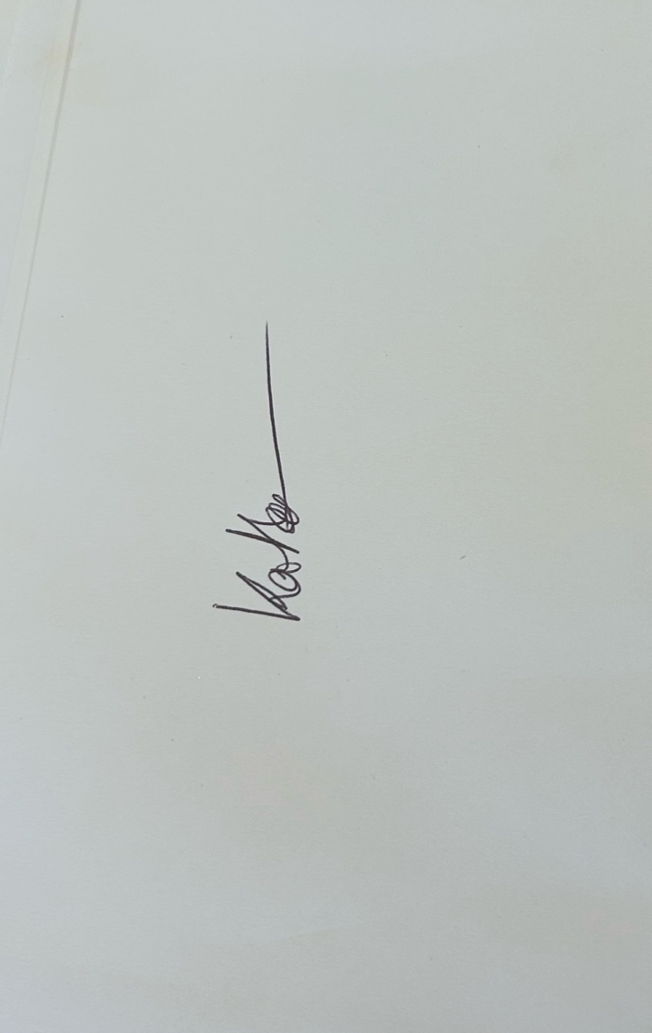
Katie Honour

Date: 11/07/2025
Uploading a signed copy to your LUU webpage and LUU Engage is a requirement of running a Club or Society.
Code of Standards
In order to hold any office at LUU, either elected or appointed, you must agree to the code of standards below, recognising that you are held to this standard throughout your time as an Office Holder, and breaches of this standard may result in your removal.
Offices covers by this Code include (but are not limited to):
Student Executive Officers
Activities Executive
School Representatives
Liberation Coordinators
Community Representatives
Club & Society Committee Members
Code of Standards
The Code of Standards for LUU Office Holders is based on the Nolan Principles - a set of ethical standards expected of all public office holders - and by the LUU governing documents.
Selflessness
Office Holders will not make decisions or take actions on the basis of self-interest, but will ensure that all LUU members are considered and their views taken into account, regardless of any liberation or other characteristics with which the Office Holder does not personally identify.
Integrity
Office Holders will act with integrity, ensuring their decisions and actions are consistent and accurate.
Objectivity
Office Holders will set aside their biases to ensure that they lead the society in an objective way. If an Office Holder feels they cannot be objective for any reason, they will declare this as a ‘conflict of interest’ and will step away from the conversation, decision, or activity in question.
Accountability
Office Holders will be accountable for their actions, and for the actions and decisions of their whole decision making group (for example the whole Activities Executive, or a whole society committee), even where they may not have personally participated.
Openness
Office Holders will be open with LUU and with members. While some decisions may need to be made ‘behind closed doors’, Office Holders will not take actions without ensuring that the appropriate LUU staff are properly informed, and will not prevent members from accessing any information it is their right to access.
Honesty
Office Holders will act honestly, and will not engage in activity which is dishonest or deceptive. Office Holders will disclose to LUU any details which might make them unsuitable to hold office, which include, but are not limited to:
- Outstanding or unspent legal convictions
- Involvement in ongoing disputes or incidents involving the police
- Involvement in ongoing disputes with a department of LUU, or with the University - Relationship to any company or organisation with which LUU or an affiliated group (for example a club or society) has regular contact, in particular if the company or organisation benefits financially from this contact
These situations do not necessarily prevent an individual from holding office, but failure to disclose these issues is considered a breach of the code of standards.
Leadership
Office Holders must fulfil their role as leaders for their given cohort, recognising this means assuming responsibility for the actions of the cohort as a whole. Office Holders, as leaders, are expected to lead members in positive behaviours and to manage any issues of conduct which arise within their given cohort, or between their cohort and other LUU groups.
Signatures
Please sign and date to confirm you agree and understand the Code of Standards. The Code of Standards is signed on behalf of all committee members.
Club or Society Name: LUU Development Netball Club
Co-Presidents / Co-Club Captains:
India Finch Hatton

Megan Heard-Meadows

Secretary: covered by co-captains
India Finch Hatton

Megan Heard-Meadows

Treasurer:
Katie Honour

Date: 11/07/2025
Uploading a signed copy to your LUU webpage and LUU Engage is a requirement of running a Club or Society.

