Please download a copy of this report template to fill it out and upload it to Engage.
Once it has been uploaded, let us know by completing this online form: https://forms.office.com/e/074X53zd1J
Society Name | Date
Reproductive Rights Society | 18/03/2026

Which three tasks did you complete?
☒ Educational post on social media
☐ Fundraiser in support of a related charity/cause
☐ Event centered on related themes
☒ Group-specific safety commitment statement
☐ Collab awareness event/activity with another student group
☒ Resource guide for members
☐ Discussion session

For more info on each of these tasks, visit Get SASHA Accredited - Leeds University Union

Task 1:

Describe the task and how you approached it

Our Equality and Wellbeing Secretary created a website for the society’s wellbeing resources, categorising them into different categories based on the specific issue a member could be having.

What was the response to this?

The Info Hub (as we call it) has been very well received, with our members reporting positively back to the committee about how easy it is to use and navigate.

What is the impact of this action (predicted or already realised)

This action will make it easier for our members to find professional support tailored to their specific requirement. It also reduces the chances of a member coming to us (who are not professionals) with a problem and being given the wrong answers, as we have a foolproof place to direct them to someone who knows what they are talking about.

Share here any photos/links that show you completed this action

https://luureproductiverights.my.canva.site/

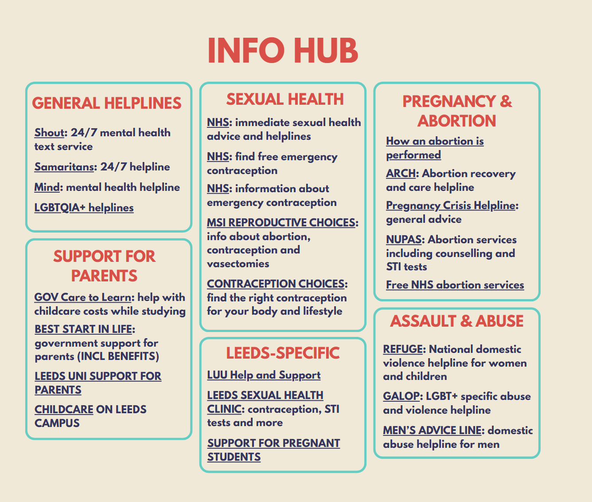

Task 2:

Describe the task and how you approached it

We created a group specific safety statement, beginning with a committee discussion about how we can make our society safer. Being a political and campaigning society who don’t do much more than relaxed discussions in small groups, we had to tailor it specifically to this kind of event. We are committed to providing quiet spaces and trigger warnings for the topics we discuss, and we have a designated Equality and Wellbeing Secretary who is available to direct people to resources or offer any help they may require. We also made it clear that we aim to be an inclusive society, and we encourage our members to share with us any concerns or suggestions they may have about making our society even more inclusive and supportive.

What was the response to this?

We haven’t had any direct responses to this statement from members yet, but all six of us on the committee agree that it accurately reflects our intentions and commitment to the safety and inclusivity of our society and its members.

What is the impact of this action (predicted or already realised)

This action will make it clear and unambiguous that we as a society do not welcome any form of harassment or abuse, and we support everyone’s right to self-expression. We are committed to providing safe spaces for students to discuss sensitive topics, and hopefully this statement will show prospective members that this is a safe environment for everyone, especially marginalized groups.

Share here any photos/links that show you completed this action

https://www.instagram.com/p/DWB1m-MCH4a/?img_index=1

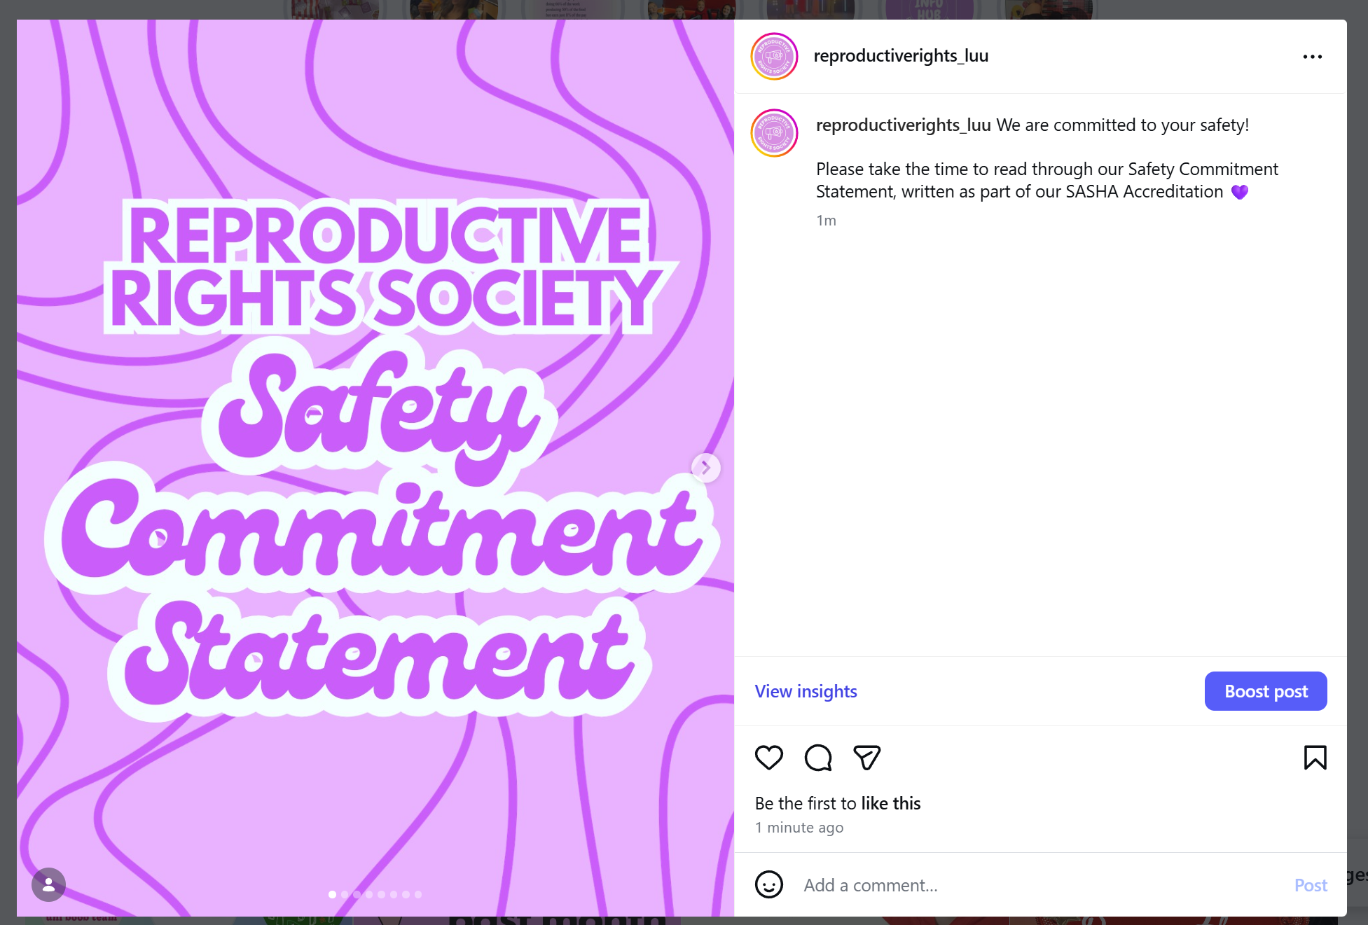

Task 3:

Describe the task and how you approached it

We created an educational social media post about what we learned at the SASHA training, covering the definition of consent, the FRIES acronym, stealthing, and how to be an active bystander.

What was the response to this?

The post has only received 12 likes so far but hopefully it will have been viewed by more people!

What is the impact of this action (predicted or already realised)

We hope that this action will increase awareness of consent and how to be an active bystander, as well as when it is and isn’t safe to speak up.

Share here any photos/links that show you completed this action

https://www.instagram.com/p/DWALKjGCN9u/?img_index=1

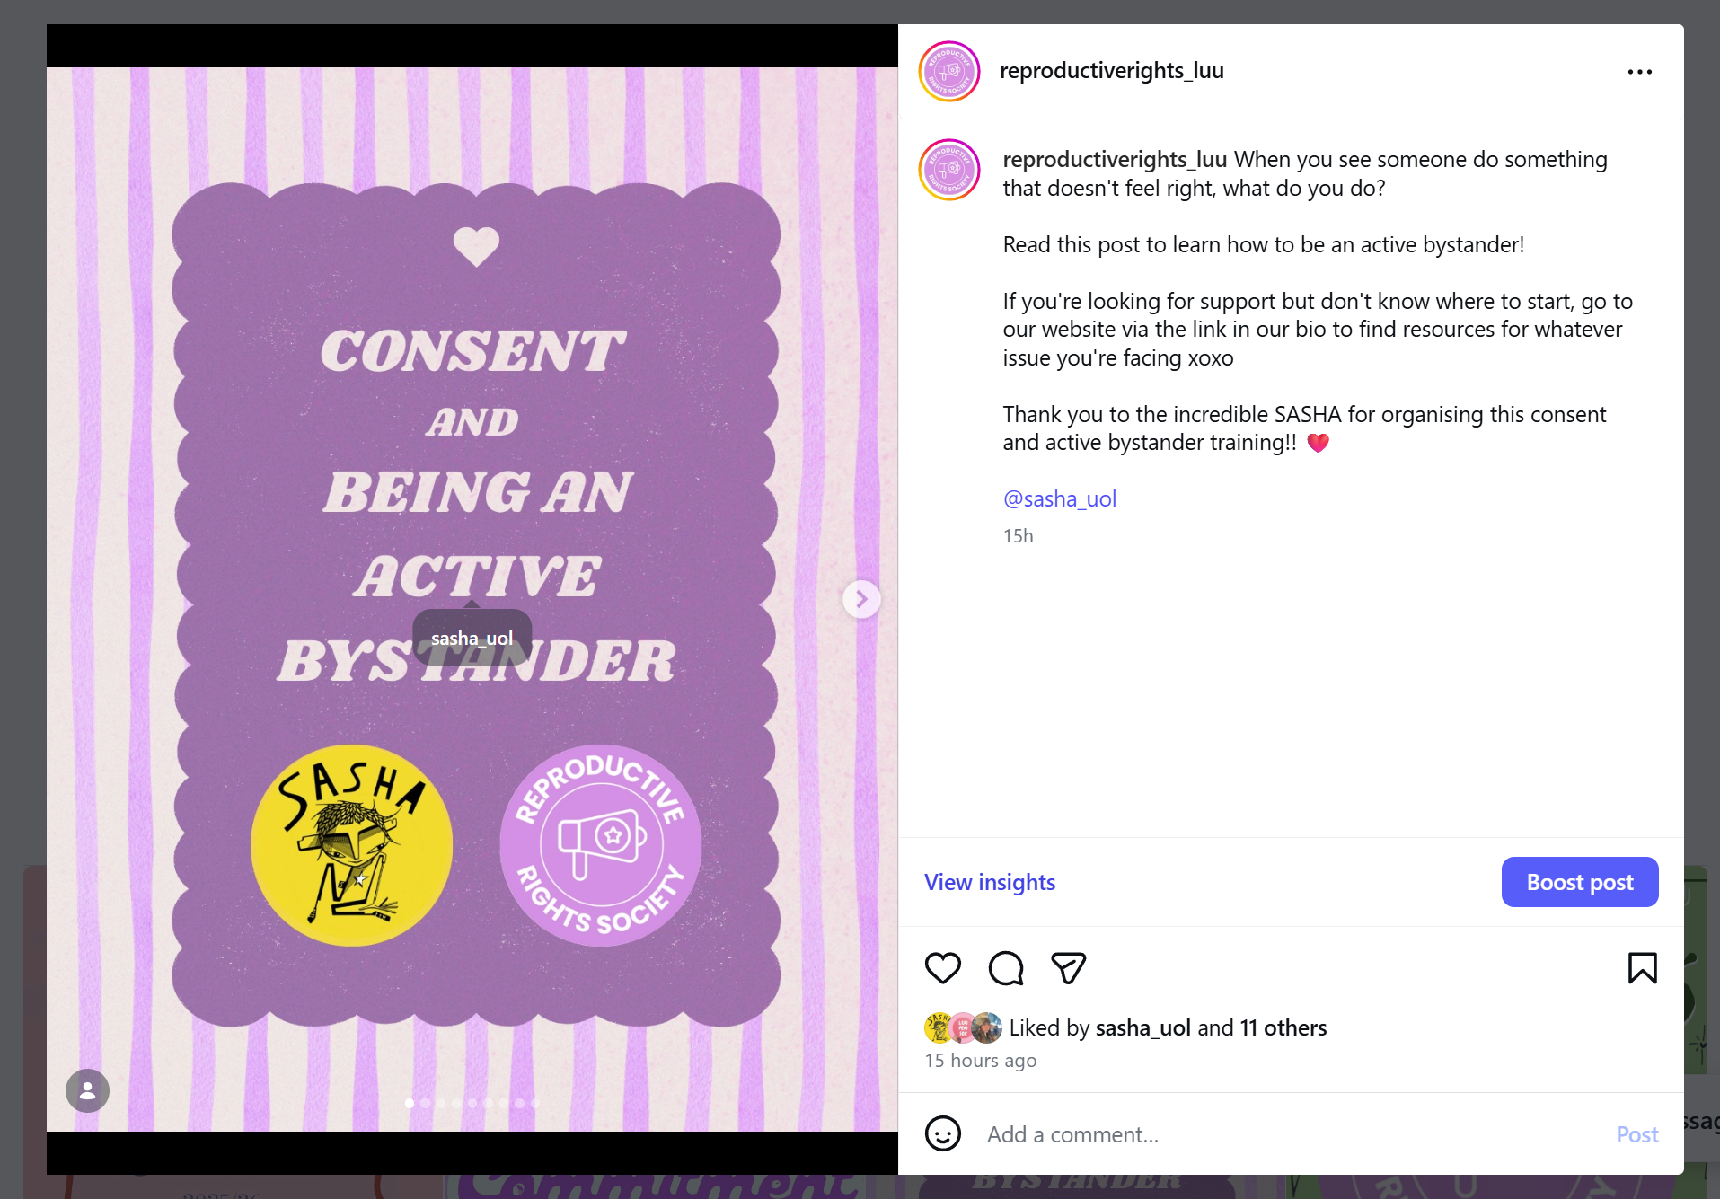

REMINDER! let us know you have submitted your report by completing this online form: https://forms.office.com/e/074X53zd1J
You will not be SASHA Accredited unless you complete both this report and the form.

