Please download a copy of this report template to fill it out and upload it to Engage.
Once it has been uploaded, let us know by completing this online form: https://forms.office.com/e/074X53zd1J
Society Name | Date
LUU Handball | 16/03/2026

Which three tasks did you complete?
☒ Educational post on social media
☐ Fundraiser in support of a related charity/cause
☐ Event centred on related themes
☐ Group-specific safety commitment statement
☐ Collab awareness event/activity with another student group
☒ Resource guide for members
☒ Discussion session

For more info on each of these tasks, visit Get SASHA Accredited - Leeds University Union

Task 1: Educational Post on Social Media

Describe the task and how you approached it

We compiled an informative Instagram post to put on the grid of our social media account. I (the Welfare Officer) used the notes I made during SASHA accreditation training, as well as the SASHA Instagram and recommended websites to compile all the information we wished to include in the post. I sent this across to our social media secretary who put it into a post that matched our usual Handball style except we used a different colour to ensure it stood out on the grid.

What was the response to this?

All of committee were entirely supportive and really proud to have this commitment and post shared as a society. After posting we received a lot of likes on the Instagram post with many of our members and committee reposting it or putting it on their stories.

What is the impact of this action (predicted or already realised)

Raised awareness within the society and amongst all of our followers. It provides key information and education around consent and how to be an active bystander.

It includes a statement about our societies stance and our commitment to an inclusive, safe space with a culture of consent clear. This means that anyone who seeks to participate in our society activities knows exactly where we stand and what we won’t tolerate, thus hopefully it can prevent harmful behaviour from the start.

It’s an important public reference point for education and our commitment as a society towards increasing student safety and tackling sexual harassment and assault.

Share here any photos/links that show you completed this action
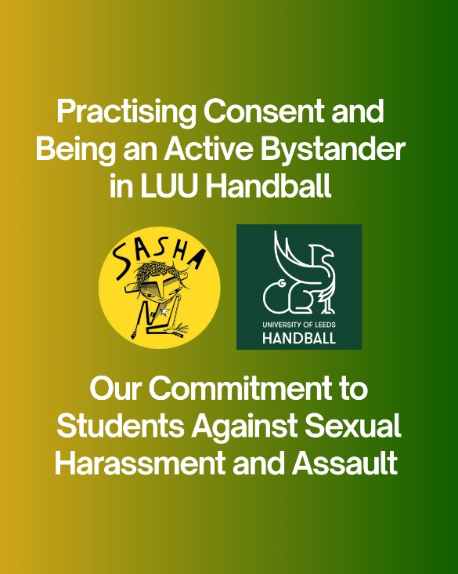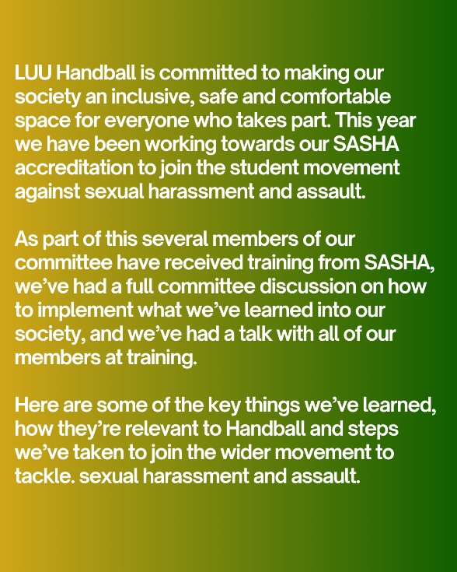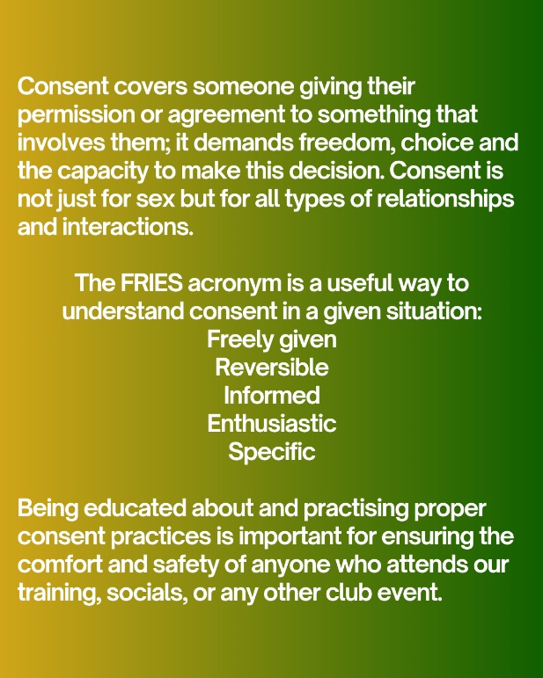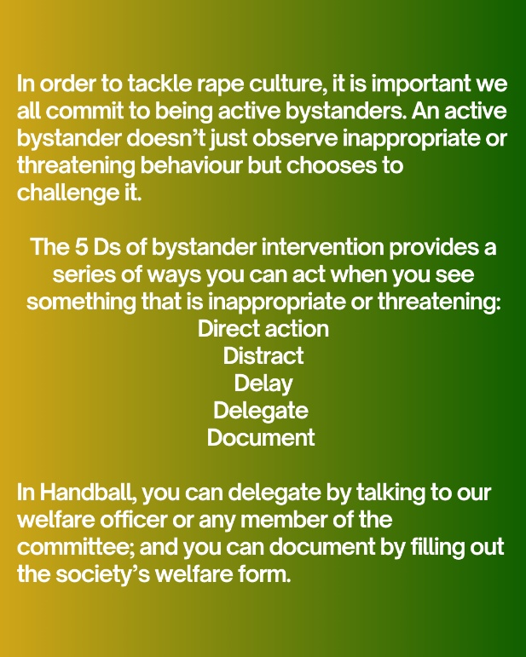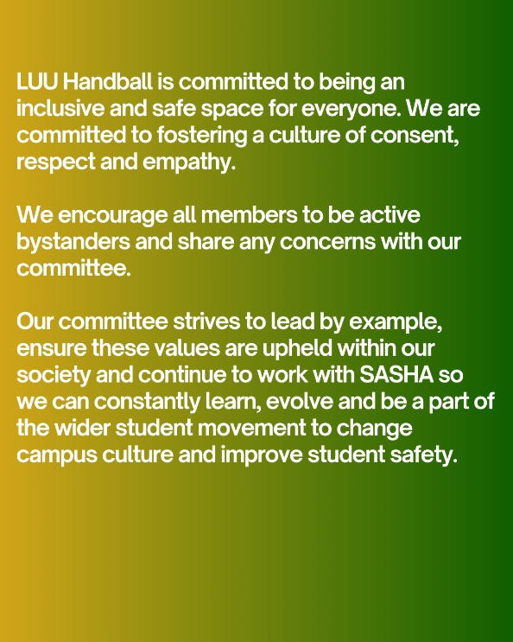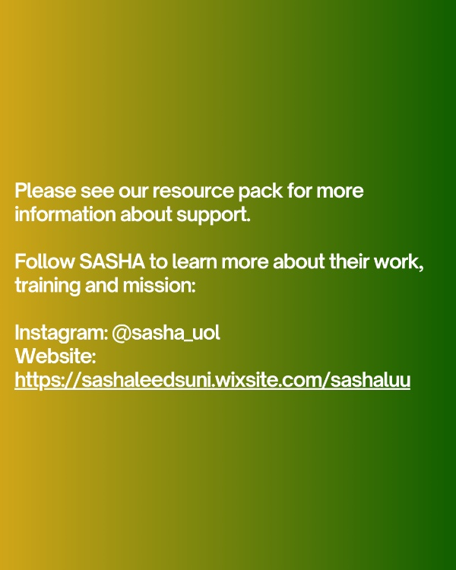

https://www.instagram.com/p/DWAN6Fygk-3/?utm_source=ig_web_copy_link&igsh=MzRlODBiNWFlZA==

Task 2:

Describe the task and how you approached it

We created a resource pack with information about SASHA and links to helplines, local charities, uni specific support and advice packs.

To do this, I first used notes from a training about misconduct and harassment support run by the university and union. Then I added this to the pack; I put in our society’s welfare form and links to the support uni can provide.

Secondly, I did some initial research of charities but then went to the SASHA linktree to find lots of important services and links here which I added to the pack.

Ultimately, I want the pack to be super readable and easy to navigate. So I split the support into different sections so people can clearly see what they would like to access in that moment. Then I put it in a dyslexic friendly, larger font, and bold effect to make the different sections clear.

Then we put this resource pack in our Instagram bio, referenced it in our Instagram post and put in on both the general society WhatsApp chat and the announcements channel. All members should now be aware its there and because of it being in the bio and announcement channel, it’ll be easy to access too.

What was the response to this?

Positive response giving people access to help and support if needed.

What is the impact of this action (predicted or already realised)

Having a resource pack enables people to access support and help when needed easily and efficiently – having all the information in one place.

Share here any photos/links that show you completed this action

https://docs.google.com/document/d/1OHEYr0lb0-3yAp2ebO9ViagxIAfIRgm5zy_8VD674zM/edit?usp=sharing

Task 3:

Describe the task and how you approached it

The task was a group discussion with committee and our coaches to explain what we learned in our training and how we can implement these into the way we run our society. We frequently have committee meetings before training so we did that same format again except this meeting was entirely committed to SASHA. Our 4 committee members who received the SASHA training were present.

What was the response to this?

Super positive response, although at first people were nervous to get involved because they didn’t want to say something silly, everyone eventually got super engaged and shared their own ideas/thoughts. Everyone listened well and was actively engaged in the discussion.

What is the impact of this action (predicted or already realised)

All of our committee and coaches are now educated with all of the information SASHA taught us and are super mindful of it when it comes to every society activity. Coaches are now hyper aware and mindful of practising safe and true consent when it comes to playing the sport as Handball involves tackling so many drills centre around this. Additionally, committee are now all confident in how to be an active bystander which is vital for our Wednesday night socials. Now if something does arise we know how we can act in the moment, but also understand channels of support and steps to take afterwards. This was a very important step and brought us together as a committee, we’re all on the same page and united in our commitment to SASHA.

Share here any photos/links that show you completed this action

We don’t have any photographic evidence of this so we asked a few committee members how did you find the talk? Here are some testimonials:
‘It was really informative. I didn’t know anything about FRIES before but have referred back to it ever since.’ Emma Rhodes
‘I found it very interesting and insightful, I’m now very confident in how to be an active bystander both as a committee member and in general.’ Freya Broderick

REMINDER! let us know you have submitted your report by completing this online form: https://forms.office.com/e/074X53zd1J
You will not be SASHA Accredited unless you complete both this report and the form.

