CLUB AND SOCIETY INDIVIDUAL RISK ASSESSMENT | Degree of Risk | Risk Rating Matrix
 |  | 
  Society Name: | LUU PERKS
  Category: | Academic
  Author(s): | Kertu Babik
  Author(s) signature and date: | 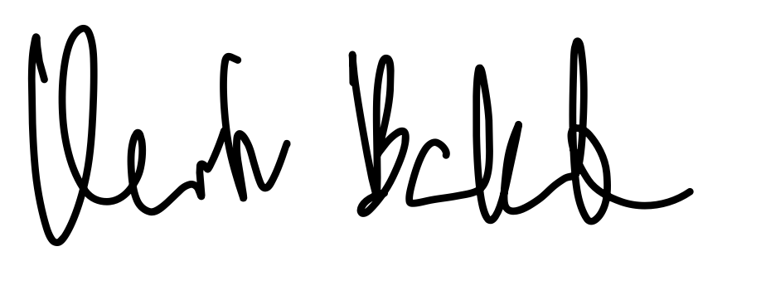  15.07.25
  Persons Responsible: | Finlay Hewson  Kertu Babik  Matthew Burke  Fariha Anzer
  Staff Sign Off:
  Staff Additional Check:
  Locations: | Leeds University Campus, St James Hospital, LGI Leeds.
  Details of Activity: | Academic Events: Guest lectures and talks from clinicians, researchers, and industry professionals, held on university campus or at hospital sites (LGI, St James's).  Career & Enterprise Events: Networking sessions, career talks, and workshops focused on professional development.  Educational Sessions: Peer-led revision sessions, tutorials, and journal clubs to support academic learning.  Social Gatherings: Informal social events such as coffee mornings or pub socials held at LUU or other local venues to build a community among members.
  People who may be affected: | - Society members and participants  - Staff
  Likelihood
  5 | Inevitable
  4 | Highly Likely
  3 | Probable
  2 | Unlikely
  1 | Remote possibility
  Severity
  5 | Very high - multiple deaths
  4 | Highly - death, serious injury, permanent disability
  3 | Moderate - Off Uni/work for at least 5 days
  2 | Slight - First aid treatment
  1 | Nil - Very minor
  Severity
  Likelihood |  | 1 | 2 | 3 | 4 | 5
  Likelihood | 1 | 1 | 2 | 3 | 4 | 5
  Likelihood | 2 | 2 | 4 | 6 | 8 | 10
  Likelihood | 3 | 3 | 6 | 9 | 12 | 15
  Likelihood | 4 | 4 | 8 | 12 | 16 | 20
  Likelihood | 5 | 5 | 10 | 15 | 20 | 25
  Risk rating score | Action
  1 - 4 | Broadly acceptable – no action required
  5 - 9 | Moderate - Reduce risks if reasonably practicable
  10 - 15 | High risk - Priority action to be undertaken
  16 - 25 | Unacceptable - Action must be taken immediately

Identify Hazards | Estimate the risk |  |  |  | Evaluate the risk |  |  |  | Evaluate residual risk
Hazard | How may harm result? | Likelihood | Severity | Rating | Risk control measures | Likelihood | Severity | Rating | Further action required?  Only fill out if additional control measures are needed to be implemented or reviewed  Include timescales and who is responsible for implementation
Slips, trips, and falls during events | Members or guests tripping over trailing cables, bags, or coats in lecture theatres or other venues, causing minor injuries like sprains or bruises. | 3 | 2 | 6 | Event organisers check the venue for obvious trip hazards before the event begins.  Attendees are reminded at the start of events to keep walkways and aisles clear of personal belongings.  Use gaffer tape to secure any necessary trailing cables.  Ensure all venues used are adequately lit. | 2 | 2 | 4
Use of faulty or unsafe electrical equipment | Electric shock or fire from using faulty personal laptops for presentations or from university-owned equipment. | 2 | 3 | 6 | Use university/venue-provided and PAT-tested equipment where possible.  The committee performs a visual check on any society-owned equipment for damage before use.  Ensure plug sockets are not overloaded. | 1 | 3 | 3
Psychological distress and exposure to biohazards during post-mortem observation | Students may experience fainting, nausea, or significant emotional distress. Remote risk of exposure to biological material if correct procedures are not followed. | 3 | 3 | 9 | Activity is run in strict accordance with the host hospital mortuary's policies.  Students must attend a mandatory briefing session beforehand, explaining what to expect.  Students are informed they can leave at any time without question if they feel unwell.  A committee member is available to support any student who leaves the session.  Personal Protective Equipment (PPE) must be worn as directed by mortuary staff.  A debrief session is offered afterwards to discuss the experience. | 2 | 3 | 6 | Committee to confirm booking procedures and supervision with the hospital mortuary team prior to the event.  The events coordinators of the society can be in communication with post-mortem staff to help provide assistance to anyone who seems visibly uncomfortable or voices concerns.
Breach of patient confidentiality, infection control, or hospital rules when visiting hospitals | Members entering restricted clinical areas, disrupting hospital work, or violating patient privacy, posing a risk to patients and the society. | 2 | 4 | 8 | All events on hospital sites are conducted in pre-booked, non-clinical areas.  Members are reminded at the start of the event to respect patient confidentiality and remain in the designated area.  Attendees must follow all local hospital policies, including infection control measures. | 1 | 4 | 4
Allergic reactions or food poisoning from food provided at events | A member with a severe allergy could have an anaphylactic reaction. Poor food hygiene could lead to illness. | 2 | 4 | 8 | Food is bought from reputable, registered businesses.  Allergen information is requested from the supplier and made available to attendees.  Event sign-up forms will include a field for attendees to declare any allergies.  The society does not provide or permit alcohol at its events, eliminating associated risks. | 1 | 4 | 4 | Ensure allergy information is requested on sign-up forms for all catered events.
Fire or fire alarm activation during an event | Panic during evacuation, smoke inhalation, or injury if evacuation is disorderly or exits are blocked. | 1 | 4 | 4 | Committee members are aware of the fire evacuation procedures for all regular venues.  At the start of each event, the chair will briefly identify the nearest fire exits.  Ensure that fire exits and escape routes are never blocked. | 1 | 2 | 2 | Committee to confirm they know procedures for their main venues at the start of the year.

