CLUB AND SOCIETY RISK ASSESSMENT | Degree of Risk | Risk Rating Matrix
 |  | 
  Society Name: | LUU Scout and Guide
  Category: | Outdoor
  Author(s): | Rebecca Mortimer, Lucy Jackson, Reuben Hocking
  Author(s) signature and date: | 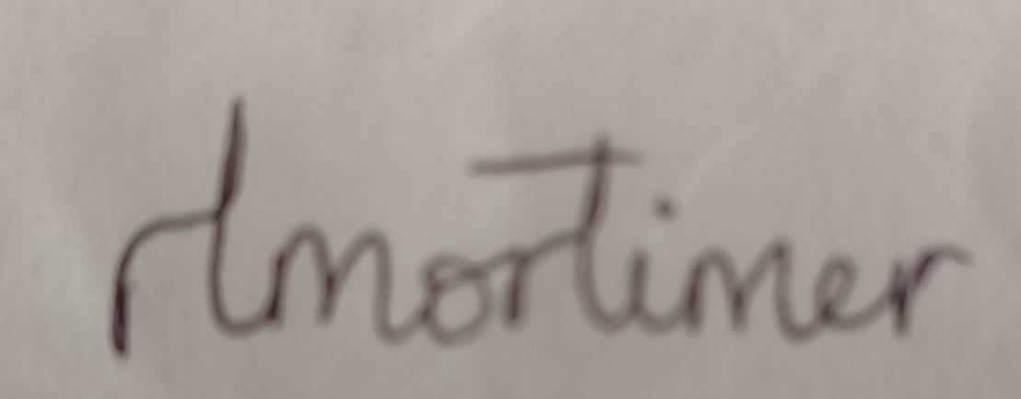  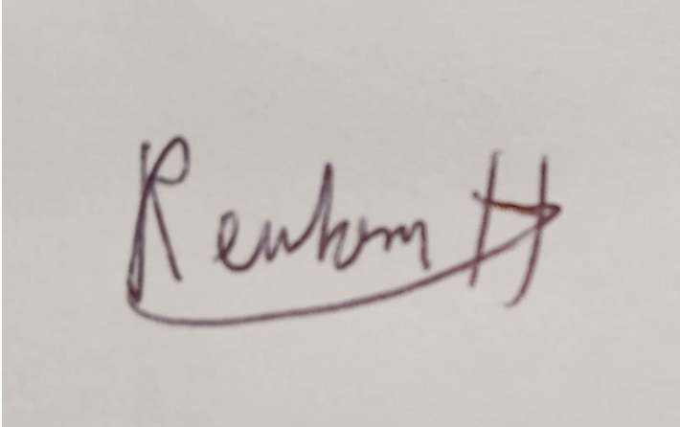
  Persons Responsible: | Club and society committees and leaders
  Staff Sign Off: | [Signature] [Date]
  Staff Additional Check: | [Signature] [Date]
  Locations: | LUU Building  Venues within Leeds City Centre  Hikes (individual risk assessment completed for route once decided on)  Camps (individual activity risk assessments completed when locations decided)
  Details of Activities: | LUUSAG runs a mix of social activities as well as going hiking and camping. The society is part of the national Scout and Guide Organisation and attends national camps up to 3 times a year.
  People who may be affected: | - Society members and participants  - Members of the public  - Staff
  Likelihood
  5 | Inevitable
  4 | Highly Likely
  3 | Probable
  2 | Unlikely
  1 | Remote possibility
  Severity
  5 | Very high - multiple deaths
  4 | Highly - death, serious injury, permanent disability
  3 | Moderate - Off Uni/work for at least 5 days
  2 | Slight - First aid treatment
  1 | Nil - Very minor
  Severity
  Likelihood |  | 1 | 2 | 3 | 4 | 5
  Likelihood | 1 | 1 | 2 | 3 | 4 | 5
  Likelihood | 2 | 2 | 4 | 6 | 8 | 10
  Likelihood | 3 | 3 | 6 | 9 | 12 | 15
  Likelihood | 4 | 4 | 8 | 12 | 16 | 20
  Likelihood | 5 | 5 | 10 | 15 | 20 | 25
  Risk rating score | Action
  1 - 4 | Broadly acceptable – no action required
  5 - 9 | Moderate - Reduce risks if reasonably practicable
  10 - 15 | High risk - Priority action to be undertaken
  16 - 25 | Unacceptable - Action must be taken immediately

Identify Hazards | Estimate the risk |  |  |  | Evaluate the risk |  |  |  | Evaluate residual risk
Hazard | How may harm result? | Likelihood | Severity | Rating | Risk control measures | Likelihood | Severity | Rating | Further action required?  Only fill out if additional control measures are needed to be implemented or reviewed  Include timescales and who is responsible for implementation
Unsuitable footwear or clothing | Any members participating in the activity with incorrect clothing or equipment could be harmed through injury. | 3 | 2 | 6 | - Members advised of appropriate clothing for the activity and given kit lists beforehand.  - Committee will check that all members have the correct clothing and equipment prior to the activity.  - If a member turns up with footwear or clothing deemed to be dangerously inappropriate they will be asked to sit out of the activity. | 2 | 2 | 4
Slips, trips and falls | Members participating in the activity could be injured. | 3 | 2 | 6 | - Hike routes will be assessed for suitability beforehand.  - Committee members will take into account the experience of the participants and ensure that the walk/hike/activity is suitable for everyone.  - Members will be advised to be careful when participating.  - Where possible, group leaders will have first aid training.  - Each hiking group will have access to a first aid kit on a hike - the committee will ensure at least 2 will be brought to each hike and will be held by members of committee. | 2 | 2 | 4
Falls from height | Members participating could be injured from falling | 2 | 4 | 8 | - Members to be made aware of specific dangers of the route when they sign up e.g. large hills, cliff faces  - Route choice will be selected based on group experience, avoidance of exposure with novices on routes, briefing prior to route choice.  - Alternative routes will be available for people deemed too inexperienced. | 1 | 4 | 4
Members getting separated from group when on a trip | Members participating in activity could get lost and/or harmed. On a hike, this may result in one of the above scenarios. | 2 | 3 | 6 | - The Secretary will make sure that a list of all names and contact details is brought on every trip/camp.  - Every name will be ticked off before departure.  - Every member will be given the contact number of the committee members on the trip.  - A meeting point will be agreed in every new place in case of separation.  - A designated committee member will conduct regular head counts of the group. | 1 | 2 | 2
Adverse Weather | Members could be at risk during a hike, camp or another outdoor activity during harsh weather conditions  Hot - Harm and/or potential death from sunburn, heatstroke, dehydration in hot conditions  Cold/wet conditions - Harm and/or potential death from exposure and/or hypothermia in cold/wet conditions  Thunderstorms/Lightning - Electrocution by direct hit and from falling rocks hit by lightning strikes | 4 | 3 | 12 | - Weather forecast checked when considering route.  - Take regular breaks and encourage members to bring and drink sufficient water and advise about the benefits of sun protection.  - Rehydration sachets will be taken in extreme heat and carried in Leaders’ first aid kit.  - If the weather is too dangerous e.g. lightning/thunderstorms/heavy rain forecast, the activity will be postponed or cancelled to keep members safe.  - Activity leader/Committee members will ensure everyone has weather appropriate clothing, footwear and equipment. | 2 | 2 | 4
Water hazards | Members falling when crossing rivers on routes, and death by hypothermia after submersion in water. | 2 | 3 | 6 | - Leaders to avoid river crossing where possible by using bridges and designated crossings and will identify any required river crossings during planning.  - River crossings to be conducted carefully and under close supervision of the leader/committee. Leaders to be at the front and rear of group.  - Alternative route to be available should river crossing be deemed unsuitable at time of attempt (this may involve turning back) | 1 | 2 | 2
Poor food hygiene during socials/on camps | Anyone eating the food could get food poisoning | 2 | 3 | 6 | - Surfaces will be cleaned before and after preparing food.  - Committee will ensure that water is available for hand washing prior to preparation and eating of food.  - If handling raw meat, cooking stations will be fully cleaned before handling other foods to avoid cross contamination.  - A fully stocked first aid kit will be taken on the trip/camp and a trained first aider should be in attendance.  - Committee will ensure that the campsite has an adequate clean drinking water supply.  - Those handling food will be asked to ensure that the food is cooked thoroughly.  - Food will be stored safely throughout the event e.g. use of cool boxes.  - Cooking equipment will be properly cleaned after use and before if needed.  - Food used will be in date. | 1 | 3 | 3
Poor personal hygiene on trips/camps | Anyone in attendance could fall ill due to poor hygiene | 3 | 3 | 9 | - Committee will ensure the campsite has suitable toilet and washing facilities for the activity.  - Committee will ensure the site has suitable water supplies or will provide drinking water.  - A fully stocked first aid kit will be taken to activities in case it’s needed. | 2 | 2 | 4
Allergies and Intolerances | Anyone with an allergy or food intolerance that isn’t appropriately catered for. | 2 | 4 | 8 | - All members are asked for any medical/dietary requirements the society need to know, prior to the event.  - All food allergies will be catered for appropriately, being careful to avoid cross contamination.  - Committee members will be informed of any medical needs and any measures in place and will be trained accordingly. | 1 | 3 | 3
Fire Lighting | Members could get burnt, harmed by smoke inhalation, splinters/blisters from handling rough wood | 2 | 3 | 6 | - Gloves will be advised to members if rough wood is being used on fire.  - Safe group sizes will be considered in relation to the equipment and space available for building the fires.  - Members will be advised about the risks in fire lighting and ways to avoid them.  - Accelerants will not be used to light fires e.g. petrol or lighter fuel, only kindling or fire lighters will be used.  - Members with loose clothing (Ie. Neckers) or long hair will be advised to tuck their clothing in and/or tie up their hair.  - An appropriate first aid kit will be made available .  - Fire extinguishers (or other suitable measures) will be in place to extinguish the fire should it be required.  - The location of fires will be carefully thought about in relation to the location of trees, tents, etc.  - Members will be told about fire safety and how to behave around fire. | 1 | 3 | 3
Mistakes when navigating on a hike | Members participating in the activity may get lost and harmed | 2 | 2 | 4 | - Routes used will be suitable for the members’ navigation skills and physical capabilities.  - Each group will be provided with adequate maps, compasses, route instructions and spares.  - Each group will have adequate means of emergency communication with committee members and be advised of when to report to the emergency services.  - Escape routes will be planned in case of emergency (e.g. blocked path). | 1 | 1 | 1
Blisters, muscle and joint pain. Illness, bites and allergies | Members could undergo minor injuries and discomfort caused by the listed.  Risk of lyme disease from tick bites. | 4 | 2 | 8 | - Members advised to change socks and wash and dry feet after hiking.  - At least 2 first aid kits will be carried by committee members during each hike and any appropriate action will be taken, when required.  - All first aid kits contain a tick remover to allow for safe removal of ticks, and members are encouraged to use bug spray to mitigate risk of exposure and bites. | 2 | 2 | 4
Inappropriate campsite chosen | Members participating in the camp could be harmed | 2 | 3 | 6 | - Committee members will do thorough research into campsites to ensure suitability (.e.g. ensuring clean water supply, decent toilets, etc).  - Notes will be taken about why certain campsites may be unsuitable so these can be used in the future to decide on campsites. | 1 | 3 | 3
Unruly/aggressive animals | Members participating could undergo animal-related injuries, including but not limited to stampede, kicks, bites, etc | 3 | 2 | 6 | - Respect wild/farm animals and follow guidance on signs when passing through open access land and public footpaths.  - Take due care and attention if passing animals, allowing suitable distance and avoiding young animals.  - Assess the situation accordingly and find route diversions if necessary. | 1 | 2 | 2
Camping | Members could be injured by equipment or poor conditions | 4 | 2 | 8 | - Tents will be checked that they’ve been put up correctly so they won’t fall down.  - A suitable campsite will be chosen by the organisers, to ensure suitable facilities and running water.  - Members will be provided with a kit list and access to suitable equipment they should need (sleeping bags, roll mats, etc).  - Members will be advised to ask the committee if they are unsure on the suitability of their own equipment.  - Members use their own equipment at their own risk.  - Weather will be monitored and back up activities planned if there are unsuitable conditions.  - Updated health forms will be required from all participants and will be kept by the secretary.  - A suitable home contact will be chosen to have as an emergency contact should an incident occur. | 2 | 2 | 4
Incompetent leaders | Members may be put in danger of harm, injury if leaders are attempting activities beyond competency/skill-set | 2 | 3 | 6 | - All hikes are led by committee members and each hike group will have at least 2 map-readers to ensure the correct route is taken.  - Conditions on the day of hike will be taken into consideration on all occasions.  - Where possible, at least 1 first aid trained committee member will be present and at least 2 first aid kits will always be taken and held by 2 committee members.  - Hikes to follow designated footpaths as much as possible. | 2 | 2 | 4
Lack of communication of risk assessment to members | Members may be injured through lack of communication of risks | 2 | 2 | 4 | - Risk assessment is either made available on the LUU engage club page if possible or circulated to members when they join. | 1 | 1 | 1
Vehicle collisions with pedestrian | Members - Death or injury caused by collision with a motor vehicle | 2 | 4 | 8 | - Members to be made aware of dangers of walking along and crossing roads.  - Committee members to be at the front and rear of the group during excursions. | 1 | 4 | 4
Lack of awareness of first aid procedures | Any member participating in the activity may be harmed further if they are injured and the correct procedures are not in place | 3 | 3 | 9 | - If on campus, make sure the committee are aware of the nearest first aider on campus and all have LUU Duty Manager’s phone number (07581476084) recorded in their mobile phones.  - If social is at an external activity provider, committee will check that first aid provision will be provided by them.  - Make sure all members, particularly committee, are aware of when to report to the emergency services in the event of major accidents or injuries.  - Accidents and near misses will be reported to LUU as required.  - Members will be responsible for bringing any medicine or specific medical equipment that they require to any activities e.g. inhaler, epipen, knee supports.  - A fully-stocked first aid kit will be taken on trips/camps and there will be a trained first aider in attendance if possible.  - Members will be advised to bring appropriate clothing and footwear to reduce the risk of illness and injury.  - If a member on the trip/camp becomes seriously unwell, the trip leader should be notified and the emergency services should be called. | 2 | 2 | 4
Lack of emergency procedures in place, or communication of it | All participating members may be harmed in an emergency if there isn’t a emergency procedure in place or if they’re unaware of it | 2 | 4 | 8 | - Ensure that the emergency procedure is known for every site that we are meeting at.  - The committee will decide on a suitable procedure in case of emergency, and this will be relayed to all the members. | 1 | 3 | 3
When the emergency exits are blocked | Anyone in the building could be harmed if they cannot leave safely in an emergency | 2 | 4 | 8 | - Ensure that personal belongings and equipment are not blocking the emergency exits.  - Members will be informed of the location of the emergency exits. | 1 | 3 | 3
Alcohol | Any member after drinking alcohol may cause harm to themselves or those around them | 3 | 3 | 9 | - Non-drinking socials will also be run to make sure everyone feels included.  - Members will be warned about the risks of alcohol, and make sure people are aware of their limits.  - If someone is drinking excessively, the committee will cut them off if necessary.  - Any issues will be reported to staff/security when necessary.  - Make sure there is awareness of when to report to emergency services.  - Members will be told to message the committee when they get home after drinking to ensure we know they’re safe.  - Ensure that first aid procedures are known by the committee in case of injury. | 1 | 3 | 3
Drinks or other liquids spilt on the floor | Members could slip and injure themselves | 2 | 2 | 4 | - Committee are to routinely check the floors and alert all members of any hazard immediately.  - Remove all obstacles which could be a trip hazard.  - Ensure that first aid procedures are known by the committee in case of injury. | 1 | 2 | 2
Unsuitable venue for the activity | Harm and injury could be caused to members participating in the activity | 1 | 2 | 2 | - Committee to check the venue is suitable prior to the activity.  - Keep venue tidy throughout the activity.  - Committee to ensure there are suitable emergency exits in case of emergency.  - Ask members to sign up to activities to gauge a rough number of attendees to ensure that the venue is suitable.  - Committee to ensure that the space is suitable for the amount of people.  - If venue is deemed unsuitable a note will be made for the future about how and why the venue was unsuitable.  - Ensure that first aid procedures are known by the committee in case of harm or injury. | 1 | 1 | 1
Object falls on someone’s head | Member could be harmed | 3 | 3 | 9 | - Ensure that the equipment in the lockers and chapel are stored safely to minimise risk of falling.  - Members will be reminded to be aware of their surroundings (e.g. low-hanging branches/doors/shelves). | 2 | 3 | 6
Equipment unsafely set up/stored/transported e.g. tents | The equipment could get damaged if not stored correctly; members could be injured if trying to access equipment or during use | 2 | 3 | 6 | - Committee to check that equipment is set up properly prior to the activity and that it is tidied away correctly afterwards.  - If at an external activity provider, the instructors will be trusted to set up and tidy up equipment correctly in line with their own policies.  - Equipment will be stored in ideal locations so it remains durable as long as possible.  - If equipment is stored on high shelves, suitable measures will be in place to retrieve it (step stool, ladder, etc). | 1 | 3 | 3
Unsuitable equipment | Any member participating in the activity could be injured | 2 | 3 | 6 | - Equipment should be checked prior to the activity.  - Ensure only equipment suitable for the activity is used.  - Members will be given a kit list prior to the event and expected to bring all the required kit. Should members not have the correct kit, they will be refused participation at committee’s discretion. | 1 | 3 | 3
Damaged equipment | Any member participating in the activity could be injured or unsuitably prepared for the activity | 2 | 3 | 6 | - Damaged equipment is not to be used.  - If damaged equipment belongs to the society, the quartermaster is to be informed of any damage, and take appropriate actions  - Otherwise, it is to be reported to the duty manager/venue staff/activity instructors. | 1 | 3 | 3
Mis-using electrical equipment e.g. overloading sockets or using unauthorised equipment | Any member could be electrocuted | 2 | 4 | 8 | - All electrical equipment must have a valid PAT test certificate or proof of purchase within the year.  - Power sockets will not be overloaded. | 1 | 4 | 4
Abuse/violence (verbal, physical, sexual) or inappropriate behaviour from members of the public or other members in the society | Members of the society or members of the public could be harmed | 3 | 2 | 6 | - Members will be told to stay in groups when on an activity.  - Members will be told to try to avoid confrontation where possible.  - When out in public areas, members will be warned about their behaviour, how to act in public, and potential consequences if they are not upheld e.g. removal from activity/temporary ban from society activities/exclusion from the society.  - If required, members will be removed from the situation.  - Issues will be reported to venue staff/security as appropriate.  - Members will be made aware of when to report to the emergency services.  - Members will be supported by the committee should they be the victim of abuse, and will be helped to find the support they need.  - Any incidents will be reported to LUU as required. | 1 | 2 | 2
Strobe lighting and/or excessive noise | Any members with light/noise sensitivity or photo-sensitive epilepsy could be harmed | 1 | 3 | 3 | - Secretary to ensure that medical records are kept up-to-date so that the committee is aware of any medical conditions.  - Ensure that members are made aware before the event of any possible strobe lighting or excessive noise.  - Committee will check in with members throughout the activity. | 1 | 2 | 2
Medical records not kept up-to-date | Adequate care and support may not be provided to members who need it which could cause harm | 2 | 4 | 8 | - Ensure that members are asked to update their medical information at the start of each semester.  - Prior to any trips/camps, members will be asked to update their medical information to ensure that the committee is aware of any relevant medical conditions.  - If a member’s existing medical conditions require immediate action e.g. epipen or insulin, then the member will be encouraged to inform the other members, or at least the committee, of this and where they keep their medications. | 1 | 4 | 4
Navigating to an activity at night time/when it’s dark | Members may get lost or harmed | 4 | 3 | 12 | - Members will be advised to travel on well lit routes with adequate street lighting and to use torches where needed.  - Members advised to travel together to activities and having a method of contacting a committee member on the journey. | 2 | 2 | 4
Issues with booked transport e.g. breakdowns, accidents, accessibility issues | Members could be separated from the group and could be harmed | 3 | 2 | 6 | - If travelling in separate vehicles, regular communication will be set up between passengers to ensure everyone is aware of what's going on.  - If using a hired driver, they will be booked well in advance with a reputable company.  - Committee will be prepared should alternative transport be required e.g. knowing bus and train times for the area.  - Members will be asked for any possible accessibility issues and these requirements will be met before the day.  - All drivers will be told the endpoint for the journey so can still arrive safely if separated. | 2 | 1 | 2
Driving private vehicles | Members may be harmed by unsafe driving | 3 | 3 | 9 | - Drivers will be registered with the LUU.  - Members will be reminded to respect the driver and not distract them or behave inappropriately.  - LUU guidance will be followed on reporting accidents.  - Any drivers are to have appropriate insurance for the car they are driving.  - Members will be made aware of when to report to the emergency services e.g. contacting 999 if any major incidents or injuries occur. | 2 | 2 | 4
Disclosure of sensitive information not in line with GDPR | Members may be harmed by the spread of their personal information | 2 | 3 | 6 | - Secretary will ensure that records are kept according to GDPR and any LUU policy.  - Any possible breach of GDPR will be reported to the President and this will be escalated appropriately .  - Any personal information no longer needed will be destroyed or returned to the member. | 1 | 2 | 2
Carrying valuables in a public area | Members could be a target of theft | 4 | 3 | 12 | - Members will be informed that they are responsible for their personal belongings and that they should bring these to any activities at their own risk - the society will not accept any responsibility of lost belongings.  - Members will be encouraged to consider what valuables they bring to any activities and remain vigilant when out and about in public.  - Should someone be a victim of theft, the committee will help support them and get them help.  - Any theft will be reported to the police. | 2 | 2 | 4
Use of illicit substances | Members could harm themselves or others | 2 | 4 | 8 | - Members will be informed of the behavioural standards of the society at the start of the year, including the ban on use of illicit substances.  - Should a member break the rules, they will be sent home and further disciplinary action may be taken e.g. suspension or exclusion from the society.  - Incidents will be reported to LUU and SSAGO (the Student Scout and Guide Association) accordingly. | 1 | 4 | 4

