LUUVC CONSTITUTION
Terminology
Activities Executive (The Activities Sub-committee of Better Union)
Activities Assembly (The sub-committees of the Activities Executive)
1 Name, Aim and Objectives
1.1 The name of the Activity Group shall be Leeds University Union Volleyball Club, hereafter referred to as the Activity Group.
1.2 The aims and objectives of the Activity Group shall be:-
1.2.1 To offer coaching and competitive opportunities in volleyball
1.2.2 To promote volleyball within the local community and ensure a duty of care and fairness to all members of the club

2 Membership
2.1 All members shall be required to pay a group membership fee decided by the Activity Group committee.
2.2 All members shall be entitled to the relevant Membership Privileges.
2.3 Any member may be suspended or expelled from any or all of the privileges of the Activity Group, including membership of it, for any period by a decision of the Activity Group Committee.
2.4 Full Membership may be granted to current students at the University of Leeds who are members of Leeds University Union (LUU), and they shall be entitled to privileges 2.9.1 to 2.9.5 inclusive.
2.5 Associate Membership may be granted to other students, subject to the approval of the Activity Group’s committee and they shall be entitled to privilege 2.9.1 only.
2.6 Honorary Life Membership may be granted to a person that the Activity Group wishes to honour for services to the Activity Group and they shall be entitled to privilege 2.9.1 only.
2.7 The Activities Officer shall be ex officio a Full Member of the Activity Group and shall act as signatory to the Activity Group’s cash office mandate.
2.8 The Activities Executive Chair and the Activities Executive Representative shall be ex officio Associate Members of the Activity Group.
2.9 Membership Privileges
2.9.1 To attend all meetings.
2.9.2 To vote on all questions of policy within the Activity Group.
2.9.3 To propose or second candidates for election to the Activity Group committee.
2.9.4 To vote for such officers as are nominated for election.
2.9.5 To hold office on and stand for election to the Activity Group committee.
2.10 Expulsion and Suspension
2.10.1 The committee of the activity group can expel or suspend any member of the group so long as there is good reason.
2.10.2 The Activity Group committee shall notify the Activities Executive of any expulsions or suspensions.
2.10.3 Expelled or Suspended members may submit a written appeal to the Activities Executive.
2.10.4 The Activity Group committee shall be notified of the appeal and may submit a written explanation of their decision within ten working days.
2.10.5 If no explanation is received within ten working days of notification, the appeal shall proceed.
2.10.6 A simple majority vote by the Activities Executive shall decide the appeal and, in the event of a tie, the Chair shall have the casting vote.
3 Committee
3.1 The committee shall consist of three Core Officers, and any Additional Officers required.
3.2 Officers must be full Activity Group members who are also Student Ordinary Members of LUU.
3.3 Committee Duties
3.3.1 To attend Committee Meetings.
3.3.2 To ensure the Activity Group’s LUU webpage and, if applicable, own website and/or facebook or similar social media site, are maintained.
3.3.3 To ensure the good running and proper financial running of the Activity Group.
3.3.4 To inform any suspended or expelled member of their rights of appeal through LUU structures.
3.4 Committee Powers
3.4.1 To manage the Activity Group on behalf of its members and in accordance with its stated aims and objectives.
3.4.2 To suspend or expel any member from any or all privileges of the Activity, including membership of it, for any period, subject to appeal.
3.5 Core Officers
3.5.1 Core Officer Duties
3.5.1.a To attend the Annual General Meeting.
3.5.1.b To be a signatory of the Activity Group’s Cash Office account.
3.5.1.c To attend the relevant Activities Assembly.
3.5.1.d To attend committee training.
3.5.1.e Failure to fulfil these duties may result in a motion of no-confidence and removal of office by an EGM or the Activities Executive.
The Core Officers shall be:-
3.5.a President/Captain/Chair
3.5.a.1 The President/Captain/Chair should organise and oversee the running of the Activity Group.
3.5.a.2 The President/Captain/Chair should chair Committee Meetings.
3.5.a.3 The President/Captain/Chair should produce an annual report.
3.5.a.4 The President/Captain/Chair should provide an entry for inclusion on the Activity Group’s LUU webpage.
3.5.b Secretary
3.5.b.1 The Secretary should maintain membership records containing at least the name and Student card number, if applicable, of all the Activity Group’s members.
3.5.b.2 The Secretary should produce agenda documents for all meetings.
3.5.b.3 The Secretary should maintain a written record of all meetings.
3.5.b.4 The Secretary should maintain an up-to-date copy of the Activity Group constitution.
3.5.c Treasurer
3.5.c.1 The Treasurer should be responsible for the finances of the Activity Group.
3.5.c.2 The Treasurer should maintain up-to-date accounts with the LUU Cash Office only.
3.5.c.3 The Treasurer should submit subsidy applications to Activities Executive.
3.5.c.4 The Treasurer should produce a termly report and yearly budget.
3.5.c.5 The Treasurer should submit a detailed statement of accounts for the year to the Activity Group’s Annual General Meeting.
3.6 Additional Officers
<The Sample Additional Officers section is an example. Activity Groups may add or remove as many Additional Officers as required.>
The Additional Officers shall be:-
3.6.a Events Officer
3.6.a.1 The Events Officer should organise events for the Activity Group.
3.6.a.2 The Events Officer should publicise all Activity Group events.
3.6.b Equal Opportunities Officer
3.6.b.1 The Equal Opportunities Officer should be the contact point and representative for minority groups.
3.6.b.2 The Equal Opportunities Officer should assist with the recruitment of minority group members.
3.7 Elections
3.7.1 Elections shall take place at the AGM or the EGM.
3.7.2 Candidates for positions on the Activity Group committee shall be proposed and seconded by full members of the Activity Group.
3.7.3 Candidates may neither propose nor second themselves.
3.7.4 Members may only propose or second one candidate for each committee position.
3.7.5 Notification of opening of nominations shall be at least ten working days before the date of the AGM or EGM.
3.7.6 Nominations shall open at least five working days before the date of the AGM or EGM.
3.7.7 Newly elected Activity Group Committee members must assume their responsibilities within ten working days of their election.
4 Meetings
4.1 The Activities Executive may, at its discretion, send an observer to any Meetings.
4.2 If any member moves no confidence in the Chair, a vote shall be taken immediately.
4.3 If a motion of no confidence in the Chair is passed, a new temporary Chair will be elected by the meeting.
4.4 Voting shall be by show of hands unless a secret ballot has previously been requested, and decisions will be made by simple majority.
4.5 No member shall have more than one vote.
4.6 Committee Meetings
4.6.1 The time, date and location of Committee Meetings must be posted on the Activity Group LUU webpage or a member accessible web source, at least two working days in advance.
4.6.2 Committee Meetings shall be open to all members of the Activity Group.
4.6.3 The agenda for Committee Meetings should be made available at the start of the meeting.
4.6.4 The quorum for all Committee Meetings shall be two thirds of all officers, or three officers, whichever is greater.
4.6.5 The minutes of any decisions made at the meetings must be displayed on the LUU webpage or a member accessible web source, once ratified as a true and accurate record of the meeting.
4.6.6 Minutes may additionally be posted on the Activity Group’s LUU notice board.
4.7 Annual General Meeting
4.7.1 The Annual General Meeting (AGM) shall be held within 395 days of the previous AGM.
4.7.2 Notice of the AGM must be posted on the Activity Group LUU webpage or a member accessible web source, at least ten working days in advance.
4.7.3 The agenda for the AGM must be posted on the Activity Group LUU webpage or a member accessible web source at least five working days in advance.
4.7.4 The order of business shall be:-
4.7.4.a President’s/Captain’s/Chair’s report
4.7.4.b Financial report
4.7.4.c Constitutional Amendments
4.7.4.d Elections
4.7.4.e Any other business
4.7.5 The quorum for the AGM shall be either one third of all the full members or 20 full members, whichever is the lesser.
4.7.6 If an AGM is declared inquorate, it must adjourn to be reconvened within ten working days.
4.7.7 If a reconvened AGM is declared inquorate, the Activity Group shall report this to the Activities Executive.
4.7.8 The Activity Group must submit the full agenda and minutes of their AGM to the Activities Executive, if requested by the Activities Executive.
4.7.9 Ratified minutes shall also be provided at a later date if there are any amendments.
4.8 Extraordinary General Meetings
4.8.1 An Extraordinary General Meeting (EGM) may be called by either one third of all the full members or 20 full members, whichever is the lesser.
4.8.2 Notice of the EGM, together with their agenda, shall be posted on the Activity Group LUU webpage or a member accessible web source within two working days of the meeting being called.
4.8.3 The agenda for the EGM shall be restricted to the motion or business for which the meeting was called.
4.8.4 The quorum for the EGM shall be either one third of all the full members or 20 full members, whichever is the lesser.
4.8.5 If an EGM is declared inquorate it may not proceed.
4.8.6 The Activity Group must submit the full agenda and minutes of their EGM to the Activities Executive, if requested by the Activities Executive.
4.8.7 Ratified minutes shall also be provided at a later date if there are any amendments.
5 Miscellaneous Provisions
5.1 Constitution
5.1.1 The interpretation of this constitution is the responsibility of the Activity Group committee.
5.1.2 In case of dispute over a particular interpretation of this constitution, the Activities Executive shall be the final arbiter.
5.1.3 The assets or liabilities of the Activity Group shall remain with the Activity Group regardless of any changes to committee, group structure or constitution.
5.1.4 The Activity Group shall be a constituent part of LUU and thus subject to the rulings of Union Council.
5.1.5 In the event of dissolution or abolition of the Activity Group its assets will revert to LUU.
5.1.6 Constitutional Amendments
5.1.6.1 Constitutional amendments may be approved either by an Annual General Meeting or Extraordinary General Meeting of the Activity Group.
5.1.6.2 Constitutional amendments contravening or significantly altering the Activity Group Sample Constitution must be submitted to the Activities Executive for approval.
5.1.6.3 If constitutional amendments contravening or significantly altering the Activity Group Sample Constitution are not submitted to the Activities Executive, such amendments shall be invalid.
5.1.6.4 Proposed constitutional amendments must be published in the agenda for the appropriate General Meeting and cannot be moved under ‘Any other business’.
5.1.6.5 Constitutional amendments shall come into effect immediately unless otherwise stated in the motion.
5.2 Administration and Finance
5.2.1 The Activity Group finances and accounts shall be under the ultimate control of Better Union.
5.2.2 The Activity Group must produce within 24 hours, a detailed statement of accounts to the Activities Executive if requested by the Activities Executive.
5.2.3 The Core Officers shall accept full administrative and financial responsibility for the Activity Group.
5.2.4 Committee members may not receive financial payment or profit as a result of their position on the committee.
5.2.5 Committee members may be reimbursed for any expenditure on behalf of the Activity Group only after submitting a receipt to the Treasurer.
5.3 Cash Office
5.3.1 The Activity Group shall have bank account(s) with the LUU Cash Office only.
5.3.2 At least two Core Officers’ signatures shall be required to make payments from the Activity Group account.
5.3.3 The Activity Group shall keep full, up-to-date accounts of its finances through the LUU Cash Office.
5.3.4 LUU Subsidies allocated to the Activity Group may not be spent on perishable goods such as food, drink or tobacco.
5.3.5 The Activity Group Subsidy account shall be zeroed at the end of each academic year and Activity Group Union account shall not.
Signatures:

President: 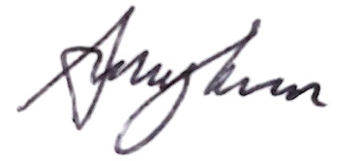

Treasurer: 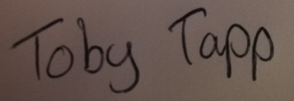

Secretary: 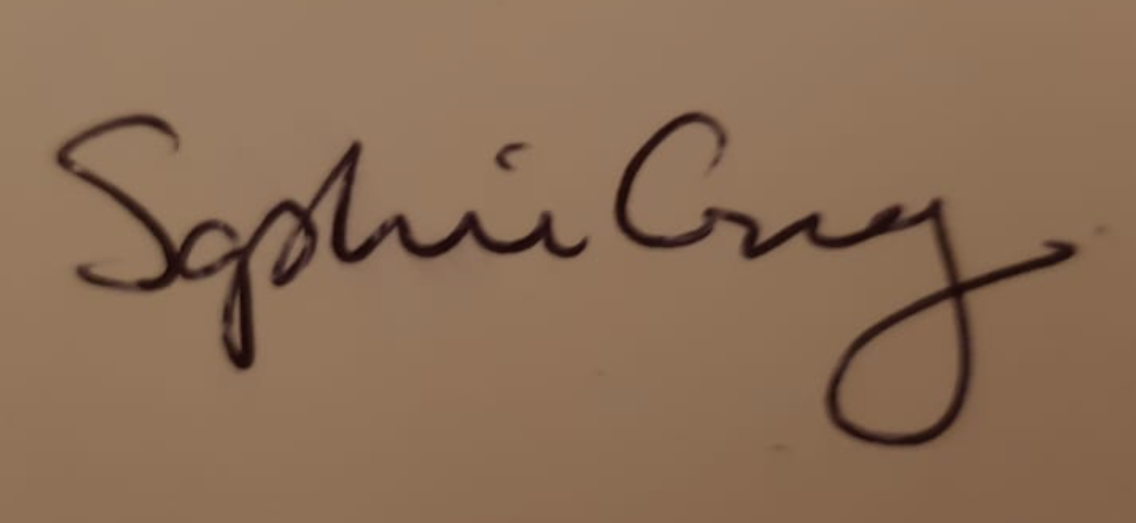

Date: 26/08/2021

