Please make a copy of this report template to fill it out and upload it to Engage.
Once it has been uploaded, let us know by completing this online form: https://forms.office.com/e/074X53zd1J
Society Name | Date
Leeds University Union Hiking Club (LUUHC) | 09/03/026

Which 3 tasks did you complete?
☐ Educational post on social media
☒ Fundraiser in support of a related charity/cause
☒ Event centered on related themes
☐ Group-specific safety commitment statement
☒ Collab awareness event/activity with another student group
☐ Resource guide for members
☒ Discussion session

For more info on each of these tasks, visit Get SASHA Accredited - Leeds University Union

Task 1:

LUUHC ran a collaborative social with SASHA where we did paracord making. During this myself as LUUHC welfare secretary of LUUHC and Tom A from the SASHA committee lead a discussion on consent and the role of active bystanders as well as what SASHA values mean to hiking and the outdoor community.
The social event was well attended and members were able to have open discussions about the themes discussed and what hiking meant in terms of a space for recovery and healing from sexual violence and from a wider mental health aspect. The members were also aware of the SASHA space and activism.

Members of Hiking feel more empowered to act as active bystanders and the FRIES consent acronym. This means members are more aware of how to protect others as well as a wider definition of consent.

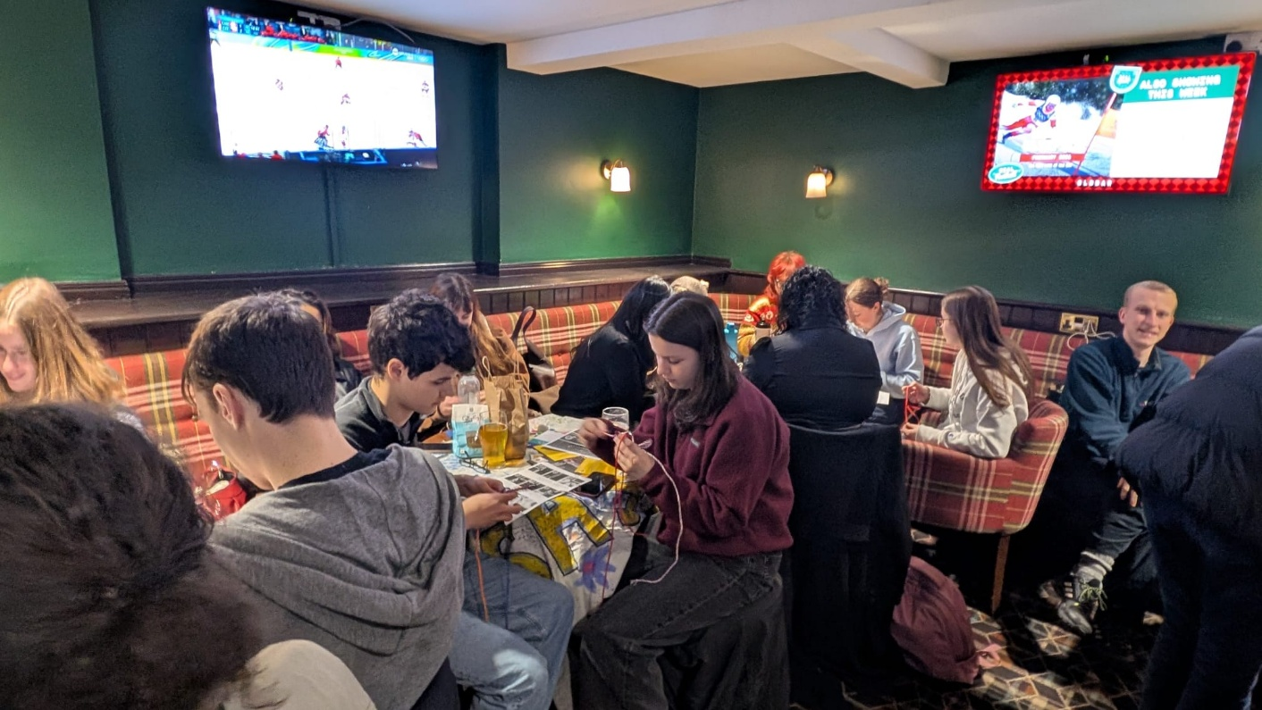

Task 2:

The Hiking Society lead a presentation / discussion session for hiking leaders within the society. These people are in charge of leading routes across hiking trips including; Sunday day hikes, weekend trips, winter trips and our international trip. They are members of the society with a position of responsibility for the safety and wellbeing of members on hikes they lead. During the session Myself and Tom A presented a condensed version of the SASHA consent and active bystander training presentation, we focused on situations involving consent in hiking such as taking group photos, technical hiking leading where a leader may have to get close to a member to demonstrate or assist in a technical move. In addition to this welfare was also discussed for the club as to how people may make members feel more comfortable, strategies and ideas by leaders were shared for this.
The Leaders who attended engaged very well with the SASHA presentation and participated in discussions about unique consent situations within the hiking society. Many ideas to improve inclusion and to make hiking a safer space were discussed.
This will bring increased awareness to society events and trips, especially on hikes where physical safety is often the primary concern, leaders will also feel able to act as active bystanders in situations knowing tactics such as distraction etc.

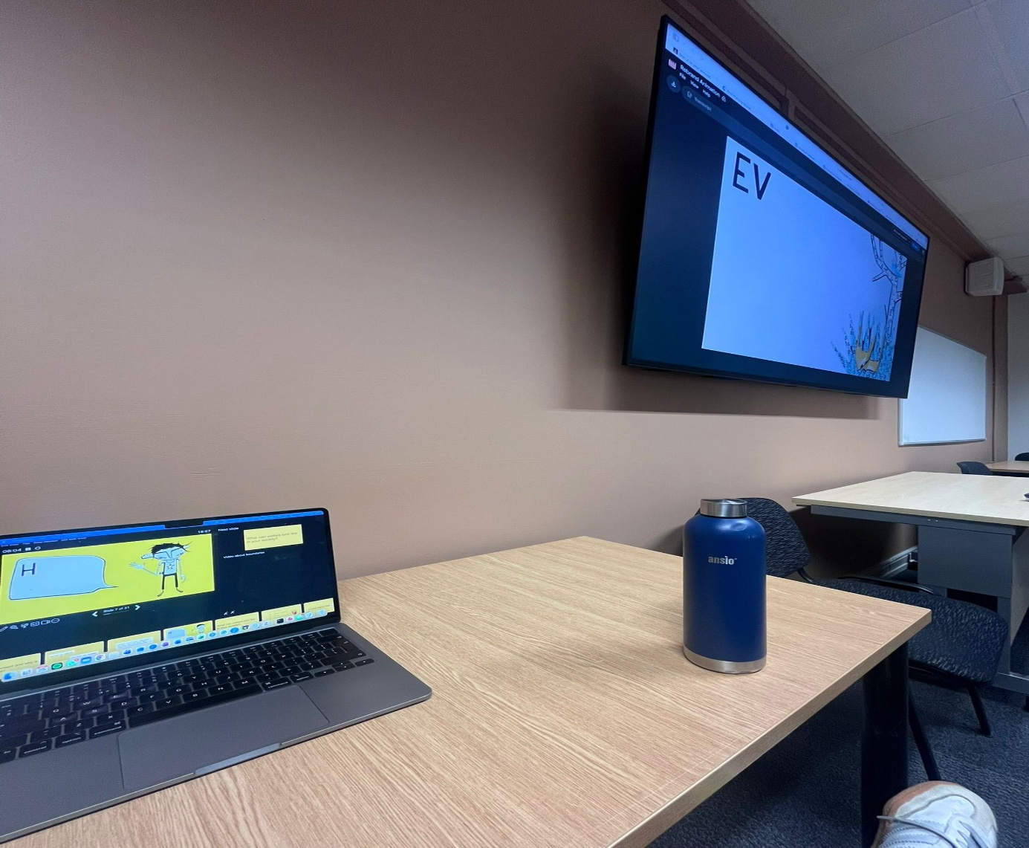

Task 3:

Fundraiser for Support After Rape & Sexual Violence Leeds (SARSVL), introduced during the SASHA collab and advertised through club WhatsApp and Instagram

Members of the Hiking society and their families / friends were able to support the amazing work of SARSVL. The members also gained awareness of charities and support available in the Leeds area.

The hiking club has been able to raise money for SARSVL

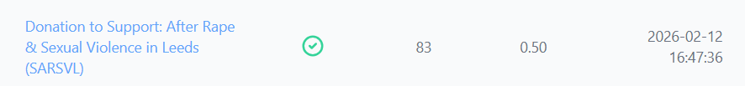

REMINDER! let us know you have submitted your report by completing this online form: https://forms.office.com/e/074X53zd1J
You will not be SASHA Accredited unless you complete both this report and the form.

