Please download a copy of this report template to fill it out and upload it to Engage.
Once it has been uploaded, let us know by completing this online form: https://forms.office.com/e/074X53zd1J
Society Name | Date
Vertical Fitness | 16/02/26

Which three tasks did you complete?
☐ Educational post on social media
☐ Fundraiser in support of a related charity/cause
☐ Event centered on related themes
☐ Group-specific safety commitment statement
☐ Collab awareness event/activity with another student group
☐ Resource guide for members
☐ Discussion session

For more info on each of these tasks, visit Get SASHA Accredited - Leeds University Union

Task 1: Social media Post

Describe the task and how you approached it
After attending the session hosted by SASHA, the Co-Presidents collaborated on creating an educational post based on what they learnt. The post consisted of 7 slides including: About SASHA, Consent & FRIES, active bystanders, Spiking, Reducing stigma, Support resources and Our statement. We included acronyms such as FRIES and the 5D’s used by sasha themselves and included hotline numbers and charities for those in needs of support. We wanted to make sure that the information was also relevant to our society so we included a section on our statement and the environment we intend to create as a society. We made sure to include a trigger warning as well.

What was the response to this?
We received a significant number of reposts and shares, demonstrating that our post has been received positively by our members and other followers, and furthermore is being spread beyond just the reach of our account, which is fantastic.

What is the impact of this action (predicted or already realised)
With the post having such a positive reception and significant shares, this means the information such as the acronyms of FRIES and the 5 D’s, and how to deal with spiking, have been read and recognised by lots of our members and beyond! This is a positive step in the right direction to a safer society. Perhaps a member will be able to safely support a friend if they are spiked, or will know how to safely intervene if they witness a case of sexual harassment which they may have been previously unsure of how to respond.

Share here any photos/links that show you completed this action

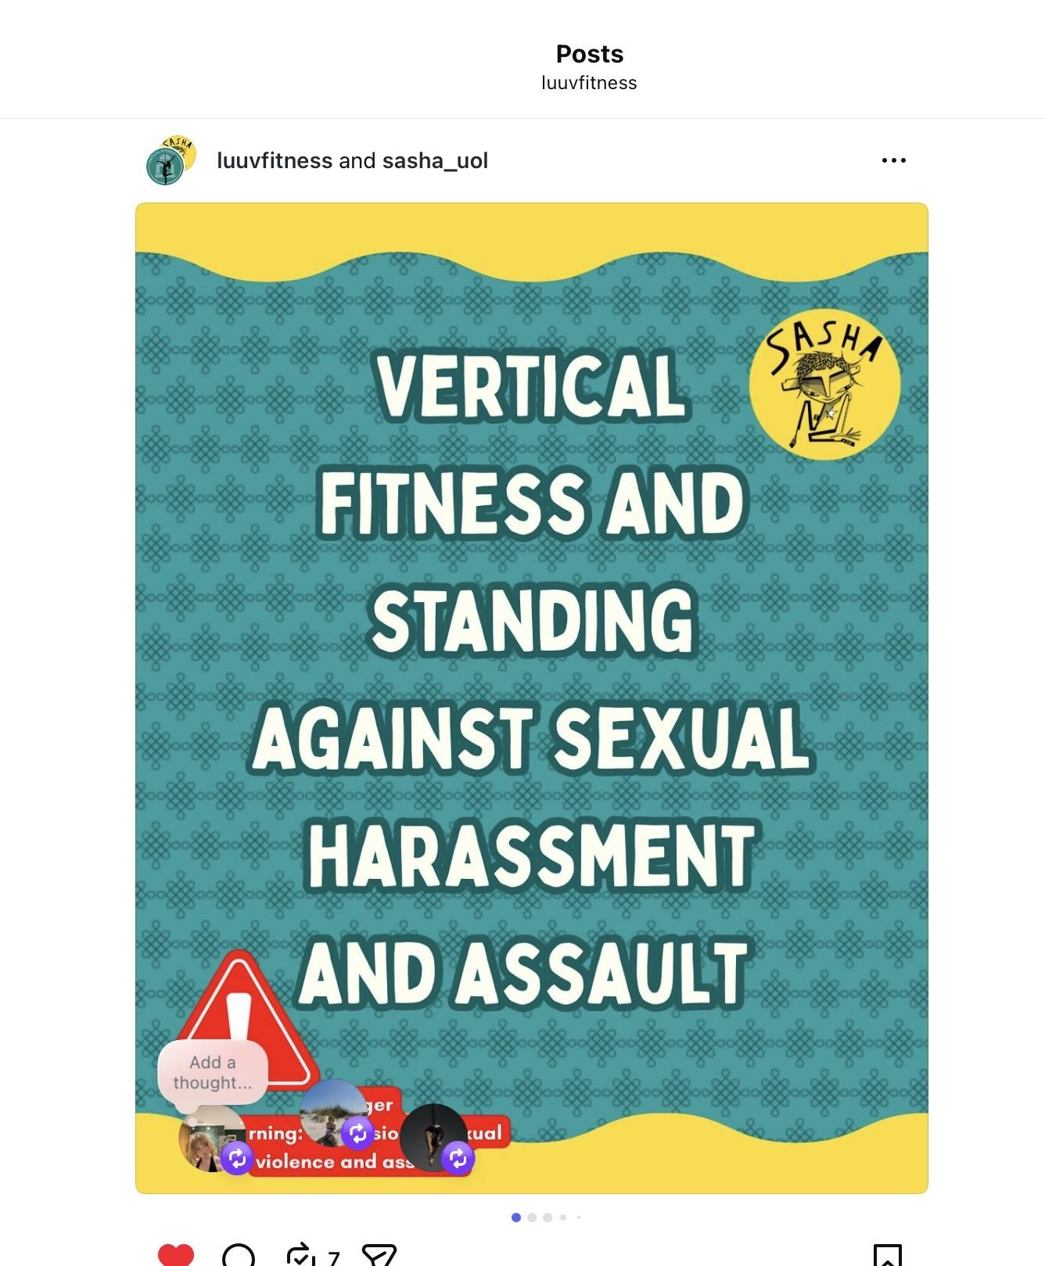

Task 2: Charity fundraiser

Describe the task and how you approached it
We completed our annual 24 hour pole-a-thon in December in aid of Basis Yorkshire. This is a charity that supports sex workers and those vulnerable to sexual exploitation in the local area. We raised money via sponsorship of the challenge, paying to try out the pole, a bake sale and face paint & Glitter. As well as raising money we aim to raise awareness by handing out their flyers, having signs about the charity and speaking to the people that come over to our stand. We also had a visit from SisterHood in Solidarity, a grassroots, neurodiverse and sex worker run solidarity group which provides safe spaces and community for sex workers, and were able to hand out some of their flyers too!

What was the response to this?
As mentioned above, we raised £218 for Basis Yorkshire, an increase in proceeds on the past 2 years which is super positive. Having the pole up in the university union we gain quite a lot of attention and people coming over to us to ask what is going on! This means that we are able to talk about Basis, the work that they do and how they can get involved. We gave out almost all of the information flyers to people, getting the word out there!

What is the impact of this action (predicted or already realised)
The money raised for Basis will contribute to funding training courses for practitioners to successfully support sex workers and those experiencing sexual exploitation, continue to allow them to run free drop in clinics and sessions for sex workers, plus an outreach van. Basis’ work is vital and we are so proud to support them.
The flyers handed out could signpost student sex workers to the support they can access from Basis, providing greater protection to a vulnerable group.
The event also promoted our showcase, which all the proceeds go to Basis. A sold out show would raise over £3000 for Basis, which would be absolutely sensational and the most ever raised, so we hope that this promotion will bring us closer to that goal.
Our public support of Basis and their work will continue to defeat the stigma surrounding sex work, a stigma which makes the lives of sex workers more at risk while it exists.

Share here any photos/links that show you completed this action
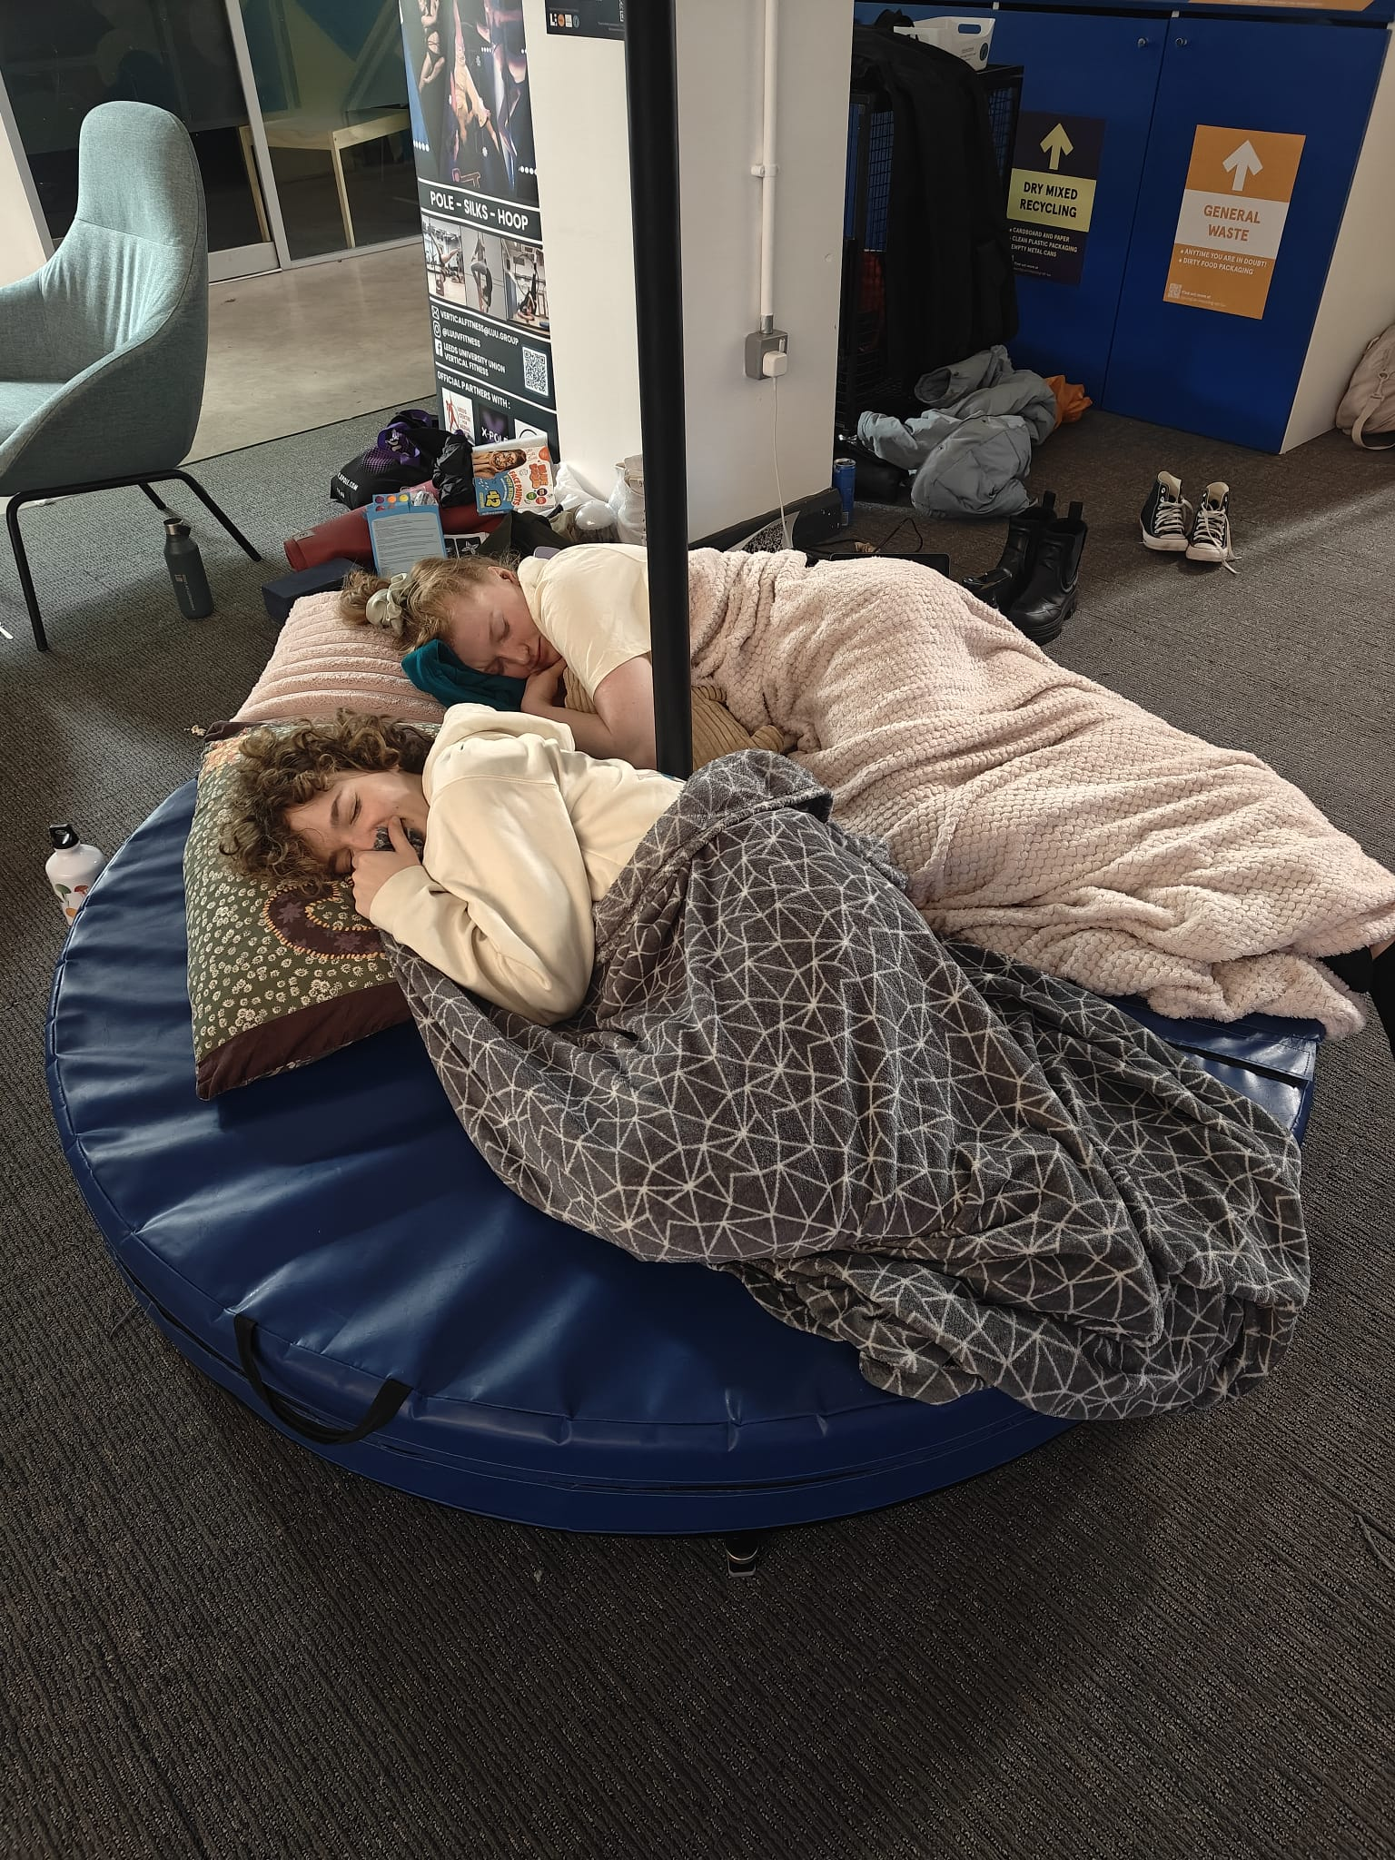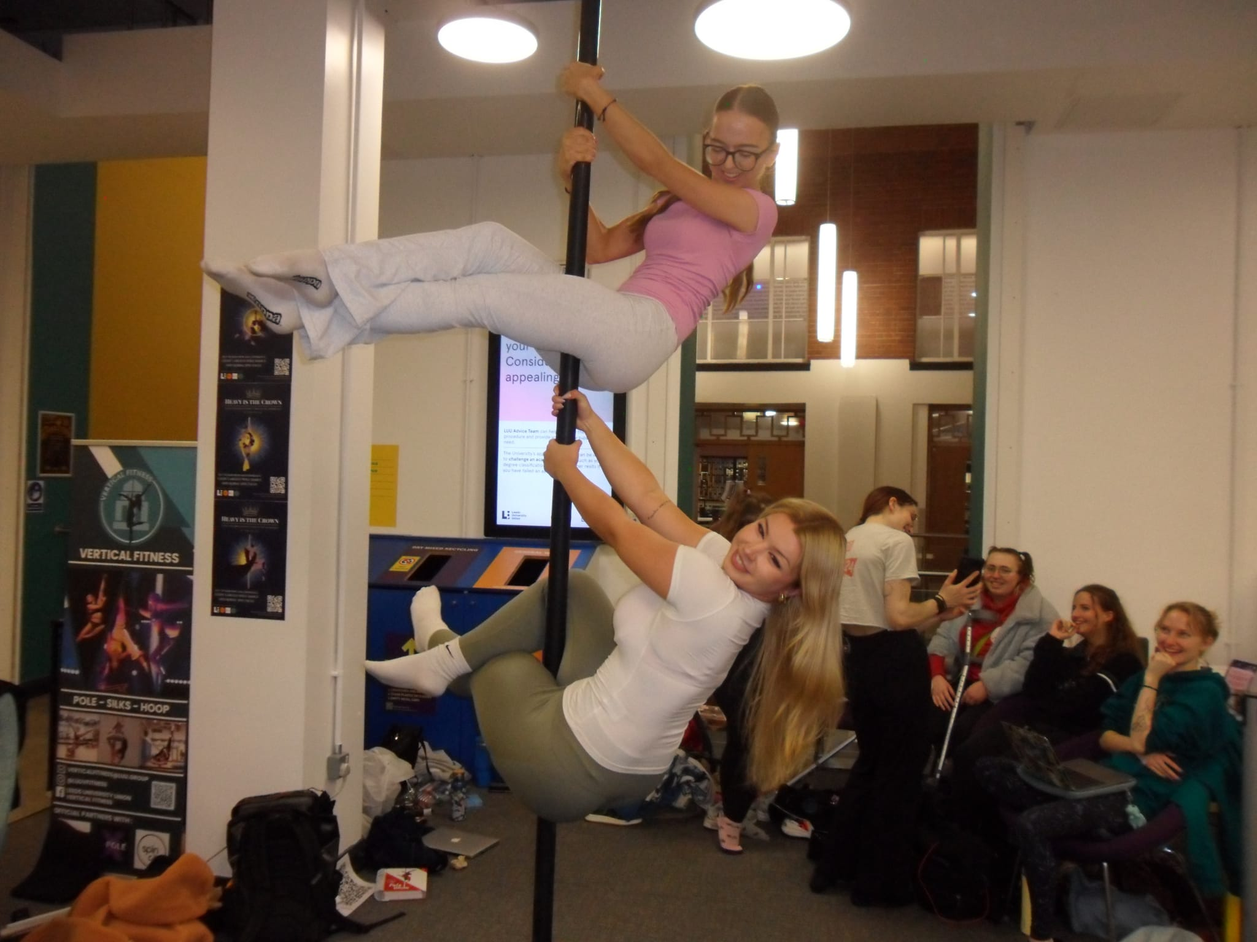

Task 3: Group Specific statement

Describe the task and how you approached it
After attending the workshop with SASHA the presidents and Welfare officer got together to write a commitment statement. We were able to think about the things that our society already has in place to promote a safe environment for consent and boundaries to be discussed and how we can support those affected by sexual violence. We have a Welfare officer, who is always there to support members and sign post them to appropriate people/organistations. We have a sober committee member at every social. We also paid specific attention to elements of our sport that are relevant, for example consent when spotting and advocating for your preferences, as well as creating an inclusive environment around clothing, Pole fitness requires some amount of bare skin, but we emphasise individuals abilities to do what makes them comfortable.
We also thought carefully about our procedures if an instance does occur of assault under our supervision.
We lay out very clearly our stand against sexual assault and harassment.
We did ask SASHA society for feedback on this after we had written it but we didn’t receive a response.

What was the response to this?
This is more of a slow weekly repeated impact than one with a dramatic response, but we hope the statement is being read and received by all our members - as well as linking it we also highlight for members to look at it in the main email as well ,so it does not go missed!

What is the impact of this action (predicted or already realised)
We now include this in our weekly email so that everyone is aware of it, we hope to see members advocating for preference in classes. We know that having sober committee members at socials is important for members safety, we have kept this policy for the past 2 years so we know it has an impact and makes people feel comfortable. We hope this is a statement that will be kept up year after year, and will pass on its importance to next years committee. We want VF to be a safe space and we hope this statement will solidify that.

Share here any photos/links that show you completed this action

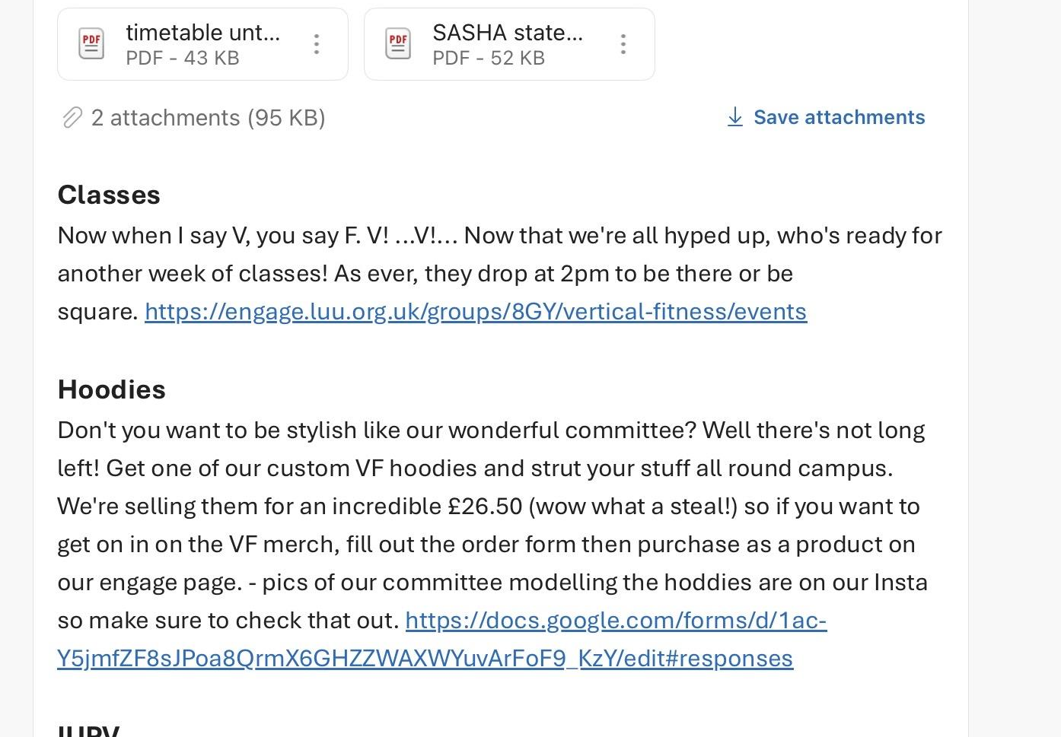

- second attachment in weekly email
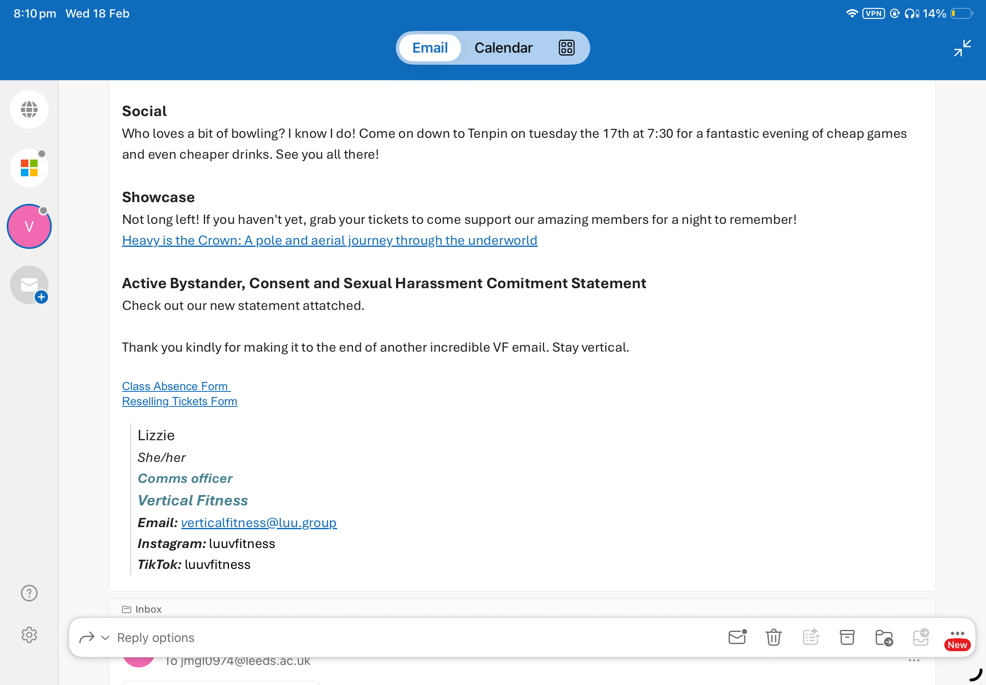
- see our signpost to the statement too!
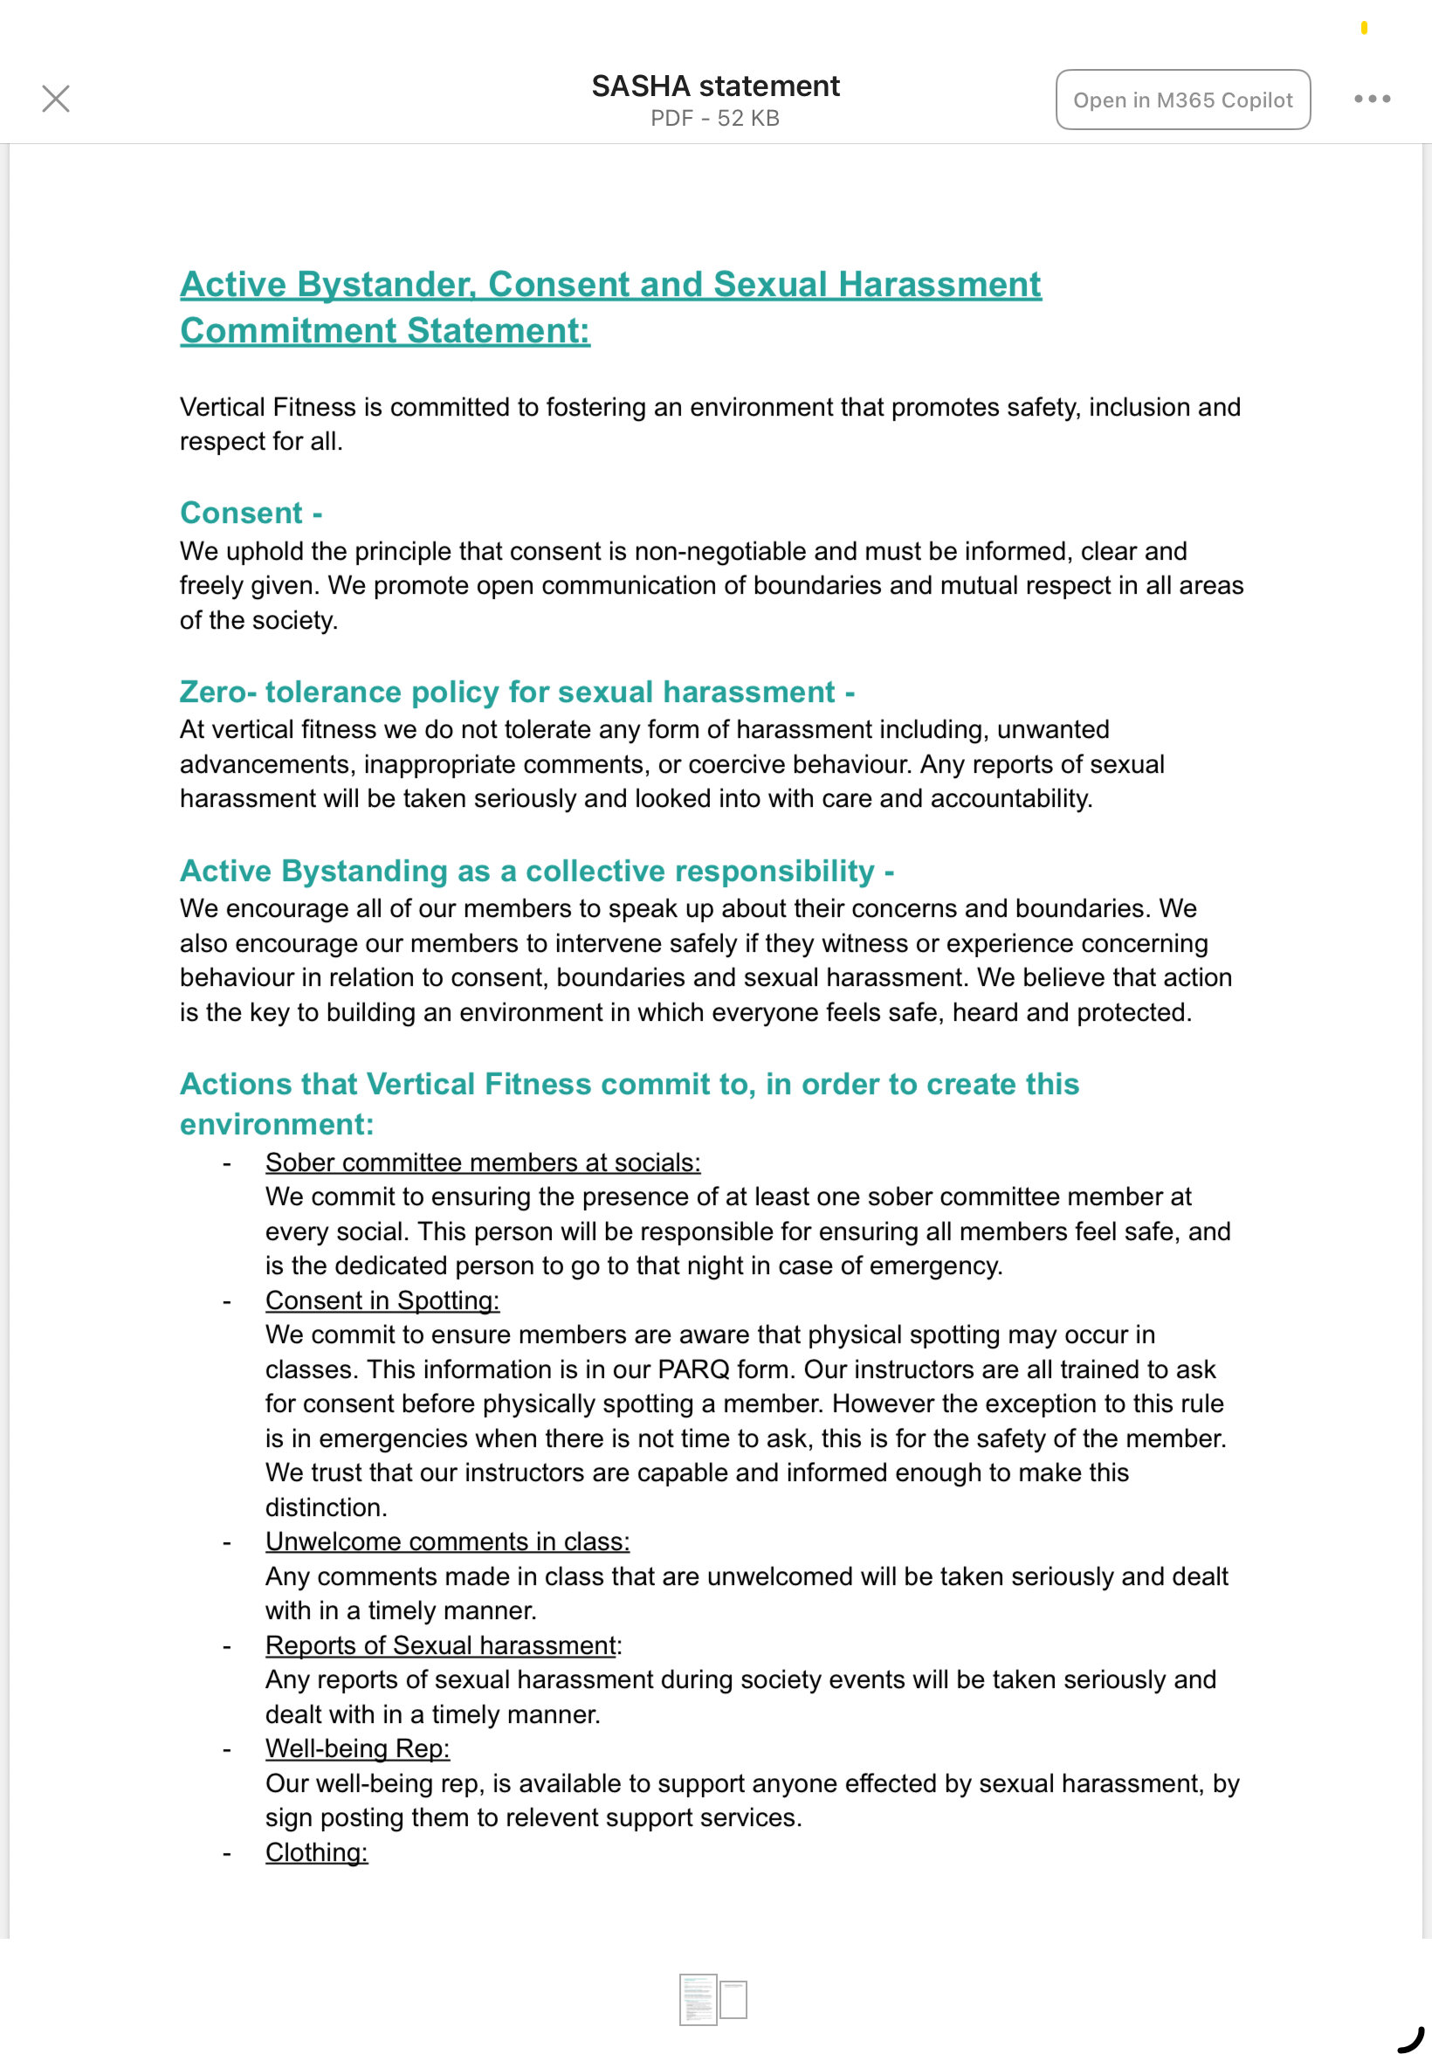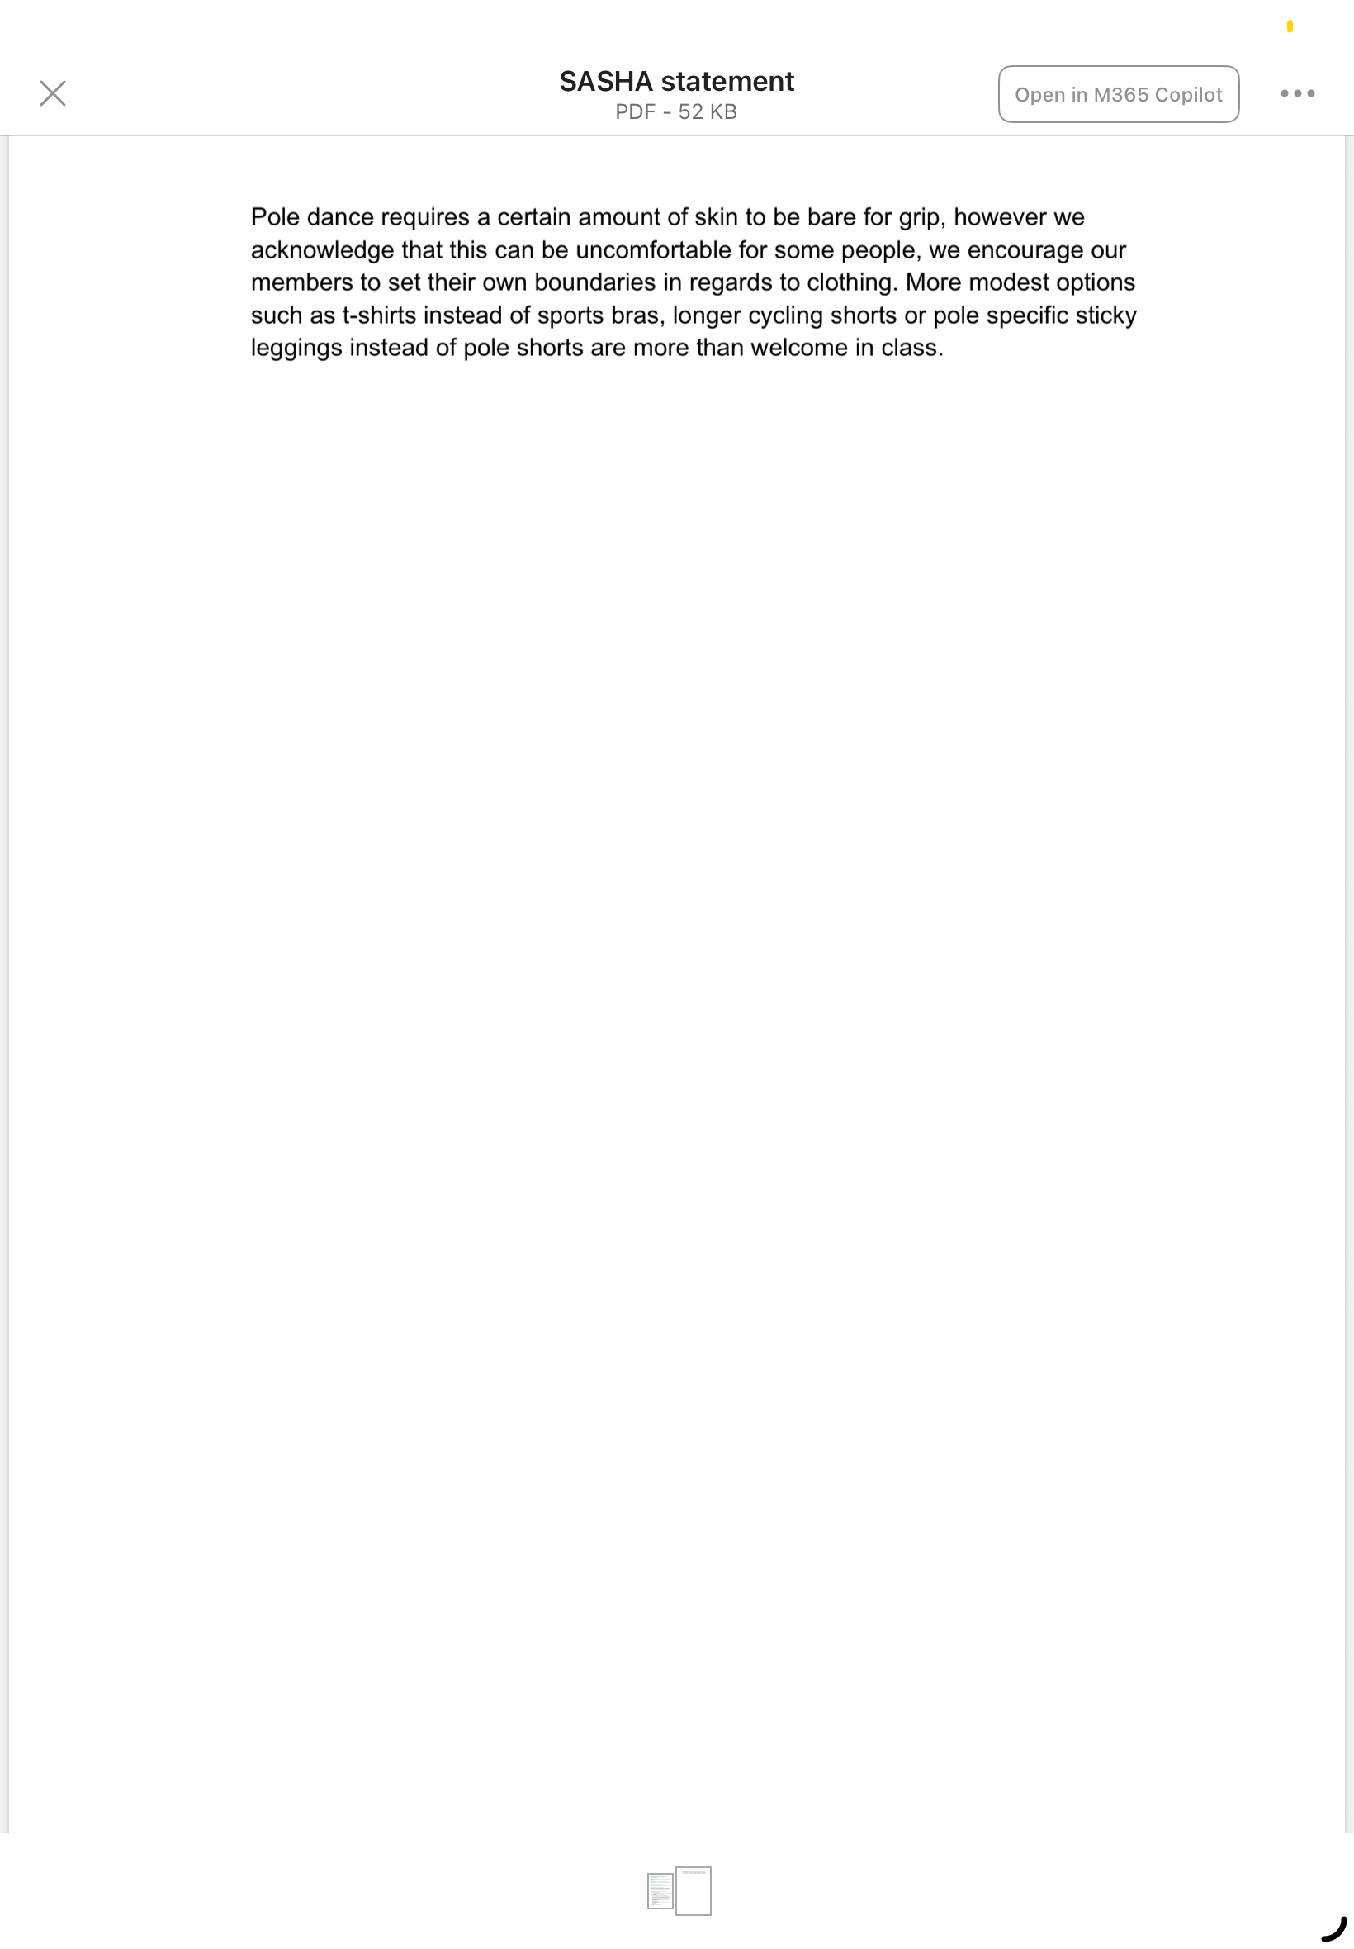

REMINDER! let us know you have submitted your report by completing this online form: https://forms.office.com/e/074X53zd1J
You will not be SASHA Accredited unless you complete both this report and the form.

