Please download a copy of this report template to fill it out and upload it to Engage.
Once it has been uploaded, let us know by completing this online form: https://forms.office.com/e/074X53zd1J
Society Name | Date
Homed Society | 04/02/26

Which three tasks did you complete?
☒ Educational post on social media
☐ Fundraiser in support of a related charity/cause
☐ Event centered on related themes
☒ Group-specific safety commitment statement
☐ Collab awareness event/activity with another student group
☐ Resource guide for members
☒ Discussion session

For more info on each of these tasks, visit Get SASHA Accredited - Leeds University Union

Task 1:
Educational post on social media
Describe the task and how you approached it

As a society, we collaborated to create an infographic and posted it on our social media page and our story. We wanted people to be able to refer to it whenever they wanted to, which is why we have pinned it on our Instagram, so it is at the top and easily accessible.

What was the response to this?

Our members appreciate the work we are doing to show that we are passionate about making everyone feel comfortable in our society. Some of our committee members also reposted the infographic on their own stories to further spread this document to raise awareness on this issue.

What is the impact of this action (predicted or already realised)

We predict that people will refer to the infographic if they are unsure about an issue related to consent and want more guidance. We also hope that it will help members in our society feel more comfortable telling someone on the committee any issues that they have had in this area.

Share here any photos/links that show you completed this action

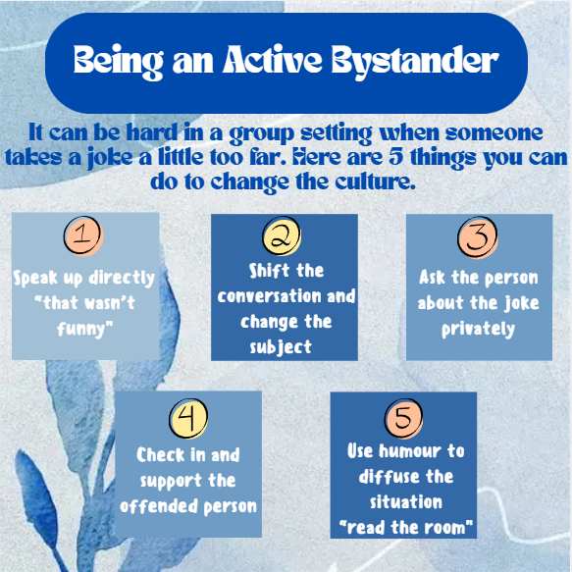

Task 2: Group specific safety commitment

Describe the task and how you approached it

At our last committee meeting we discussed what was learnt at the consent training and made a commitment to put more measures in place to promote safety at our future socials and volunteering opportunities.

What was the response to this?

Our members are even more aware of the safety measures we put into place to protect them on our sandwich runs and socials, they provided us with feedback on our commitments and were appreciative of everything that we do behind the scenes.

What is the impact of this action (predicted or already realised)

Already there has been some positive feedback on the safe and welcoming environment our committee members create on the sandwich runs. We predict our members will feel even more comfortable to bring to light any issues they encounter on these runs and additionally at our socials.

Share here any photos/links that show you completed this action

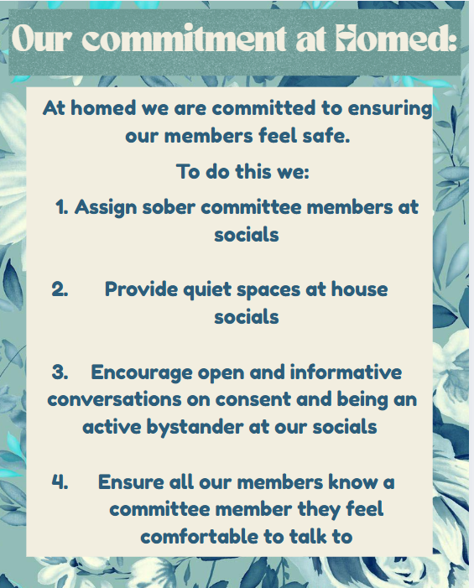

Task 3: Committee discussion session

Describe the task and how you approached it

We set aside some time at our committee meeting for the welfare secretary to discuss what they had learnt at the consent training. We then discussed this information and thought of ways as a committee we can ensure that our members feel safe at every event we host. We want to ensure the information we learnt at the consent training is applied through the rest of the year and leaves a lasting legacy on our society for the future committee members. To do this we will discuss the measures we have in place to protect our members with the new committee for next year to ensure they understand the importance of continuing them.

What was the response to this?

The committee was very receptive to learning more about consent and about being an active bystander and were keen to put forward their own ideas on how we can improve as a society.

What is the impact of this action (predicted or already realised)

The discussion was productive, and we now feel more capable of dealing with an issue in our society if it arises.

Share here any photos/links that show you completed this action

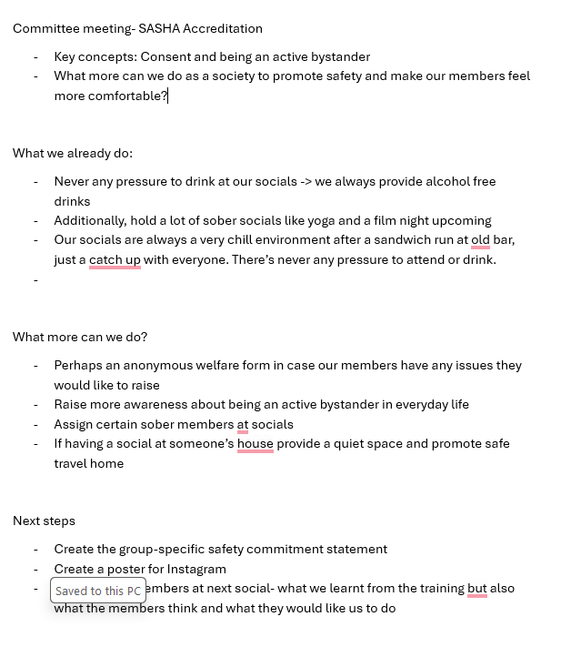

REMINDER! let us know you have submitted your report by completing this online form: https://forms.office.com/e/074X53zd1J
You will not be SASHA Accredited unless you complete both this report and the form.

